

**UNIVERSIDAD MARIANO GALVEZ DE GUATEMALA**

**INGENIERIA EN SISTEMAS DE INFORMACION Y CIENCIAS DE LA COMPUTACION**

**BASE DE DATOS II- A**

**SECCION A**

**PROYECTO FINAL**

**DATA MINING**

1. **ERICK FERNANDO FUENTES OROZCO 0905-16-5265**
2. **EDUARDO DAVID NATARENO MENCOS 0905-16-5260**
3. **JORGE MIGUEL GUDIEL GUDIEL 0905-16-5263**
4. **HECTOR MANUEL MARTINEZ MOREIRA 0905-16-5268**
5. **GUERIN STEVEN COLOCHO CHACON 0905-16-4002**
6. **FRANKLIN ANTONIO RECINOS OLIVARES 0905-16-17530**
7. **ERICK NOEL BARILLAS GALICIA 0905-16-3391**
8. **OSCAR OSWALDO ORTIZ GARCIA 0905-16-4754**

**MAYO 25, 2019**

**Tabla de Contenidos**

Capítulo 1 Introducción e información general 1

Objetivos 1

Antecedentes 2

Justificación 4

Software 4

Hardware 4

Capítulo 2 Determinación de Modelos Multidimensionales 5

Uso de Cubos OLAP 5

Creación de Proyecto Multidimensional 6

Creación de un proyecto de análisis multidimensional llamado Proyecto_Bd 6

Creación Data Source 7

Instancia a la base de datos 7

Usuario y contraseña de instancia 8

Nombre del Data Source 9

Creación del Data Source View 10

Selección del Data Source 10

Selección de dimensiones a trabajar 11

Nombre del Data Source View 12

Esquema de la topología de la vista 13

Estructura del cubo 1 13

Estructura del cubo 2 13

Estructura del cubo 4 14

Estructura del cubo 5 15

Estructura del cubo 6 15

Estructura del cubo 7 16

Estructura del cubo 8 16

Estructura del cubo 9 17

Crear dimensión de una tabla existente 18

Selección de tabla 19

Selección de columnas deseadas de la tabla 20

Nombre de la dimension 21

Creación de un cubo 22

Crear cubos de tablas existentes 22

Selección de la tabla de hechos 23

Selección de dimensiones a trabajar 24

Instancia del Server en el proyecto 25

Capítulo 3 Resultados de los Estudios Respectivos 26

Estudio 1 26

Representación en Excel de variabilidad por años 26

Representación gráfica de variabilidad por años 26

Representación en Excel de variabilidad de ventas por producto 27

Representación gráfica de variabilidad de ventas por producto 30

Conclusión: 30

La variabilidad de la venta decrece en relación al aumento de estas, ya que a partir del año 2007 establece un punto promedio base para los siguientes años. 30

Estudio 2 31

Representación en Excel 31

Estudio 3 60

Representación por Excel de las áreas potenciales de venta por país 60

Representación gráfica de las áreas potenciales de venta por país 60

Conclusión: 60

Representación por Excel de las áreas potenciales de venta por número de vehículos en posesíon. 61

Representación gráfica de las áreas potenciales de venta por número de vehículos en posesión. 61

Conclusión: 61

Representación por Excel de las áreas potenciales de venta según nivel de educación. 62

Representación gráfica de las áreas potenciales de venta por educación. 62

Conclusión: 62

Representación por Excel de las áreas potenciales de venta por género. 62

Representación gráfica de las áreas potenciales de venta por género. 63

Conclusión: 63

Representación por Excel de las áreas potenciales de venta por estado civil 63

Representación gráfica de las áreas potenciales de venta por estado civil 64

Conclusión: 64

Representación por Excel de las áreas potenciales de venta por ocupación. 64

Representación gráfica de las áreas potenciales de venta según ocupación 65

Conclusión: 65

Representación por Excel de las áreas potenciales de venta por número de hijos. 65

Representación gráfica de las áreas potenciales de venta por número de hijos. 66

Conclusión: 66

Estudio 4 66

Representación del cubo sobre la descripción de los argumentos solicitados. 66

Estudio 5 67

Representación en excel de las ventas menores por producto del año 2007 67

Representación en Excel de las ventas menores por producto del año 2008 68

Estudio 6 74

Estudio 7 75

Representación en Excel del impacto de promociones según la promoción. 75

Conclusión: 76

Estudio 8 76

Representación en Excel de la moneda más utilizada. 76

Representación gráfica de las moneda más usadas en compras. 77

Conclusión. 77

Estudio 9 78

Capítulo 4 79

Minería de Datos 79

Definición de Vista 79

Query de Vista: 79

Nombre de Vista. 81

Creación del Proyecto Data Mining 82

Creación Data Sources 83

Modelo de Minería. 85

Seleccion del primer modelo 85

Especificación del caso de uso para la minería. 86

Especificando el número de casos para el modelo de testeo. 88

Nombrando la Estructura 88

Creación de los modelos restantes para el análisis. 89

Procesamiento de los datos. 90

Analsis Árbol de decisiones 91

Analisis Clustering 92

Capítulo 5 100

Diccionario de Datos 100

Capítulo 6 130

Alta Disponibilidad 130

Configuración 130

Capítulo 7 139

Conclusiones y Recomendaciones 139

Conclusiones 139

Recomendaciones 139

# Capítulo 1 Introducción e información general

El respaldo de la información es vital para cualquier organización, empresa pequeña, grande o bueno cualquier ente en sí que necesite llevar un control sobre sus operaciones, los sistemas de base datos son herramientas increíblemente útiles para la gestión y el respaldo de datos; perfeccionando esto surgen utilidades como los Data warehouses que son almacenes de datos, con información pertinente de operaciones pasadas para operaciones futuras, y gracias a ellos podemos hacer implementaciones de sistemas multidimensionales que se pueden ver como bases de datos de una sola tabla, en las cuales hay una relación de campo por métrica y hecho, otra implementación relevante es el Data Mining, proceso fundamental para recolección de información y que enfocándola principalmente a inteligencia de negocios puede darnos un triunfo sensato en el mercado. Las tecnologias Data Tools de SQL Server, proveen de todo el cuadro de trabajo necesario para la acción de todas estas operaciones

## Objetivos

1. Crear un modelado que ayude a tomar futuras decisiones y el realizar estrategias mejorando así los resultados de la empresa en cuestión.
2. Comprobar y aplicar estrategias efectivas para masificar los clientes de la empresa.
3. Generar un nivel mayor de ganancias monetarias para empresa y un aumento de prestigio ante los clientes de esta.

## Antecedentes

La Empresa “BdII Final Project”, dedicada al desarrollo de Sistemas de Informáticos y Soluciones de Infraestructura a requerimiento, actualmente asume la responsabilidad del desarrollo de un “Análisis e Implementación de Modelos Multidimensionales y Estadísticos” que permita la Toma de Decisiones de una Empresa en particular, cuyo enfoque es el de Ventas por Internet y como una nueva incursión, la Venta de Seguros.

Dentro del requerimiento se encuentra que dichos modelos permitan determinar, por medio de un análisis multidimensional y estadístico información importante que permita a la empresa “Multiservices Inc.” obtener especificaciones de información en áreas importantes de la misma.

Dicha Implementación deberá de permitir obtener un análisis de como mínimo los siguientes:

1. La variabilidad de las Ventas, estas comparativamente en todos los años (Si se encontraran un número no mayor a 5 años) o al menos 5 años y evaluando el incremento y decremento de las mismas por Producto y Ciudad.

2. Número de Ordenes, el Total de Costo Estándar del Producto y el Total del Precio Unitario, considerando esta información por Año, Mes y Día.

3. Determinar las áreas potenciales de ventas.

4. Descripción de productos en tallas y categorías con mayores descuentos y la información de clientes y sus características que hayan comprado los mismos.

5. Determinar por año, el o los meses en donde se presentan las menores ventas, desagregadas por producto y con antecedentes de al menos 2 años.

6. Determinar el Tax a pagar, según proyección de ventas para los 5 años siguientes al último registrado en la Base de Datos respectiva.

7. Determinar que promoción y en que fechas se han tenido los mayores impactos en las ventas.

8. Determinar cuál es el tipo de moneda y ciudad donde más se utiliza ésta para realizar las compras.

9. Obtener información de contacto de los clientes con más variación en compras.

10. Otros a consideración. Así mismo se le solicita que lidere un estudio para determinar la línea de trabajo a seguir para la realización de una campaña publicitaria enfocada a las Ventas de Seguros, que es una nueva incursión de la empresa contratante, por lo que se le solicita realizar un modelo de Minería de Datos para determinar información relacionada al contacto de Clientes con mayor potencial de compra, mismos que deberán ser considerados de acuerdo a particularidades establecidas a través de un estudio de mercado; determinando este, que se deben considerar a aquellos que cumplan con las características siguientes:

1. Compradores de Productos que posean un nombre de sub categoría: Bicicleta de montaña, Bicicleta de carretera, Bicicleta de paseo.

2. Clientes que dentro de sus compras no se incluyan productos de nombre: Casco deportivo: 100 de cualquier color.

3. Clientes cuyos ingresos anuales superen los $50000.

4. Clientes cuya edad supere los 35 años,

5. Clientes Hombres y Mujeres con un estado conyugal (Estado Civil) Solteros/as o Casados/as.

6. Que sean propietarios de al menos 1 vehículo.

7. Que sean propietarios de vivienda o no.

8. Que pertenezcan al País con Nombre de Región: Estados Unidos, Australia, Canadá, Alemania y Francia.

Como resultado de lo anteriormente expuesto se designa a su equipo de trabajo para que realice las tareas relacionadas al tema de Base de Datos (Cubos de Información y Minería de Datos) que sustentará el estudio en mención.

Dentro de lo considerado se encuentra.

Modelo Conceptual, Lógico y de Visión de la Base de Datos (Dw)

Modelos de Definición (Estrella - Copo de Nieve)

Diccionario de Datos

Análisis que determine el modelo Multidimensional y de Minería de Datos respectivo.

Detalles de configuración e implementación del Modelo Multidimensional y de Minería de Datos.

Defunción de Cubos de Información

Archivos de Configuración

## Justificación

### Software

* Microsoft Excel 2010
* Windows Server 2012
* SQL Management Studio 2017
* Visual Studio 2017
* VMWARE Workstation Pro 15

### 

### Hardware

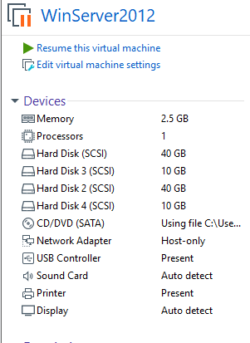

# Capítulo 2 Determinación de Modelos Multidimensionales

## Uso de Cubos OLAP

La gran cantidad de datos heterogéneos acumulados por las organizaciones representa una de las razones por las que las empresas necesitan una tecnología que les permita realizar rápidamente un análisis complejo sobre estos datos. Debido a que las bases de datos relacionales son ineficaces, desde este punto de vista se requiere un nuevo concepto, el concepto de base de datos multidimensional.

Una base de datos multidimensional representa un tipo de base de datos donde los datos se almacenan en celdas y cada posición de celda está definida por una serie de variables denominadas dimensiones.

Base de datos multidimensional:

Organización de datos: matriz de datos multidimensional, celdas, dimensiones, tablas de hechos.

* Nivel de datos: datos detallados y datos agregados.
* Operaciones típicas: análisis.
* Lenguaje para Querys: MDX.
* Uso de espacio en disco: bajo.
* Rendimiento: bueno.
* Flexibilidad: baja.
* Tiempo de procesamiento de datos: alto.
* Escalabilidad: baja.
* Alcance del diseño: limitado.
* Acceso a datos: soporta acceso directo a los datos.

Una base de datos multidimensional presenta varias ventajas:

* Utiliza un espacio en disco menor porque está comprimido y no utiliza la indexación para buscar datos.
* Tiene mejores prestaciones sirviendo necesidades al usuario ya que los datos agregados son precalculados y el formato de almacenamiento reduce el número de operaciones de entrada y salida.
* Garantiza un rendimiento superior porque se modelan teniendo en cuenta sólo los requisitos de un solo grupo de usuarios.
* Soporta un acceso, directo, eficiente y rápido a los datos.

.

## Creación de Proyecto Multidimensional

### Creación de un proyecto de análisis multidimensional llamado Proyecto_Bd

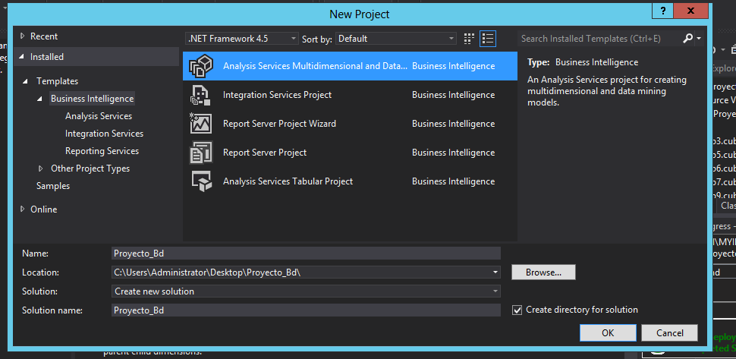

### Creación Data Source



### Instancia a la base de datos

### 

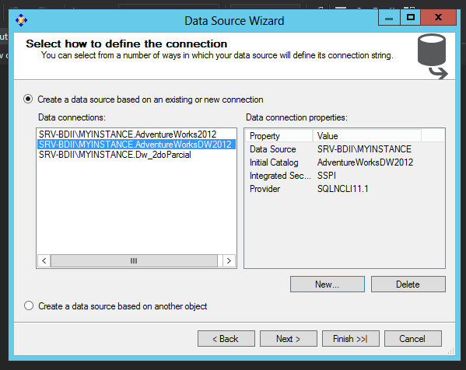

### Usuario y contraseña de instancia

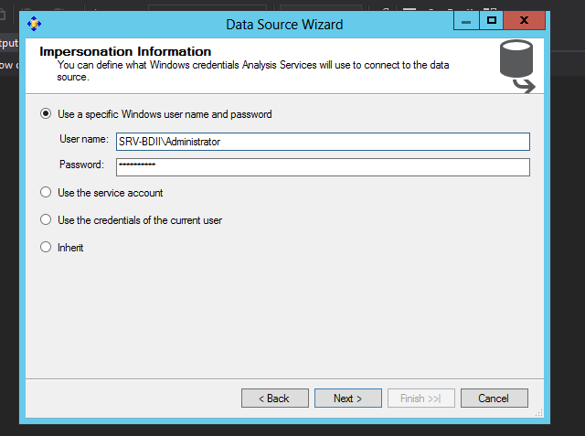

### Nombre del Data Source

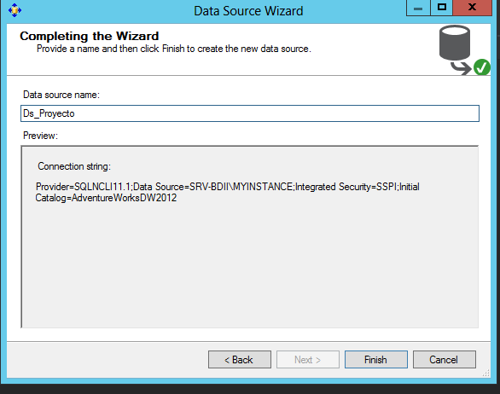

### Creación del Data Source View



### Selección del Data Source

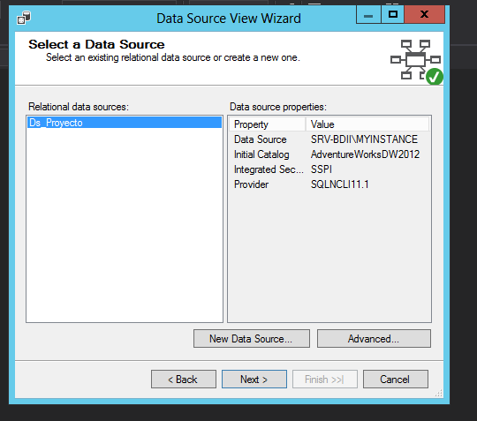

### Selección de dimensiones a trabajar

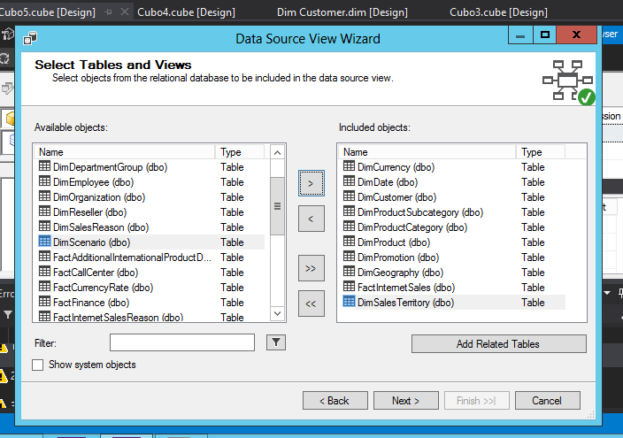

### Nombre del Data Source View

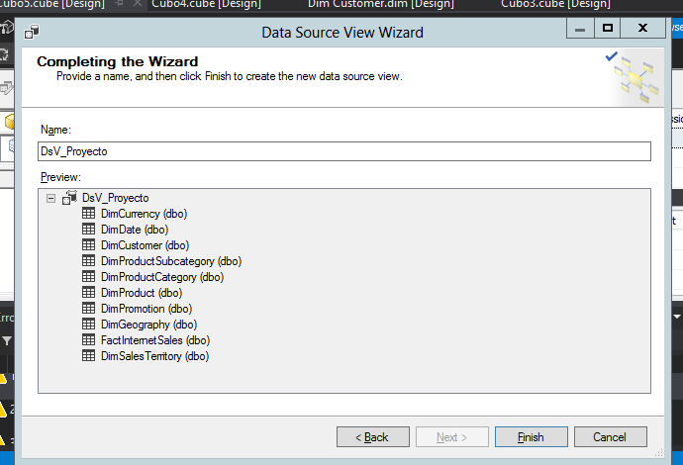

### Esquema de la topología de la vista

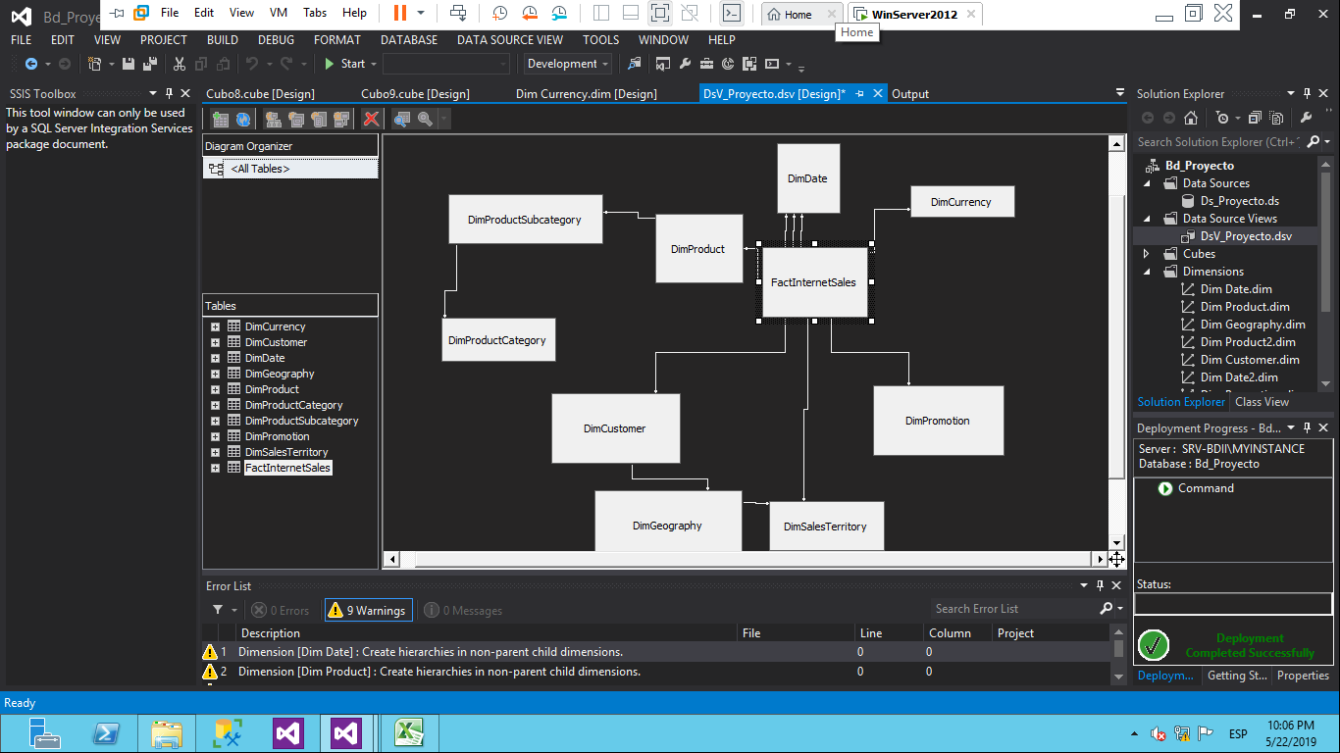

### Estructura del cubo 1

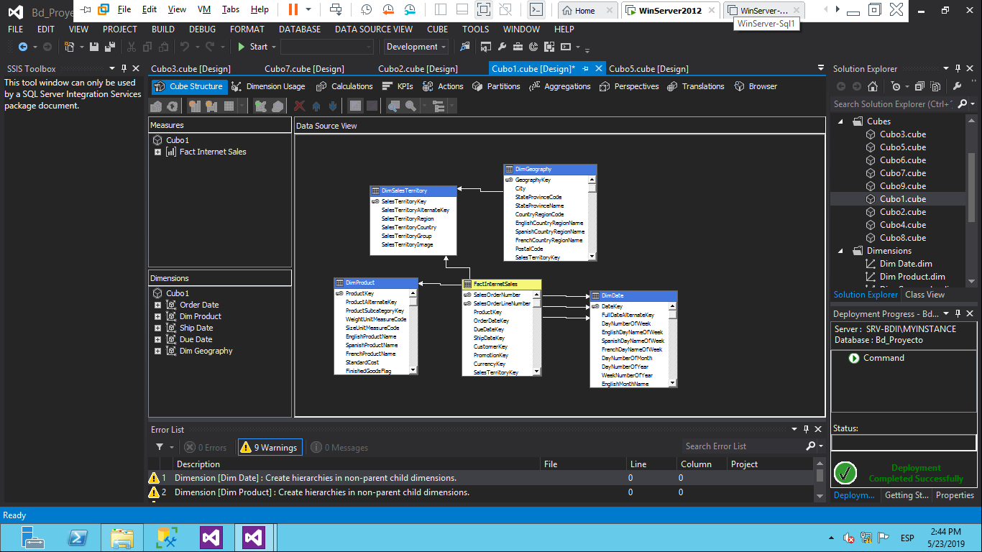

### Estructura del cubo 2

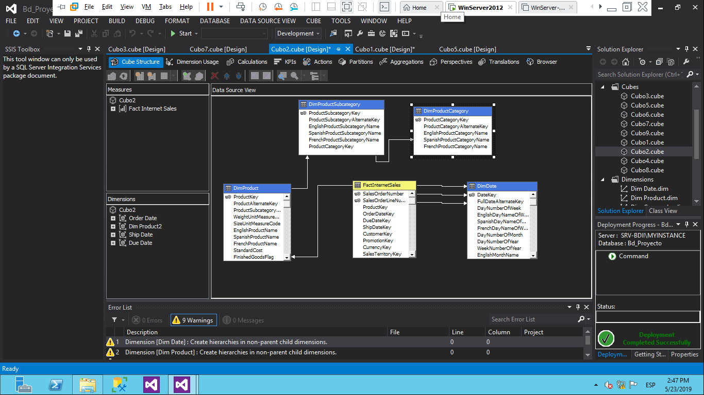

Estructura del cubo 3

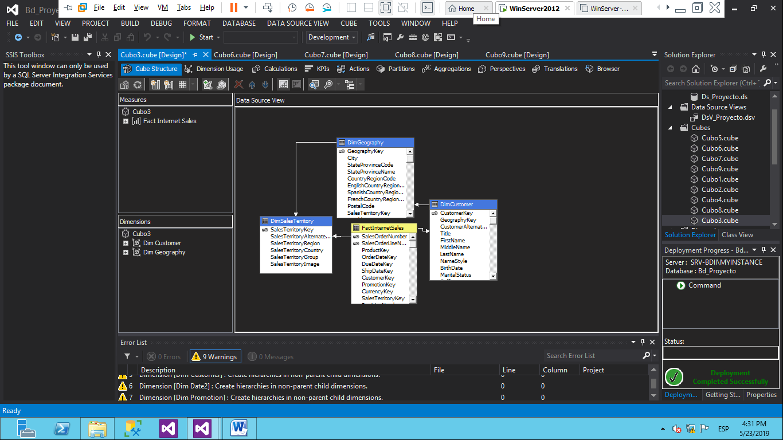

### Estructura del cubo 4

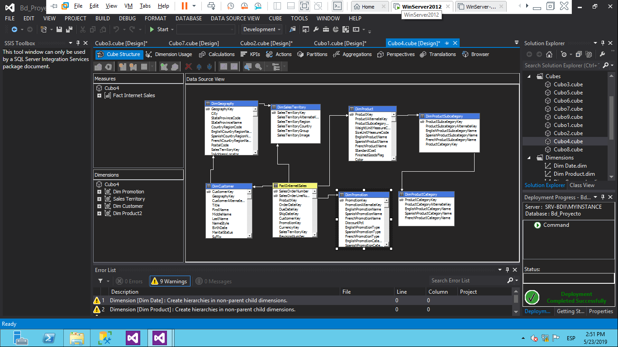

### Estructura del cubo 5

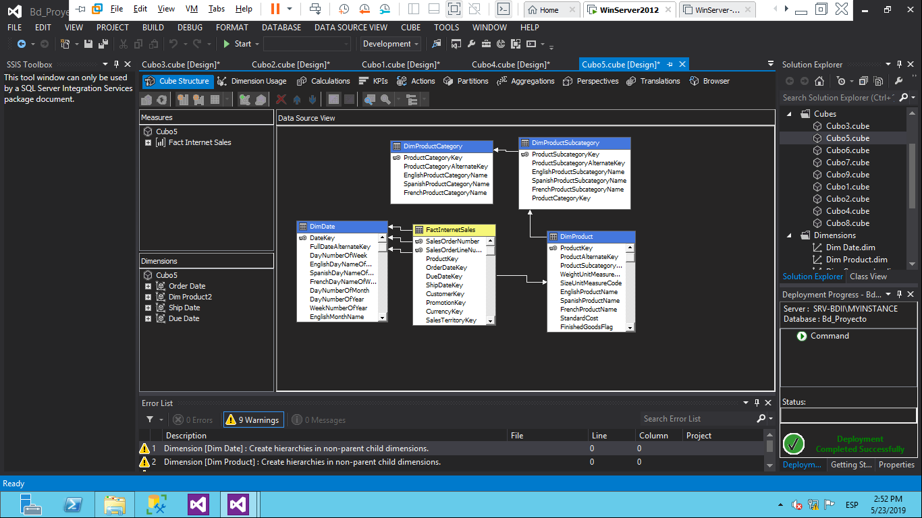

### Estructura del cubo 6

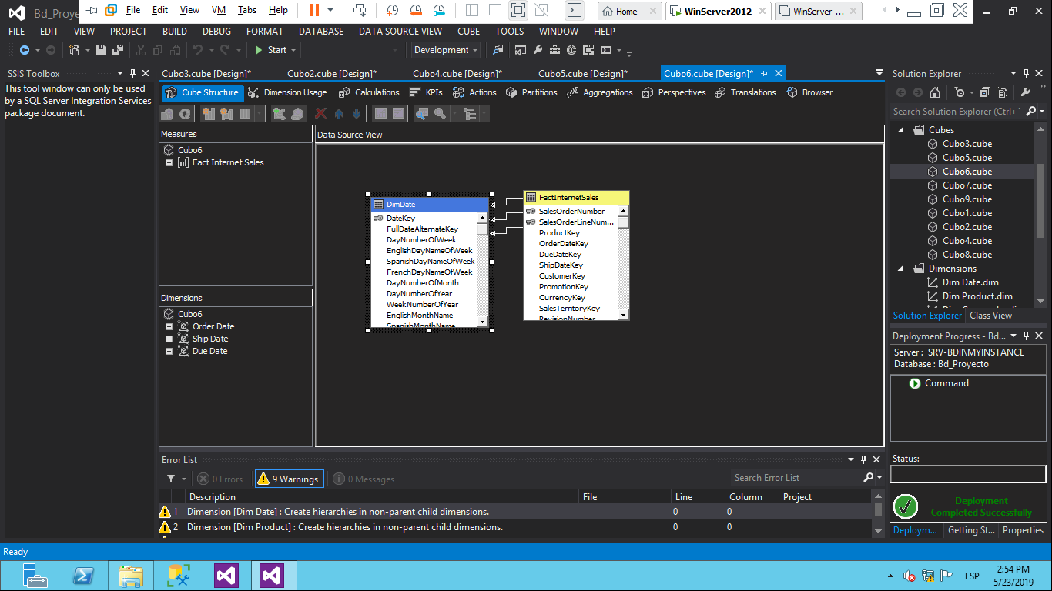

### Estructura del cubo 7

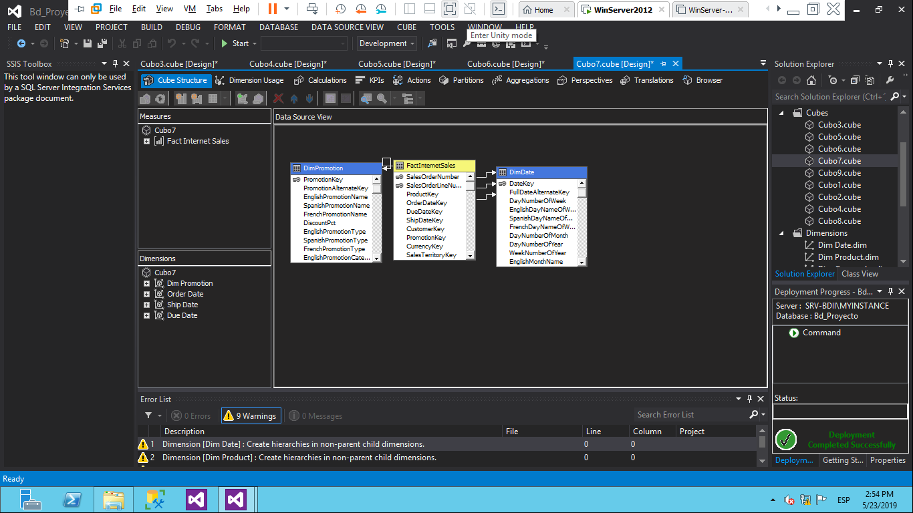

### Estructura del cubo 8

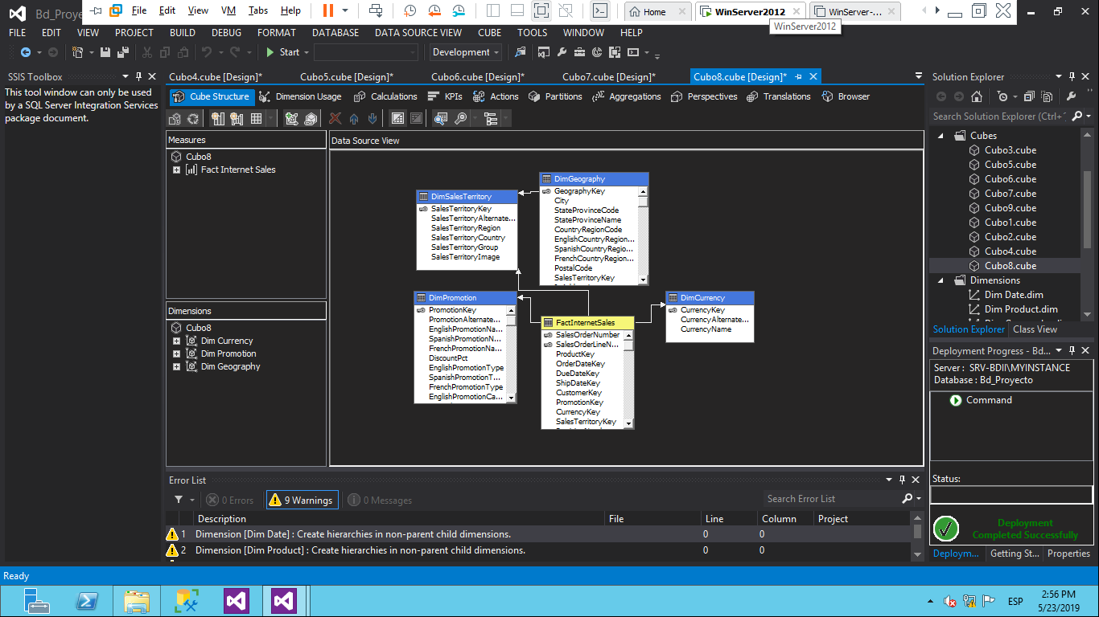

### Estructura del cubo 9

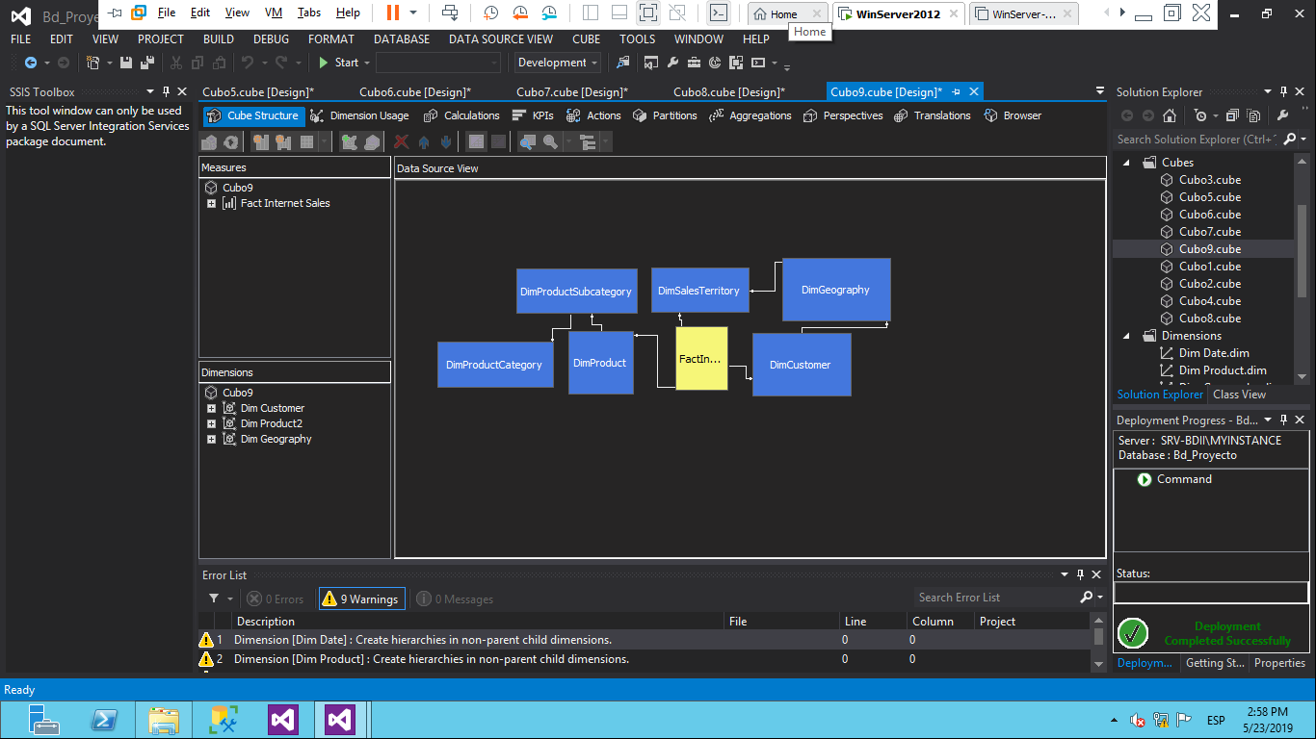

Creación de una dimension



### Crear dimensión de una tabla existente

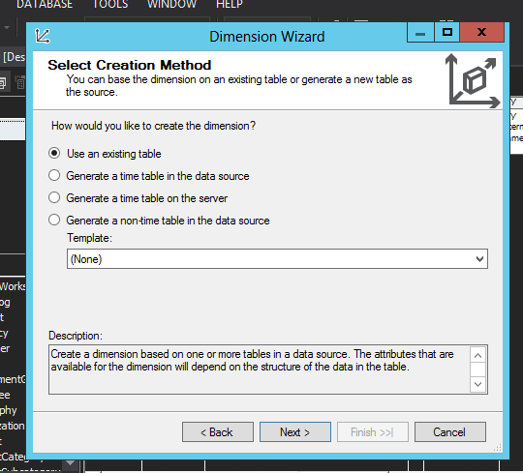

### Selección de tabla

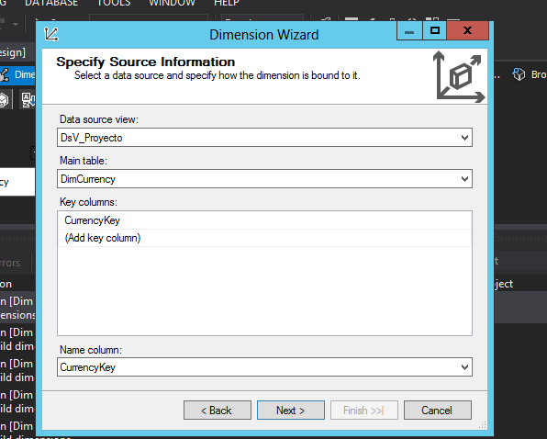

### Selección de columnas deseadas de la tabla

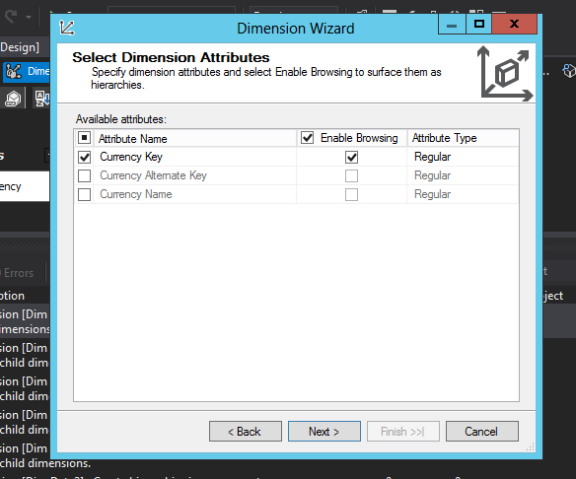

### Nombre de la dimension

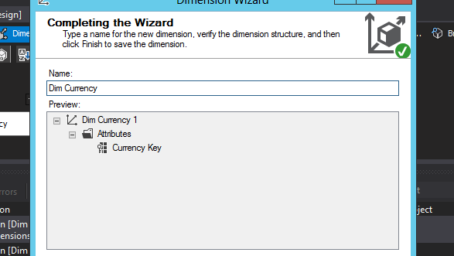

### Creación de un cubo

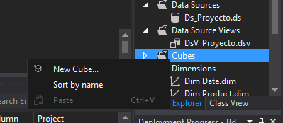

### Crear cubos de tablas existentes

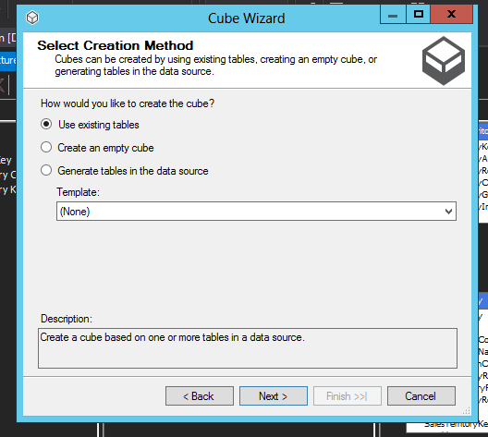

### Selección de la tabla de hechos

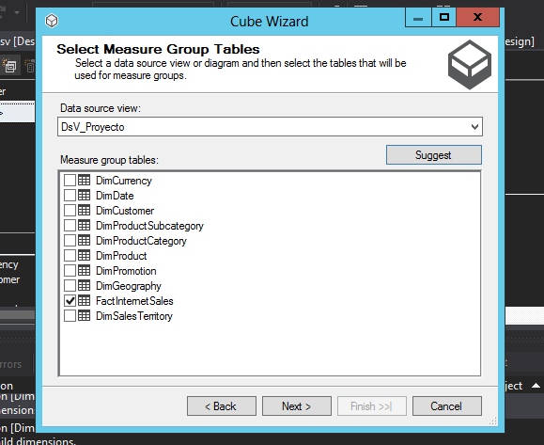

### Selección de dimensiones a trabajar

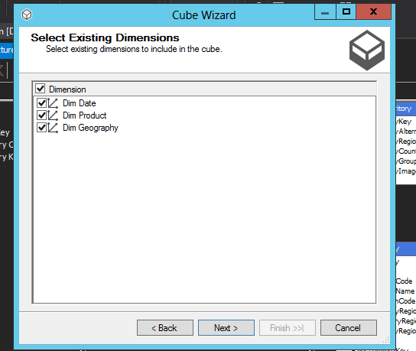

### Instancia del Server en el proyecto

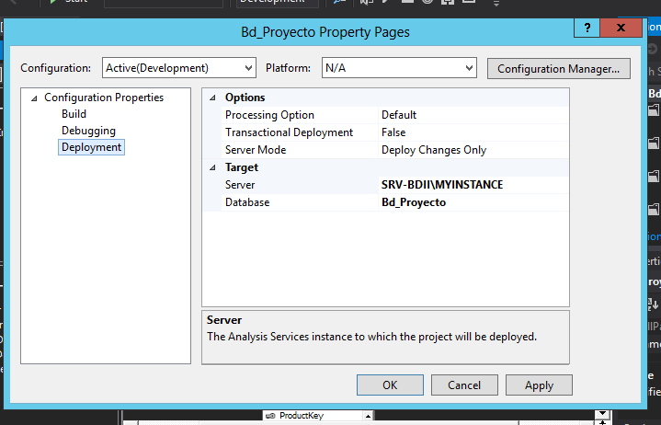

# Capítulo 3 Resultados de los Estudios Respectivos

## Estudio 1

La variabilidad de las Ventas, estas comparativamente en todos los años (Si se encontraran un número no mayor a 5 años) o al menos 5 años y evaluando el incremento y decremento de las mismas por Producto y Ciudad.

### Representación en Excel de variabilidad por años

|  |  |
| --- | --- |
| **Año** | **Ventas** |
| 2005 | 3266373.657 |
| 2006 | 6530343.526 |
| 2007 | 9791060.298 |
| 2008 | 9770899.74 |
| **Total general** | **29358677.22** |

### Representación gráfica de variabilidad por años

### Representación en Excel de variabilidad de ventas por producto

|  |  |
| --- | --- |
| **Producto** | **Ventas** |
| All-Purpose Bike Stand | 39591 |
| AWC Logo Cap | 19688.1 |
| Bike Wash - Dissolver | 7218.6 |
| Classic Vest, L | 12382.5 |
| Classic Vest, M | 12636.5 |
| Classic Vest, S | 10668 |
| Fender Set - Mountain | 46619.58 |
| Half-Finger Gloves, L | 10849.07 |
| Half-Finger Gloves, M | 12220.51 |
| Half-Finger Gloves, S | 11951.12 |
| Hitch Rack - 4-Bike | 39360 |
| HL Mountain Tire | 48860 |
| HL Road Tire | 27970.8 |
| Hydration Pack - 70 oz. | 40307.67 |
| LL Mountain Tire | 21541.38 |
| LL Road Tire | 22435.56 |
| Long-Sleeve Logo Jersey, L | 22595.48 |
| Long-Sleeve Logo Jersey, M | 22095.58 |
| Long-Sleeve Logo Jersey, S | 21445.71 |
| Long-Sleeve Logo Jersey, XL | 20645.87 |
| ML Mountain Tire | 34818.39 |
| ML Road Tire | 23140.74 |
| Mountain Bottle Cage | 20229.75 |
| Mountain Tire Tube | 15444.05 |
| Mountain-100 Black, 38 | 165374.51 |
| Mountain-100 Black, 42 | 151874.55 |
| Mountain-100 Black, 44 | 202499.4 |
| Mountain-100 Black, 48 | 192374.43 |
| Mountain-100 Silver, 38 | 197199.42 |
| Mountain-100 Silver, 42 | 142799.58 |
| Mountain-100 Silver, 44 | 166599.51 |
| Mountain-100 Silver, 48 | 122399.64 |
| Mountain-200 Black, 38 | 1294866.141 |
| Mountain-200 Black, 42 | 1363142.093 |
| Mountain-200 Black, 46 | 1373469.548 |
| Mountain-200 Silver, 38 | 1339462.79 |
| Mountain-200 Silver, 42 | 1257434.573 |
| Mountain-200 Silver, 46 | 1301100.098 |
| Mountain-400-W Silver, 38 | 113884.52 |
| Mountain-400-W Silver, 40 | 98494.72 |
| Mountain-400-W Silver, 42 | 99264.21 |
| Mountain-400-W Silver, 46 | 106189.62 |
| Mountain-500 Black, 40 | 25919.52 |
| Mountain-500 Black, 42 | 26459.51 |
| Mountain-500 Black, 44 | 31319.42 |
| Mountain-500 Black, 48 | 30239.44 |
| Mountain-500 Black, 52 | 22139.59 |
| Mountain-500 Silver, 40 | 25424.55 |
| Mountain-500 Silver, 42 | 25424.55 |
| Mountain-500 Silver, 44 | 22034.61 |
| Mountain-500 Silver, 48 | 28249.5 |
| Mountain-500 Silver, 52 | 27119.52 |
| Patch Kit/8 Patches | 7307.39 |
| Racing Socks, L | 2427.3 |
| Racing Socks, M | 2679.02 |
| Road Bottle Cage | 15390.88 |
| Road Tire Tube | 9480.24 |
| Road-150 Red, 44 | 1005493.87 |
| Road-150 Red, 48 | 1205876.99 |
| Road-150 Red, 52 | 1080637.54 |
| Road-150 Red, 56 | 1055589.65 |
| Road-150 Red, 62 | 1202298.72 |
| Road-250 Black, 44 | 628377.2625 |
| Road-250 Black, 48 | 691206.2625 |
| Road-250 Black, 52 | 734401.2 |
| Road-250 Black, 58 | 622007.1 |
| Road-250 Red, 44 | 351842.4 |
| Road-250 Red, 48 | 395822.7 |
| Road-250 Red, 52 | 324965.55 |
| Road-250 Red, 58 | 702637.65 |
| Road-350-W Yellow, 40 | 418443.54 |
| Road-350-W Yellow, 42 | 399732.65 |
| Road-350-W Yellow, 44 | 367413.84 |
| Road-350-W Yellow, 48 | 394629.68 |
| Road-550-W Yellow, 38 | 293888.52 |
| Road-550-W Yellow, 40 | 290006.8225 |
| Road-550-W Yellow, 42 | 334586.3175 |
| Road-550-W Yellow, 44 | 312336.5875 |
| Road-550-W Yellow, 48 | 283804.11 |
| Road-650 Black, 44 | 47566.6422 |
| Road-650 Black, 48 | 45553.2394 |
| Road-650 Black, 52 | 66917.6806 |
| Road-650 Black, 58 | 57997.1876 |
| Road-650 Black, 60 | 57158.2696 |
| Road-650 Black, 62 | 49048.7304 |
| Road-650 Red, 44 | 54529.6604 |
| Road-650 Red, 48 | 66721.9332 |
| Road-650 Red, 52 | 46084.554 |
| Road-650 Red, 58 | 56347.3158 |
| Road-650 Red, 60 | 40072.3094 |
| Road-650 Red, 62 | 57381.9812 |
| Road-750 Black, 44 | 194396.4 |
| Road-750 Black, 48 | 196016.37 |
| Road-750 Black, 52 | 208436.14 |
| Road-750 Black, 58 | 180356.66 |
| Short-Sleeve Classic Jersey, L | 20192.26 |
| Short-Sleeve Classic Jersey, M | 21973.93 |
| Short-Sleeve Classic Jersey, S | 21919.94 |
| Short-Sleeve Classic Jersey, XL | 22081.91 |
| Sport-100 Helmet, Black | 72954.15 |
| Sport-100 Helmet, Blue | 74353.75 |
| Sport-100 Helmet, Red | 78027.7 |
| Touring Tire | 27105.65 |
| Touring Tire Tube | 7425.12 |
| Touring-1000 Blue, 46 | 421980.39 |
| Touring-1000 Blue, 50 | 357610.5 |
| Touring-1000 Blue, 54 | 381451.2 |
| Touring-1000 Blue, 60 | 350458.29 |
| Touring-1000 Yellow, 46 | 410060.04 |
| Touring-1000 Yellow, 50 | 359994.57 |
| Touring-1000 Yellow, 54 | 376683.06 |
| Touring-1000 Yellow, 60 | 333769.8 |
| Touring-2000 Blue, 46 | 117840.45 |
| Touring-2000 Blue, 50 | 128774.1 |
| Touring-2000 Blue, 54 | 106906.8 |
| Touring-2000 Blue, 60 | 98402.85 |
| Touring-3000 Blue, 44 | 39344.55 |
| Touring-3000 Blue, 50 | 35632.8 |
| Touring-3000 Blue, 54 | 40829.25 |
| Touring-3000 Blue, 58 | 42313.95 |
| Touring-3000 Blue, 62 | 47510.4 |
| Touring-3000 Yellow, 44 | 43798.65 |
| Touring-3000 Yellow, 50 | 43798.65 |
| Touring-3000 Yellow, 54 | 35632.8 |
| Touring-3000 Yellow, 58 | 34890.45 |
| Touring-3000 Yellow, 62 | 37117.5 |
| Water Bottle - 30 oz. | 21177.56 |
| Women's Mountain Shorts, L | 25406.37 |
| Women's Mountain Shorts, M | 24636.48 |
| Women's Mountain Shorts, S | 21276.96 |
| **Total general** | **29358677.22** |

### Representación gráfica de variabilidad de ventas por producto

### Conclusión:

### La variabilidad de la venta decrece en relación al aumento de estas, ya que a partir del año 2007 establece un punto promedio base para los siguientes años.

## Estudio 2

Número de Ordenes, el Total de Costo Estándar del Producto y el Total del Precio Unitario, considerando ésta información por Año, Mes y Día.

### Representación en Excel

|  |  |  |  |
| --- | --- | --- | --- |
| **Fecha** | **Order Quantity** | **Product Standard Cost** | **Unit Price** |
| 2005-07-01 | 5 | 8320.9037 | 14477.3382 |
| 2005-07-02 | 4 | 8152.8372 | 13931.52 |
| 2005-07-03 | 5 | 9098.3231 | 15012.1782 |
| 2005-07-04 | 2 | 4342.5884 | 7156.54 |
| 2005-07-05 | 5 | 9098.3231 | 15012.1782 |
| 2005-07-06 | 4 | 8685.1768 | 14313.08 |
| 2005-07-07 | 3 | 4755.7347 | 7855.6382 |
| 2005-07-08 | 3 | 4755.7347 | 7855.6382 |
| 2005-07-09 | 6 | 12236.2858 | 20909.78 |
| 2005-07-10 | 3 | 6254.7428 | 10556.53 |
| 2005-07-11 | 4 | 8685.1768 | 14313.08 |
| 2005-07-12 | 4 | 8426.037 | 14134.8 |
| 2005-07-13 | 2 | 4342.5884 | 7156.54 |
| 2005-07-14 | 7 | 15199.0594 | 25047.89 |
| 2005-07-15 | 4 | 6653.8291 | 11230.6282 |
| 2005-07-16 | 4 | 8685.1768 | 14313.08 |
| 2005-07-17 | 4 | 8426.037 | 14134.8 |
| 2005-07-18 | 2 | 4069.3886 | 6953.26 |
| 2005-07-19 | 8 | 15353.0659 | 25568.7082 |
| 2005-07-20 | 4 | 6667.8891 | 11255.6282 |
| 2005-07-21 | 4 | 8685.1768 | 14313.08 |
| 2005-07-22 | 11 | 22301.2774 | 38241.29 |
| 2005-07-23 | 5 | 9098.3231 | 15012.1782 |
| 2005-07-24 | 3 | 6513.8826 | 10734.81 |
| 2005-07-25 | 4 | 6927.0289 | 11433.9082 |
| 2005-07-26 | 5 | 10338.1914 | 17534.79 |
| 2005-07-27 | 8 | 16564.8142 | 28041.32 |
| 2005-07-28 | 8 | 11822.7101 | 19785.3646 |
| 2005-07-29 | 5 | 10583.2712 | 17688.07 |
| 2005-07-30 | 5 | 8278.7237 | 14402.3382 |
| 2005-07-31 | 5 | 9098.3231 | 15012.1782 |
| 2005-08-01 | 5 | 10856.471 | 17891.35 |
| 2005-08-02 | 3 | 6513.8826 | 10734.81 |
| 2005-08-03 | 4 | 6653.8291 | 11230.6282 |
| 2005-08-04 | 5 | 10338.1914 | 17534.79 |
| 2005-08-05 | 6 | 9511.4694 | 15711.2764 |
| 2005-08-06 | 8 | 15093.9261 | 25390.4282 |
| 2005-08-07 | 4 | 8685.1768 | 14313.08 |
| 2005-08-08 | 4 | 6667.8891 | 11255.6282 |
| 2005-08-09 | 4 | 8138.7772 | 13906.52 |
| 2005-08-10 | 6 | 12495.4256 | 21088.06 |
| 2005-08-11 | 5 | 10856.471 | 17891.35 |
| 2005-08-12 | 6 | 13027.7652 | 21469.62 |
| 2005-08-13 | 5 | 7066.9754 | 11929.7264 |
| 2005-08-14 | 4 | 8685.1768 | 14313.08 |
| 2005-08-15 | 6 | 12509.4856 | 21113.06 |
| 2005-08-17 | 1 | 2171.2942 | 3578.27 |
| 2005-08-18 | 6 | 12754.5654 | 21266.34 |
| 2005-08-19 | 8 | 10337.762 | 17109.4728 |
| 2005-08-20 | 6 | 12754.5654 | 21266.34 |
| 2005-08-21 | 8 | 16550.7542 | 28016.32 |
| 2005-08-22 | 5 | 10583.2712 | 17688.07 |
| 2005-08-23 | 3 | 6240.6828 | 10531.53 |
| 2005-08-24 | 9 | 17265.2203 | 28968.6982 |
| 2005-08-25 | 3 | 4482.5349 | 7652.3582 |
| 2005-08-26 | 7 | 14680.7798 | 24691.33 |
| 2005-08-27 | 2 | 4342.5884 | 7156.54 |
| 2005-08-28 | 2 | 4342.5884 | 7156.54 |
| 2005-08-29 | 8 | 11822.7101 | 19785.3646 |
| 2005-08-30 | 7 | 14680.7798 | 24691.33 |
| 2005-08-31 | 6 | 12208.1658 | 20859.78 |
| 2005-09-01 | 4 | 8685.1768 | 14313.08 |
| 2005-09-02 | 10 | 21712.942 | 35782.7 |
| 2005-09-03 | 4 | 6927.0289 | 11433.9082 |
| 2005-09-04 | 6 | 12509.4856 | 21113.06 |
| 2005-09-05 | 3 | 6513.8826 | 10734.81 |
| 2005-09-06 | 7 | 13440.9115 | 22168.7182 |
| 2005-09-07 | 5 | 9098.3231 | 15012.1782 |
| 2005-09-08 | 3 | 6513.8826 | 10734.81 |
| 2005-09-09 | 7 | 14393.52 | 24463.05 |
| 2005-09-10 | 3 | 6513.8826 | 10734.81 |
| 2005-09-12 | 2 | 4083.4486 | 6978.26 |
| 2005-09-13 | 4 | 4895.6812 | 8351.4564 |
| 2005-09-14 | 5 | 10856.471 | 17891.35 |
| 2005-09-15 | 4 | 8685.1768 | 14313.08 |
| 2005-09-16 | 5 | 9098.3231 | 15012.1782 |
| 2005-09-17 | 4 | 8166.8972 | 13956.52 |
| 2005-09-18 | 5 | 10856.471 | 17891.35 |
| 2005-09-19 | 8 | 15353.0659 | 25568.7082 |
| 2005-09-20 | 2 | 4342.5884 | 7156.54 |
| 2005-09-21 | 8 | 13062.5784 | 22307.9764 |
| 2005-09-22 | 6 | 13027.7652 | 21469.62 |
| 2005-09-23 | 7 | 13440.9115 | 22168.7182 |
| 2005-09-24 | 3 | 6513.8826 | 10734.81 |
| 2005-09-25 | 3 | 6513.8826 | 10734.81 |
| 2005-09-26 | 5 | 9098.3231 | 15012.1782 |
| 2005-09-27 | 10 | 16438.4983 | 27145.1846 |
| 2005-09-28 | 2 | 2584.4405 | 4277.3682 |
| 2005-09-29 | 1 | 413.1463 | 699.0982 |
| 2005-09-30 | 10 | 21712.942 | 35782.7 |
| 2005-10-01 | 4 | 6667.8891 | 11255.6282 |
| 2005-10-02 | 3 | 6240.6828 | 10531.53 |
| 2005-10-03 | 4 | 8685.1768 | 14313.08 |
| 2005-10-04 | 2 | 4342.5884 | 7156.54 |
| 2005-10-05 | 8 | 14820.7263 | 25187.1482 |
| 2005-10-06 | 3 | 4482.5349 | 7652.3582 |
| 2005-10-07 | 4 | 6927.0289 | 11433.9082 |
| 2005-10-08 | 11 | 19849.6608 | 33246.0664 |
| 2005-10-09 | 9 | 17510.3001 | 29121.9782 |
| 2005-10-10 | 5 | 10856.471 | 17891.35 |
| 2005-10-11 | 8 | 16550.7542 | 28016.32 |
| 2005-10-12 | 12 | 25523.1908 | 42557.68 |
| 2005-10-13 | 6 | 10751.3377 | 18233.8882 |
| 2005-10-14 | 3 | 6513.8826 | 10734.81 |
| 2005-10-15 | 2 | 4069.3886 | 6953.26 |
| 2005-10-16 | 6 | 10723.2177 | 18183.8882 |
| 2005-10-17 | 3 | 6240.6828 | 10531.53 |
| 2005-10-18 | 8 | 17111.2138 | 28447.88 |
| 2005-10-19 | 5 | 9098.3231 | 15012.1782 |
| 2005-10-20 | 6 | 13027.7652 | 21469.62 |
| 2005-10-21 | 3 | 6513.8826 | 10734.81 |
| 2005-10-22 | 4 | 6667.8891 | 11255.6282 |
| 2005-10-23 | 5 | 9098.3231 | 15012.1782 |
| 2005-10-25 | 1 | 2171.2942 | 3578.27 |
| 2005-10-26 | 2 | 4342.5884 | 7156.54 |
| 2005-10-27 | 10 | 18196.6462 | 30024.3564 |
| 2005-10-28 | 5 | 9098.3231 | 15012.1782 |
| 2005-10-29 | 10 | 14148.0108 | 23884.4528 |
| 2005-10-30 | 7 | 13181.7717 | 21990.4382 |
| 2005-10-31 | 2 | 3796.1888 | 6749.98 |
| 2005-11-01 | 6 | 11977.146 | 20731.5 |
| 2005-11-02 | 3 | 6513.8826 | 10734.81 |
| 2005-11-03 | 4 | 8152.8372 | 13931.52 |
| 2005-11-04 | 6 | 11010.4775 | 18412.1682 |
| 2005-11-05 | 7 | 13181.7717 | 21990.4382 |
| 2005-11-06 | 5 | 10324.1314 | 17509.79 |
| 2005-11-07 | 9 | 16025.352 | 26446.0864 |
| 2005-11-08 | 8 | 17370.3536 | 28626.16 |
| 2005-11-09 | 4 | 8685.1768 | 14313.08 |
| 2005-11-10 | 7 | 12894.5119 | 21762.1582 |
| 2005-11-11 | 6 | 13027.7652 | 21469.62 |
| 2005-11-12 | 7 | 11682.7636 | 19289.5464 |
| 2005-11-13 | 8 | 16060.5946 | 27709.76 |
| 2005-11-14 | 9 | 16977.9605 | 28740.4182 |
| 2005-11-15 | 6 | 9238.2696 | 15507.9964 |
| 2005-11-16 | 7 | 14925.8596 | 24844.61 |
| 2005-11-17 | 4 | 6927.0289 | 11433.9082 |
| 2005-11-18 | 3 | 6254.7428 | 10556.53 |
| 2005-11-19 | 6 | 11269.6173 | 18590.4482 |
| 2005-11-20 | 5 | 8839.1833 | 14833.8982 |
| 2005-11-21 | 6 | 12509.4856 | 21113.06 |
| 2005-11-22 | 2 | 2584.4405 | 4277.3682 |
| 2005-11-23 | 4 | 6927.0289 | 11433.9082 |
| 2005-11-24 | 7 | 14652.6598 | 24641.33 |
| 2005-11-25 | 3 | 6240.6828 | 10531.53 |
| 2005-11-26 | 6 | 11269.6173 | 18590.4482 |
| 2005-11-27 | 3 | 4755.7347 | 7855.6382 |
| 2005-11-28 | 7 | 12663.4921 | 21633.8782 |
| 2005-11-29 | 5 | 10856.471 | 17891.35 |
| 2005-11-30 | 6 | 11269.6173 | 18590.4482 |
| 2005-12-01 | 5 | 10583.2712 | 17688.07 |
| 2005-12-02 | 8 | 15339.0059 | 25543.7082 |
| 2005-12-03 | 10 | 21180.6024 | 35401.14 |
| 2005-12-04 | 5 | 8839.1833 | 14833.8982 |
| 2005-12-05 | 6 | 12481.3656 | 21063.06 |
| 2005-12-06 | 5 | 10856.471 | 17891.35 |
| 2005-12-07 | 6 | 12768.6254 | 21291.34 |
| 2005-12-08 | 19 | 32855.9992 | 55454.0428 |
| 2005-12-09 | 5 | 10597.3312 | 17713.07 |
| 2005-12-10 | 2 | 4342.5884 | 7156.54 |
| 2005-12-11 | 11 | 22126.0883 | 36481.7982 |
| 2005-12-12 | 4 | 8685.1768 | 14313.08 |
| 2005-12-13 | 11 | 22273.1574 | 38191.29 |
| 2005-12-14 | 5 | 10583.2712 | 17688.07 |
| 2005-12-15 | 12 | 23765.0429 | 39678.5082 |
| 2005-12-16 | 7 | 13167.7117 | 21965.4382 |
| 2005-12-17 | 4 | 6653.8291 | 11230.6282 |
| 2005-12-18 | 6 | 13027.7652 | 21469.62 |
| 2005-12-19 | 14 | 24591.3355 | 41076.7046 |
| 2005-12-20 | 9 | 16963.9005 | 28715.4182 |
| 2005-12-21 | 10 | 16179.3585 | 26966.9046 |
| 2005-12-22 | 7 | 13440.9115 | 22168.7182 |
| 2005-12-23 | 8 | 15612.2057 | 25746.9882 |
| 2005-12-24 | 5 | 9098.3231 | 15012.1782 |
| 2005-12-25 | 7 | 11409.5638 | 19086.2664 |
| 2005-12-26 | 8 | 15339.0059 | 25543.7082 |
| 2005-12-27 | 4 | 8685.1768 | 14313.08 |
| 2005-12-28 | 10 | 16179.3585 | 26966.9046 |
| 2005-12-29 | 8 | 16823.954 | 28219.6 |
| 2005-12-30 | 7 | 14407.58 | 24488.05 |
| 2005-12-31 | 7 | 13440.9115 | 22168.7182 |
| 2006-01-01 | 5 | 7066.9754 | 11929.7264 |
| 2006-01-02 | 4 | 8685.1768 | 14313.08 |
| 2006-01-03 | 8 | 16564.8142 | 28041.32 |
| 2006-01-04 | 5 | 10597.3312 | 17713.07 |
| 2006-01-05 | 3 | 4755.7347 | 7855.6382 |
| 2006-01-06 | 6 | 12754.5654 | 21266.34 |
| 2006-01-07 | 4 | 5168.881 | 8554.7364 |
| 2006-01-08 | 8 | 15079.8661 | 25365.4282 |
| 2006-01-09 | 5 | 10856.471 | 17891.35 |
| 2006-01-10 | 4 | 8411.977 | 14109.8 |
| 2006-01-11 | 9 | 18736.1084 | 31619.59 |
| 2006-01-12 | 7 | 15199.0594 | 25047.89 |
| 2006-01-13 | 3 | 4755.7347 | 7855.6382 |
| 2006-01-14 | 9 | 18764.2284 | 31669.59 |
| 2006-01-15 | 7 | 12362.1723 | 21380.5982 |
| 2006-01-16 | 7 | 14666.7198 | 24666.33 |
| 2006-01-17 | 8 | 15079.8661 | 25365.4282 |
| 2006-01-18 | 6 | 9511.4694 | 15711.2764 |
| 2006-01-19 | 6 | 11269.6173 | 18590.4482 |
| 2006-01-20 | 6 | 13027.7652 | 21469.62 |
| 2006-01-21 | 7 | 14680.7798 | 24691.33 |
| 2006-01-22 | 9 | 18750.1684 | 31644.59 |
| 2006-01-23 | 3 | 6513.8826 | 10734.81 |
| 2006-01-24 | 8 | 15353.0659 | 25568.7082 |
| 2006-01-25 | 4 | 3410.7331 | 5675.5646 |
| 2006-01-26 | 5 | 10324.1314 | 17509.79 |
| 2006-01-27 | 5 | 8839.1833 | 14833.8982 |
| 2006-01-28 | 6 | 9238.2696 | 15507.9964 |
| 2006-01-29 | 4 | 6667.8891 | 11255.6282 |
| 2006-01-30 | 10 | 16438.4983 | 27145.1846 |
| 2006-01-31 | 7 | 12894.5119 | 21762.1582 |
| 2006-02-01 | 6 | 11269.6173 | 18590.4482 |
| 2006-02-02 | 6 | 11269.6173 | 18590.4482 |
| 2006-02-03 | 7 | 14925.8596 | 24844.61 |
| 2006-02-04 | 7 | 9924.6157 | 16410.3746 |
| 2006-02-05 | 6 | 12222.2258 | 20884.78 |
| 2006-02-06 | 10 | 14421.2106 | 24087.7328 |
| 2006-02-07 | 6 | 12495.4256 | 21088.06 |
| 2006-02-08 | 4 | 8411.977 | 14109.8 |
| 2006-02-09 | 3 | 6513.8826 | 10734.81 |
| 2006-02-10 | 10 | 21180.6024 | 35401.14 |
| 2006-02-11 | 12 | 24297.3825 | 40060.0682 |
| 2006-02-12 | 3 | 6240.6828 | 10531.53 |
| 2006-02-13 | 7 | 14666.7198 | 24666.33 |
| 2006-02-14 | 8 | 13854.0578 | 22867.8164 |
| 2006-02-15 | 6 | 13027.7652 | 21469.62 |
| 2006-02-16 | 3 | 4496.5949 | 7677.3582 |
| 2006-02-17 | 4 | 8685.1768 | 14313.08 |
| 2006-02-18 | 2 | 4342.5884 | 7156.54 |
| 2006-02-19 | 6 | 11269.6173 | 18590.4482 |
| 2006-02-20 | 5 | 9098.3231 | 15012.1782 |
| 2006-02-21 | 1 | 2171.2942 | 3578.27 |
| 2006-02-22 | 10 | 21180.6024 | 35401.14 |
| 2006-02-23 | 5 | 10856.471 | 17891.35 |
| 2006-02-24 | 9 | 17783.4999 | 29325.2582 |
| 2006-02-25 | 5 | 5582.0273 | 9253.8346 |
| 2006-02-26 | 12 | 24024.1827 | 39856.7882 |
| 2006-02-27 | 3 | 6513.8826 | 10734.81 |
| 2006-02-28 | 5 | 10583.2712 | 17688.07 |
| 2006-03-01 | 6 | 10996.4175 | 18387.1682 |
| 2006-03-02 | 7 | 13181.7717 | 21990.4382 |
| 2006-03-03 | 9 | 13994.0043 | 23363.6346 |
| 2006-03-04 | 8 | 15339.0059 | 25543.7082 |
| 2006-03-05 | 3 | 6513.8826 | 10734.81 |
| 2006-03-06 | 9 | 17524.3601 | 29146.9782 |
| 2006-03-07 | 9 | 16992.0205 | 28765.4182 |
| 2006-03-08 | 4 | 8138.7772 | 13906.52 |
| 2006-03-09 | 6 | 11269.6173 | 18590.4482 |
| 2006-03-10 | 2 | 4342.5884 | 7156.54 |
| 2006-03-11 | 6 | 12222.2258 | 20884.78 |
| 2006-03-12 | 5 | 8839.1833 | 14833.8982 |
| 2006-03-13 | 10 | 18876.0549 | 32115.4082 |
| 2006-03-14 | 4 | 6667.8891 | 11255.6282 |
| 2006-03-15 | 10 | 17650.2466 | 29617.7964 |
| 2006-03-16 | 5 | 10856.471 | 17891.35 |
| 2006-03-17 | 9 | 14988.7928 | 25732.9664 |
| 2006-03-18 | 8 | 13854.0578 | 22867.8164 |
| 2006-03-19 | 4 | 6927.0289 | 11433.9082 |
| 2006-03-20 | 9 | 19023.3682 | 31847.87 |
| 2006-03-21 | 4 | 8685.1768 | 14313.08 |
| 2006-03-22 | 6 | 12222.2258 | 20884.78 |
| 2006-03-23 | 5 | 10583.2712 | 17688.07 |
| 2006-03-24 | 12 | 25249.991 | 42354.4 |
| 2006-03-25 | 5 | 10583.2712 | 17688.07 |
| 2006-03-26 | 9 | 15766.2122 | 26267.8064 |
| 2006-03-27 | 3 | 6513.8826 | 10734.81 |
| 2006-03-28 | 8 | 17370.3536 | 28626.16 |
| 2006-03-29 | 6 | 12754.5654 | 21266.34 |
| 2006-03-30 | 4 | 8685.1768 | 14313.08 |
| 2006-03-31 | 4 | 8152.8372 | 13931.52 |
| 2006-04-01 | 5 | 7340.1752 | 12133.0064 |
| 2006-04-02 | 3 | 6254.7428 | 10556.53 |
| 2006-04-03 | 9 | 17510.3001 | 29121.9782 |
| 2006-04-04 | 7 | 14652.6598 | 24641.33 |
| 2006-04-05 | 5 | 10583.2712 | 17688.07 |
| 2006-04-06 | 5 | 8839.1833 | 14833.8982 |
| 2006-04-07 | 9 | 15478.9524 | 26039.5264 |
| 2006-04-08 | 3 | 6513.8826 | 10734.81 |
| 2006-04-09 | 5 | 10856.471 | 17891.35 |
| 2006-04-10 | 5 | 8825.1233 | 14808.8982 |
| 2006-04-11 | 6 | 12222.2258 | 20884.78 |
| 2006-04-12 | 12 | 21992.835 | 36774.3364 |
| 2006-04-13 | 4 | 8152.8372 | 13931.52 |
| 2006-04-14 | 3 | 4755.7347 | 7855.6382 |
| 2006-04-15 | 13 | 27694.485 | 46135.95 |
| 2006-04-16 | 7 | 14148.4402 | 24309.77 |
| 2006-04-17 | 9 | 19023.3682 | 31847.87 |
| 2006-04-18 | 7 | 13440.9115 | 22168.7182 |
| 2006-04-19 | 4 | 6653.8291 | 11230.6282 |
| 2006-04-20 | 11 | 19821.5408 | 33196.0664 |
| 2006-04-21 | 5 | 8565.9835 | 14630.6182 |
| 2006-04-22 | 4 | 8426.037 | 14134.8 |
| 2006-04-23 | 10 | 19695.6543 | 32725.2482 |
| 2006-04-24 | 4 | 6653.8291 | 11230.6282 |
| 2006-04-25 | 8 | 13062.5784 | 22307.9764 |
| 2006-04-26 | 4 | 8685.1768 | 14313.08 |
| 2006-04-27 | 9 | 19268.448 | 32001.15 |
| 2006-04-28 | 7 | 9924.6157 | 16410.3746 |
| 2006-04-29 | 11 | 23351.8966 | 38979.41 |
| 2006-04-30 | 13 | 23904.9894 | 40174.3264 |
| 2006-05-01 | 12 | 22539.2346 | 37180.8964 |
| 2006-05-02 | 5 | 10856.471 | 17891.35 |
| 2006-05-03 | 5 | 7340.1752 | 12133.0064 |
| 2006-05-04 | 11 | 23351.8966 | 38979.41 |
| 2006-05-05 | 5 | 6807.8356 | 11751.4464 |
| 2006-05-06 | 9 | 13461.6647 | 22982.0746 |
| 2006-05-07 | 5 | 8565.9835 | 14630.6182 |
| 2006-05-08 | 10 | 19422.4545 | 32521.9682 |
| 2006-05-09 | 6 | 12754.5654 | 21266.34 |
| 2006-05-10 | 3 | 4482.5349 | 7652.3582 |
| 2006-05-11 | 4 | 8152.8372 | 13931.52 |
| 2006-05-12 | 9 | 19268.448 | 32001.15 |
| 2006-05-13 | 13 | 23659.9096 | 40021.0464 |
| 2006-05-14 | 6 | 12481.3656 | 21063.06 |
| 2006-05-15 | 7 | 13440.9115 | 22168.7182 |
| 2006-05-16 | 11 | 18063.3929 | 30316.8946 |
| 2006-05-17 | 9 | 18750.1684 | 31644.59 |
| 2006-05-18 | 8 | 17111.2138 | 28447.88 |
| 2006-05-19 | 6 | 8979.1298 | 15329.7164 |
| 2006-05-20 | 6 | 12768.6254 | 21291.34 |
| 2006-05-21 | 6 | 12754.5654 | 21266.34 |
| 2006-05-22 | 6 | 12754.5654 | 21266.34 |
| 2006-05-23 | 7 | 14652.6598 | 24641.33 |
| 2006-05-24 | 9 | 13216.5849 | 22828.7946 |
| 2006-05-25 | 9 | 17251.1603 | 28943.6982 |
| 2006-05-26 | 6 | 11269.6173 | 18590.4482 |
| 2006-05-27 | 5 | 8825.1233 | 14808.8982 |
| 2006-05-28 | 5 | 8825.1233 | 14808.8982 |
| 2006-05-29 | 1 | 2171.2942 | 3578.27 |
| 2006-05-30 | 7 | 13167.7117 | 21965.4382 |
| 2006-05-31 | 3 | 4482.5349 | 7652.3582 |
| 2006-06-01 | 4 | 8685.1768 | 14313.08 |
| 2006-06-02 | 12 | 24038.2427 | 39881.7882 |
| 2006-06-03 | 3 | 4482.5349 | 7652.3582 |
| 2006-06-04 | 7 | 12908.5719 | 21787.1582 |
| 2006-06-05 | 6 | 11010.4775 | 18412.1682 |
| 2006-06-06 | 7 | 14666.7198 | 24666.33 |
| 2006-06-07 | 8 | 14820.7263 | 25187.1482 |
| 2006-06-08 | 8 | 17097.1538 | 28422.88 |
| 2006-06-09 | 5 | 10338.1914 | 17534.79 |
| 2006-06-10 | 8 | 15079.8661 | 25365.4282 |
| 2006-06-11 | 5 | 10597.3312 | 17713.07 |
| 2006-06-12 | 12 | 20248.7471 | 33920.1646 |
| 2006-06-13 | 4 | 4636.5414 | 8173.1764 |
| 2006-06-14 | 4 | 8166.8972 | 13956.52 |
| 2006-06-15 | 6 | 9511.4694 | 15711.2764 |
| 2006-06-16 | 2 | 4342.5884 | 7156.54 |
| 2006-06-17 | 6 | 11269.6173 | 18590.4482 |
| 2006-06-18 | 11 | 16319.305 | 27462.7228 |
| 2006-06-19 | 13 | 24164.1292 | 40352.6064 |
| 2006-06-20 | 7 | 12908.5719 | 21787.1582 |
| 2006-06-21 | 9 | 17510.3001 | 29121.9782 |
| 2006-06-22 | 5 | 10597.3312 | 17713.07 |
| 2006-06-23 | 15 | 26230.2901 | 44273.4146 |
| 2006-06-24 | 7 | 13181.7717 | 21990.4382 |
| 2006-06-25 | 5 | 10597.3312 | 17713.07 |
| 2006-06-26 | 7 | 14652.6598 | 24641.33 |
| 2006-06-27 | 9 | 19268.448 | 32001.15 |
| 2006-06-28 | 5 | 8825.1233 | 14808.8982 |
| 2006-06-29 | 8 | 16823.954 | 28219.6 |
| 2006-06-30 | 6 | 10751.3377 | 18233.8882 |
| 2006-07-01 | 8 | 8383.8831 | 14497.731 |
| 2006-07-02 | 3 | 2413.0396 | 3964.99 |
| 2006-07-03 | 13 | 17308.654 | 28400.0007 |
| 2006-07-04 | 9 | 9894.6451 | 16331.0121 |
| 2006-07-05 | 10 | 12668.4095 | 21177.2553 |
| 2006-07-06 | 11 | 13539.2754 | 22461.4989 |
| 2006-07-07 | 9 | 10538.5441 | 18077.866 |
| 2006-07-08 | 6 | 8105.4342 | 13480.4857 |
| 2006-07-09 | 5 | 6367.0487 | 11056.316 |
| 2006-07-10 | 7 | 6027.8204 | 9894.095 |
| 2006-07-11 | 12 | 11679.8345 | 19769.286 |
| 2006-07-12 | 8 | 10345.8713 | 17471.6803 |
| 2006-07-13 | 12 | 13356.8937 | 22918.712 |
| 2006-07-14 | 10 | 12958.4218 | 21941.8071 |
| 2006-07-15 | 4 | 4844.9632 | 7851.2525 |
| 2006-07-16 | 6 | 6870.5265 | 11709.9828 |
| 2006-07-17 | 11 | 15315.2069 | 25195.9821 |
| 2006-07-18 | 7 | 6241.268 | 10939.9174 |
| 2006-07-19 | 8 | 9007.008 | 15176.0917 |
| 2006-07-20 | 10 | 11641.055 | 19365.2507 |
| 2006-07-21 | 10 | 12537.421 | 20937.4864 |
| 2006-07-22 | 7 | 9839.0944 | 16056.3 |
| 2006-07-23 | 7 | 9211.2442 | 15529.5839 |
| 2006-07-24 | 6 | 6890.2388 | 11250.7 |
| 2006-07-25 | 9 | 9993.8754 | 17007.7424 |
| 2006-07-26 | 5 | 5752.6706 | 9638.5632 |
| 2006-07-27 | 10 | 11408.7062 | 18926.0067 |
| 2006-07-28 | 5 | 5685.5565 | 9616.5446 |
| 2006-07-29 | 6 | 7803.376 | 12693.6125 |
| 2006-07-30 | 10 | 10072.3309 | 17244.836 |
| 2006-07-31 | 9 | 11649.7839 | 19782.566 |
| 2006-08-01 | 9 | 9571.7942 | 16261.2096 |
| 2006-08-02 | 8 | 8244.8702 | 13647.8932 |
| 2006-08-03 | 6 | 7288.2282 | 11952.59 |
| 2006-08-04 | 9 | 11224.0578 | 18929.8899 |
| 2006-08-05 | 7 | 9624.2206 | 15923.8357 |
| 2006-08-06 | 12 | 14268.2467 | 24183.3095 |
| 2006-08-07 | 11 | 14005.8645 | 23229.4946 |
| 2006-08-08 | 8 | 9528.6653 | 15943.7846 |
| 2006-08-09 | 8 | 8677.9169 | 14674.5353 |
| 2006-08-10 | 4 | 4352.8268 | 7412.6607 |
| 2006-08-11 | 5 | 5116.796 | 8501.7782 |
| 2006-08-12 | 9 | 11835.8406 | 20022.0321 |
| 2006-08-13 | 12 | 15416.328 | 26391.0766 |
| 2006-08-14 | 10 | 10718.4672 | 18225.6274 |
| 2006-08-15 | 12 | 13567.388 | 22547.2507 |
| 2006-08-16 | 5 | 5561.8886 | 9550.7417 |
| 2006-08-17 | 10 | 10785.5813 | 18247.646 |
| 2006-08-18 | 8 | 9602.0196 | 16397.5571 |
| 2006-08-19 | 11 | 14175.15 | 23598.2839 |
| 2006-08-20 | 12 | 13248.5586 | 21889.7007 |
| 2006-08-21 | 10 | 11252.1704 | 19015.6417 |
| 2006-08-22 | 10 | 11926.342 | 20281.4471 |
| 2006-08-23 | 5 | 6598.6937 | 11059.4571 |
| 2006-08-24 | 11 | 11896.1166 | 20145.0996 |
| 2006-08-25 | 11 | 12241.9789 | 20517.3328 |
| 2006-08-26 | 13 | 12409.1516 | 20835.5264 |
| 2006-08-27 | 11 | 11170.1165 | 18683.8653 |
| 2006-08-28 | 8 | 10127.6984 | 16577.5025 |
| 2006-08-29 | 6 | 7494.3552 | 12824.4464 |
| 2006-08-30 | 8 | 9086.168 | 15220.4317 |
| 2006-08-31 | 12 | 13538.2251 | 23309.8227 |
| 2006-09-01 | 2 | 1604.5625 | 2854.4096 |
| 2006-09-02 | 7 | 7059.9002 | 11554.455 |
| 2006-09-03 | 8 | 10027.0419 | 16814.1303 |
| 2006-09-04 | 6 | 6251.4231 | 10443.8746 |
| 2006-09-05 | 4 | 5282.7352 | 8726.25 |
| 2006-09-06 | 4 | 5480.8378 | 8988.0375 |
| 2006-09-07 | 2 | 2005.493 | 3226.34 |
| 2006-09-08 | 9 | 11216.7372 | 18755.9239 |
| 2006-09-09 | 9 | 9194.9555 | 15933.922 |
| 2006-09-10 | 9 | 9998.6007 | 16856.0978 |
| 2006-09-11 | 8 | 9113.9047 | 15371.2178 |
| 2006-09-12 | 7 | 5824.9925 | 9783.9521 |
| 2006-09-13 | 11 | 10796.9227 | 18462.721 |
| 2006-09-14 | 10 | 9634.5589 | 16369.8385 |
| 2006-09-15 | 4 | 5265.964 | 8855.5732 |
| 2006-09-16 | 5 | 4930.7393 | 8262.3121 |
| 2006-09-17 | 5 | 5888.3844 | 9726.6875 |
| 2006-09-18 | 9 | 11025.9552 | 18668.1024 |
| 2006-09-19 | 9 | 8669.188 | 14257.22 |
| 2006-09-20 | 7 | 5729.0613 | 9868.9353 |
| 2006-09-21 | 5 | 6371.774 | 10904.6714 |
| 2006-09-22 | 5 | 5054.4072 | 8328.115 |
| 2006-09-23 | 7 | 5109.9579 | 8602.8271 |
| 2006-09-24 | 9 | 9295.612 | 15697.2942 |
| 2006-09-25 | 6 | 5739.2164 | 9372.8925 |
| 2006-09-26 | 10 | 11321.8798 | 19363.2709 |
| 2006-09-27 | 3 | 2913.2004 | 5013.6507 |
| 2006-09-28 | 2 | 1604.5625 | 2854.4096 |
| 2006-09-29 | 7 | 7607.1642 | 12950.1892 |
| 2006-09-30 | 9 | 8350.3586 | 13599.67 |
| 2006-10-01 | 8 | 7629.0659 | 13143.4985 |
| 2006-10-02 | 8 | 7204.0436 | 12726.9253 |
| 2006-10-03 | 7 | 9223.2901 | 15551.9053 |
| 2006-10-04 | 7 | 7611.8895 | 12798.5446 |
| 2006-10-05 | 3 | 2925.2463 | 5035.9721 |
| 2006-10-06 | 7 | 6848.3255 | 12183.7042 |
| 2006-10-07 | 7 | 6936.2323 | 11488.6521 |
| 2006-10-08 | 7 | 8124.0962 | 13869.5267 |
| 2006-10-09 | 3 | 4155.4287 | 6958.1196 |
| 2006-10-10 | 4 | 5067.8614 | 8593.7857 |
| 2006-10-11 | 7 | 9235.336 | 15574.2267 |
| 2006-10-12 | 12 | 10827.5712 | 17916.6382 |
| 2006-10-13 | 13 | 13957.8176 | 24070.7941 |
| 2006-10-14 | 6 | 7679.7081 | 12627.8096 |
| 2006-10-15 | 6 | 6477.2624 | 10856.4482 |
| 2006-10-16 | 9 | 7929.7158 | 13687.0224 |
| 2006-10-17 | 6 | 6635.5824 | 10945.1282 |
| 2006-10-18 | 7 | 7145.6584 | 13122.222 |
| 2006-10-19 | 12 | 12021.3295 | 21384.8369 |
| 2006-10-20 | 9 | 8573.2568 | 14342.2032 |
| 2006-10-21 | 10 | 10936.6401 | 19119.8052 |
| 2006-10-22 | 7 | 7679.0036 | 12820.5632 |
| 2006-10-23 | 7 | 6848.3255 | 12183.7042 |
| 2006-10-24 | 9 | 10612.9788 | 18273.8506 |
| 2006-10-25 | 7 | 7034.3822 | 12423.1703 |
| 2006-10-26 | 9 | 8977.4864 | 15475.8471 |
| 2006-10-27 | 3 | 4160.154 | 6806.475 |
| 2006-10-28 | 6 | 6573.1936 | 10771.465 |
| 2006-10-29 | 6 | 5850.4926 | 10071.9442 |
| 2006-10-30 | 12 | 13954.1426 | 23374.1149 |
| 2006-10-31 | 5 | 4418.5326 | 7191.33 |
| 2006-11-01 | 6 | 6652.3536 | 10815.805 |
| 2006-11-02 | 4 | 5063.1361 | 8745.4303 |
| 2006-11-03 | 6 | 6155.4919 | 10528.8578 |
| 2006-11-04 | 1 | 1518.7864 | 2443.35 |
| 2006-11-05 | 6 | 4707.1366 | 7712.5325 |
| 2006-11-06 | 9 | 9684.4966 | 16046.9032 |
| 2006-11-07 | 5 | 4136.5447 | 7036.8471 |
| 2006-11-08 | 7 | 8107.325 | 13998.8499 |
| 2006-11-09 | 4 | 4444.0327 | 7479.3221 |
| 2006-11-10 | 7 | 7976.3365 | 13759.081 |
| 2006-11-11 | 11 | 12425.0945 | 21086.7585 |
| 2006-11-12 | 6 | 6573.1936 | 10771.465 |
| 2006-11-13 | 4 | 5265.964 | 8855.5732 |
| 2006-11-14 | 5 | 6796.7963 | 11321.2446 |
| 2006-11-15 | 3 | 3123.3489 | 5297.7596 |
| 2006-11-16 | 8 | 9113.9047 | 15371.2178 |
| 2006-11-17 | 6 | 5207.2974 | 8761.1932 |
| 2006-11-18 | 7 | 6738.1297 | 11226.8646 |
| 2006-11-19 | 4 | 4149.9989 | 7302.5178 |
| 2006-11-20 | 9 | 9378.0711 | 16503.3477 |
| 2006-11-21 | 7 | 5915.118 | 10108.4014 |
| 2006-11-22 | 4 | 4444.0327 | 7479.3221 |
| 2006-11-23 | 5 | 4136.5447 | 7036.8471 |
| 2006-11-24 | 10 | 10468.5361 | 17768.411 |
| 2006-11-25 | 8 | 9511.8941 | 16073.1078 |
| 2006-11-26 | 6 | 6048.5952 | 10333.7317 |
| 2006-11-27 | 14 | 8440.6852 | 13709.4575 |
| 2006-11-28 | 6 | 6635.5824 | 10945.1282 |
| 2006-11-29 | 6 | 6568.4683 | 10923.1096 |
| 2006-11-30 | 9 | 9271.5202 | 15652.6514 |
| 2006-12-01 | 11 | 11924.9337 | 20038.0978 |
| 2006-12-02 | 9 | 8659.7374 | 14560.5092 |
| 2006-12-03 | 16 | 17531.3302 | 29610.3024 |
| 2006-12-04 | 3 | 2198.1658 | 3832.5257 |
| 2006-12-05 | 13 | 11753.5647 | 20158.0242 |
| 2006-12-06 | 6 | 6547.6756 | 11640.1803 |
| 2006-12-07 | 17 | 17161.0482 | 28692.2892 |
| 2006-12-08 | 11 | 10923.1859 | 18854.1345 |
| 2006-12-09 | 7 | 5808.2213 | 9913.2753 |
| 2006-12-10 | 10 | 8938.5142 | 16078.8917 |
| 2006-12-11 | 14 | 14444.5242 | 24853.7841 |
| 2006-12-12 | 17 | 18818.4716 | 32050.5113 |
| 2006-12-13 | 12 | 12934.8125 | 22172.1792 |
| 2006-12-14 | 16 | 15492.7179 | 25960.1785 |
| 2006-12-15 | 5 | 5554.568 | 9376.7757 |
| 2006-12-16 | 11 | 8997.9798 | 15425.8071 |
| 2006-12-17 | 11 | 10690.026 | 18267.5949 |
| 2006-12-18 | 10 | 11035.8704 | 19796.5355 |
| 2006-12-19 | 14 | 15884.1327 | 28409.5015 |
| 2006-12-20 | 14 | 14420.4324 | 24809.1413 |
| 2006-12-21 | 3 | 2829.3151 | 5120.9553 |
| 2006-12-22 | 12 | 11247.1458 | 19834.317 |
| 2006-12-23 | 12 | 12525.8576 | 21190.1799 |
| 2006-12-24 | 13 | 12896.9207 | 22517.4359 |
| 2006-12-25 | 8 | 7037.6992 | 12028.1764 |
| 2006-12-26 | 8 | 8891.3645 | 15720.3577 |
| 2006-12-27 | 9 | 9402.5087 | 15892.4203 |
| 2006-12-28 | 10 | 11598.7658 | 20363.2892 |
| 2006-12-29 | 14 | 13916.9725 | 22998.7671 |
| 2006-12-30 | 7 | 9433.4386 | 15836.0142 |
| 2006-12-31 | 7 | 6642.1985 | 11311.8478 |
| 2007-01-01 | 8 | 7462.7215 | 12444.7496 |
| 2007-01-02 | 12 | 11556.1666 | 19703.4831 |
| 2007-01-03 | 7 | 7790.2798 | 13519.6149 |
| 2007-01-04 | 8 | 11341.1096 | 18628.9732 |
| 2007-01-05 | 7 | 7778.2339 | 13497.2935 |
| 2007-01-06 | 2 | 2641.3676 | 4363.125 |
| 2007-01-07 | 9 | 8551.7603 | 14623.171 |
| 2007-01-08 | 10 | 8748.8126 | 15733.2823 |
| 2007-01-09 | 9 | 10343.0368 | 18141.6891 |
| 2007-01-10 | 11 | 9212.8536 | 15558.2714 |
| 2007-01-11 | 7 | 8095.2791 | 13976.5285 |
| 2007-01-12 | 7 | 7360.5322 | 13254.6863 |
| 2007-01-13 | 12 | 12236.5491 | 20861.731 |
| 2007-01-14 | 6 | 6658.9518 | 12339.232 |
| 2007-01-15 | 10 | 9233.6284 | 15997.9081 |
| 2007-01-16 | 11 | 11705.3346 | 20057.2781 |
| 2007-01-17 | 7 | 6157.3827 | 11047.222 |
| 2007-01-18 | 7 | 7674.2783 | 12972.2078 |
| 2007-01-19 | 5 | 5347.0148 | 9418.2774 |
| 2007-01-20 | 7 | 8590.7146 | 15176.8338 |
| 2007-01-21 | 7 | 7063.1993 | 12316.1685 |
| 2007-01-22 | 10 | 9798.0094 | 16608.7489 |
| 2007-01-23 | 14 | 12665.2936 | 21357.5874 |
| 2007-01-24 | 7 | 7976.3365 | 13759.081 |
| 2007-01-25 | 4 | 3728.9981 | 6298.1971 |
| 2007-01-26 | 10 | 11706.7429 | 20300.6274 |
| 2007-01-27 | 3 | 3111.303 | 5275.4382 |
| 2007-01-28 | 5 | 6780.0251 | 11450.5678 |
| 2007-01-29 | 8 | 8182.4814 | 13474.23 |
| 2007-01-30 | 6 | 5524.3426 | 9240.4282 |
| 2007-01-31 | 8 | 10114.2263 | 17468.5392 |
| 2007-02-01 | 10 | 10527.6852 | 18137.8059 |
| 2007-02-02 | 10 | 11607.5126 | 19623.8971 |
| 2007-02-03 | 9 | 6487.6007 | 11302.451 |
| 2007-02-04 | 17 | 18290.5741 | 30851.0645 |
| 2007-02-05 | 8 | 9515.1932 | 16834.8213 |
| 2007-02-06 | 14 | 13272.3511 | 22601.3742 |
| 2007-02-07 | 8 | 9010.3071 | 15937.8052 |
| 2007-02-08 | 11 | 9958.2202 | 17215.7931 |
| 2007-02-09 | 11 | 11386.8632 | 20491.4012 |
| 2007-02-10 | 7 | 8404.6579 | 14937.3677 |
| 2007-02-11 | 4 | 4650.1597 | 8351.1785 |
| 2007-02-12 | 10 | 10507.9729 | 18597.0887 |
| 2007-02-13 | 11 | 11728.346 | 20359.7088 |
| 2007-02-14 | 11 | 11011.7965 | 18595.1853 |
| 2007-02-15 | 11 | 10780.1515 | 18592.0442 |
| 2007-02-16 | 4 | 4447.3318 | 8241.0356 |
| 2007-02-17 | 12 | 14276.2711 | 24793.3784 |
| 2007-02-18 | 13 | 14127.1031 | 24439.5834 |
| 2007-02-19 | 10 | 11223.3533 | 19122.6435 |
| 2007-02-20 | 10 | 10258.3876 | 17484.3021 |
| 2007-02-21 | 13 | 11681.7253 | 20287.6502 |
| 2007-02-22 | 11 | 12838.0709 | 21481.0103 |
| 2007-02-23 | 3 | 2492.1996 | 4009.33 |
| 2007-02-24 | 11 | 11292.3582 | 19663.0263 |
| 2007-02-25 | 15 | 17562.3073 | 28936.5003 |
| 2007-02-26 | 7 | 6090.2092 | 10067.7582 |
| 2007-02-27 | 3 | 3247.0168 | 5363.5625 |
| 2007-02-28 | 8 | 7228.1354 | 12771.5681 |
| 2007-03-01 | 9 | 5868.4973 | 10036.3428 |
| 2007-03-02 | 11 | 11316.45 | 19707.6691 |
| 2007-03-03 | 6 | 6457.5501 | 11315.731 |
| 2007-03-04 | 6 | 6977.4232 | 11905.1089 |
| 2007-03-05 | 17 | 19207.0104 | 33055.6905 |
| 2007-03-06 | 6 | 6056.2616 | 9852.1275 |
| 2007-03-07 | 9 | 7531.7264 | 12985.1324 |
| 2007-03-08 | 14 | 13744.8346 | 24456.694 |
| 2007-03-09 | 5 | 5136.8663 | 9134.1685 |
| 2007-03-10 | 5 | 5549.8427 | 9528.4203 |
| 2007-03-11 | 8 | 7549.9059 | 13099.1585 |
| 2007-03-12 | 19 | 19131.5726 | 33090.6337 |
| 2007-03-13 | 7 | 8392.612 | 14915.0463 |
| 2007-03-14 | 9 | 9568.8531 | 16591.1692 |
| 2007-03-15 | 5 | 6593.9684 | 11211.1017 |
| 2007-03-16 | 7 | 8314.8782 | 13957.3482 |
| 2007-03-17 | 9 | 10731.9214 | 18491.2981 |
| 2007-03-18 | 15 | 17404.3453 | 29939.4934 |
| 2007-03-19 | 12 | 11607.9951 | 19898.912 |
| 2007-03-20 | 11 | 9112.1971 | 15794.8992 |
| 2007-03-21 | 5 | 5049.6819 | 8479.7596 |
| 2007-03-22 | 7 | 5014.0267 | 8687.8103 |
| 2007-03-23 | 6 | 7262.7102 | 12821.3053 |
| 2007-03-24 | 5 | 4005.5562 | 6797.0782 |
| 2007-03-25 | 4 | 4872.3541 | 8657.6088 |
| 2007-03-26 | 8 | 6609.032 | 11505.4599 |
| 2007-03-27 | 4 | 3197.0791 | 5686.4978 |
| 2007-03-28 | 13 | 14599.873 | 24681.8878 |
| 2007-03-29 | 10 | 10294.5253 | 17551.2663 |
| 2007-03-30 | 10 | 12250.7078 | 20934.6481 |
| 2007-03-31 | 10 | 12267.479 | 20805.3249 |
| 2007-04-01 | 11 | 11503.9329 | 19033.7771 |
| 2007-04-02 | 13 | 14766.2768 | 26338.0819 |
| 2007-04-03 | 5 | 4839.5334 | 8195.6507 |
| 2007-04-04 | 12 | 11266.8581 | 19375.0342 |
| 2007-04-05 | 10 | 9093.5945 | 16363.3034 |
| 2007-04-06 | 5 | 4958.476 | 8413.0982 |
| 2007-04-07 | 11 | 10966.2082 | 18831.5103 |
| 2007-04-08 | 13 | 13624.0012 | 23720.8823 |
| 2007-04-09 | 10 | 10936.6401 | 19119.8052 |
| 2007-04-10 | 6 | 6646.9059 | 12316.9106 |
| 2007-04-11 | 13 | 13726.1726 | 24067.653 |
| 2007-04-12 | 7 | 7285.3937 | 12622.5988 |
| 2007-04-13 | 18 | 17093.2589 | 29402.3356 |
| 2007-04-14 | 7 | 7797.6004 | 13693.5809 |
| 2007-04-15 | 10 | 9980.4212 | 16742.0717 |
| 2007-04-16 | 7 | 7916.543 | 13911.0284 |
| 2007-04-17 | 16 | 15418.2832 | 25764.1939 |
| 2007-04-18 | 11 | 13039.4726 | 22504.5113 |
| 2007-04-19 | 7 | 6523.2559 | 11094.4003 |
| 2007-04-20 | 9 | 7833.7846 | 13772.0056 |
| 2007-04-21 | 5 | 3386.4528 | 5530.97 |
| 2007-04-22 | 6 | 5222.2844 | 8453.555 |
| 2007-04-23 | 6 | 6041.2746 | 10159.7657 |
| 2007-04-24 | 15 | 16062.5409 | 27973.8644 |
| 2007-04-25 | 15 | 13580.3216 | 23318.8641 |
| 2007-04-26 | 9 | 6702.4745 | 11434.9153 |
| 2007-04-27 | 11 | 11400.3353 | 19600.3645 |
| 2007-04-28 | 8 | 9241.9521 | 15940.9463 |
| 2007-04-29 | 7 | 6980.7402 | 11510.115 |
| 2007-04-30 | 11 | 9946.1743 | 17193.4717 |
| 2007-05-01 | 13 | 12317.2541 | 22080.0054 |
| 2007-05-02 | 11 | 12440.4395 | 21870.7934 |
| 2007-05-03 | 15 | 12484.0688 | 21306.5259 |
| 2007-05-04 | 9 | 9885.8983 | 17070.4042 |
| 2007-05-05 | 14 | 11743.4096 | 20654.067 |
| 2007-05-06 | 15 | 14088.5068 | 24977.5937 |
| 2007-05-07 | 9 | 9890.6236 | 16918.7596 |
| 2007-05-08 | 15 | 14930.1504 | 25894.562 |
| 2007-05-09 | 8 | 7366.7903 | 12529.7328 |
| 2007-05-10 | 6 | 5957.3893 | 10267.0703 |
| 2007-05-11 | 12 | 10888.939 | 19305.5345 |
| 2007-05-12 | 13 | 12570.7707 | 21685.9199 |
| 2007-05-13 | 9 | 6912.623 | 11719.0242 |
| 2007-05-14 | 12 | 9447.9043 | 16663.1752 |
| 2007-05-15 | 9 | 9103.7496 | 15867.2606 |
| 2007-05-16 | 8 | 6965.8598 | 12157.8024 |
| 2007-05-17 | 8 | 7764.7797 | 13231.6228 |
| 2007-05-18 | 2 | 2839.4702 | 4624.9125 |
| 2007-05-19 | 7 | 7558.6348 | 13516.4738 |
| 2007-05-20 | 10 | 9488.2848 | 16303.4799 |
| 2007-05-21 | 10 | 10389.3761 | 17724.071 |
| 2007-05-22 | 12 | 11603.9736 | 20486.6595 |
| 2007-05-23 | 12 | 12402.8935 | 21560.4799 |
| 2007-05-24 | 16 | 15262.8571 | 26135.3524 |
| 2007-05-25 | 7 | 6563.0385 | 11267.5078 |
| 2007-05-26 | 10 | 10888.1107 | 19686.0898 |
| 2007-05-27 | 10 | 10273.7326 | 18268.337 |
| 2007-05-28 | 12 | 11660.1222 | 20228.5688 |
| 2007-05-29 | 9 | 8758.9677 | 15237.2395 |
| 2007-05-30 | 15 | 16169.0796 | 27077.3174 |
| 2007-05-31 | 17 | 15482.5628 | 26456.2213 |
| 2007-06-01 | 15 | 15418.9877 | 25571.4403 |
| 2007-06-02 | 13 | 12185.1852 | 22098.0244 |
| 2007-06-03 | 9 | 5761.6006 | 9841.2167 |
| 2007-06-04 | 9 | 7643.3484 | 13028.6139 |
| 2007-06-05 | 8 | 6914.0313 | 11962.3735 |
| 2007-06-06 | 11 | 11737.4508 | 20711.9898 |
| 2007-06-07 | 11 | 10173.094 | 17348.2574 |
| 2007-06-08 | 17 | 17948.0109 | 31240.5448 |
| 2007-06-09 | 7 | 7677.5774 | 13733.9213 |
| 2007-06-10 | 14 | 13756.8805 | 24479.0154 |
| 2007-06-11 | 10 | 11730.8347 | 20345.2702 |
| 2007-06-12 | 11 | 12121.6101 | 21213.2434 |
| 2007-06-13 | 10 | 11230.6739 | 19296.6095 |
| 2007-06-14 | 11 | 9970.2661 | 17238.1145 |
| 2007-06-15 | 14 | 14654.6727 | 25137.893 |
| 2007-06-16 | 7 | 6142.0377 | 10263.1871 |
| 2007-06-17 | 10 | 9892.5144 | 17437.1238 |
| 2007-06-18 | 8 | 8589.3063 | 14933.4845 |
| 2007-06-19 | 14 | 13813.3749 | 23565.3545 |
| 2007-06-20 | 10 | 9268.6857 | 16322.6602 |
| 2007-06-21 | 16 | 14579.5807 | 24517.266 |
| 2007-06-22 | 6 | 5321.5147 | 9130.2853 |
| 2007-06-23 | 9 | 9199.6808 | 15782.2774 |
| 2007-06-24 | 11 | 10886.7024 | 19442.7405 |
| 2007-06-25 | 9 | 9187.6349 | 15759.956 |
| 2007-06-26 | 8 | 6703.8828 | 11678.2646 |
| 2007-06-27 | 13 | 16498.0462 | 28395.532 |
| 2007-06-28 | 13 | 12500.0117 | 21557.758 |
| 2007-06-29 | 7 | 7336.4404 | 13210.0435 |
| 2007-06-30 | 10 | 10904.8819 | 19556.7666 |
| 2007-07-01 | 35 | 14606.4365 | 23892.13 |
| 2007-07-02 | 42 | 14482.5298 | 25080.36 |
| 2007-07-03 | 64 | 20348.8878 | 34815.4 |
| 2007-07-04 | 58 | 25464.8998 | 43425.73 |
| 2007-07-05 | 39 | 17914.2362 | 29456.25 |
| 2007-07-06 | 24 | 7119.6149 | 12775.33 |
| 2007-07-07 | 45 | 19633.5802 | 32708.45 |
| 2007-07-08 | 38 | 15644.7507 | 27369.34 |
| 2007-07-09 | 58 | 19319.4272 | 32681.44 |
| 2007-07-10 | 34 | 13084.2767 | 21787.02 |
| 2007-07-11 | 69 | 25397.9378 | 43285.74 |
| 2007-07-12 | 47 | 13775.3735 | 22765.59 |
| 2007-07-13 | 44 | 17140.547 | 29735.14 |
| 2007-07-14 | 39 | 16404.2652 | 27143.74 |
| 2007-07-15 | 62 | 17804.9887 | 30792.07 |
| 2007-07-16 | 40 | 14155.5368 | 24151.72 |
| 2007-07-17 | 42 | 17186.6574 | 29332.06 |
| 2007-07-18 | 21 | 10433.4143 | 16864.17 |
| 2007-07-19 | 37 | 10740.7575 | 17740.48 |
| 2007-07-20 | 76 | 25732.1162 | 43007.06 |
| 2007-07-21 | 25 | 6241.7107 | 10662.1 |
| 2007-07-22 | 45 | 17510.0304 | 29251.13 |
| 2007-07-23 | 34 | 17090.2785 | 27969.63 |
| 2007-07-24 | 85 | 27269.0749 | 46251.49 |
| 2007-07-25 | 39 | 14407.9843 | 24486.97 |
| 2007-07-26 | 44 | 21677.7051 | 37173.29 |
| 2007-07-27 | 42 | 11867.1926 | 20063.24 |
| 2007-07-28 | 39 | 13272.2517 | 21670.41 |
| 2007-07-29 | 64 | 27016.7115 | 46265.11 |
| 2007-07-30 | 31 | 12487.7939 | 21245.65 |
| 2007-07-31 | 49 | 19322.7267 | 32820.6 |
| 2007-08-01 | 110 | 13126.2372 | 22444.78 |
| 2007-08-02 | 106 | 10181.7989 | 17544.65 |
| 2007-08-03 | 134 | 20087.3926 | 34958.32 |
| 2007-08-04 | 100 | 13216.6979 | 23286.94 |
| 2007-08-05 | 92 | 5828.4897 | 10631.96 |
| 2007-08-06 | 106 | 18260.7372 | 31641.04 |
| 2007-08-07 | 144 | 23385.0419 | 39821.9 |
| 2007-08-08 | 180 | 24177.4101 | 41050.11 |
| 2007-08-09 | 135 | 21429.6587 | 36502.49 |
| 2007-08-10 | 88 | 5096.2786 | 9256.88 |
| 2007-08-11 | 99 | 14057.2378 | 23441.98 |
| 2007-08-12 | 148 | 23091.7761 | 38978.88 |
| 2007-08-13 | 133 | 15123.6903 | 27145.68 |
| 2007-08-14 | 128 | 12756.4238 | 22354.94 |
| 2007-08-15 | 96 | 5104.4093 | 8935.53 |
| 2007-08-16 | 135 | 14101.2482 | 24718.88 |
| 2007-08-17 | 124 | 18364.8156 | 30727.65 |
| 2007-08-18 | 137 | 26016.8944 | 43821.13 |
| 2007-08-19 | 149 | 18816.611 | 32532.88 |
| 2007-08-20 | 101 | 13620.3255 | 22848.5 |
| 2007-08-21 | 119 | 13423.9467 | 22208.33 |
| 2007-08-22 | 64 | 9733.4702 | 16582.67 |
| 2007-08-23 | 89 | 13544.8299 | 23768.64 |
| 2007-08-24 | 166 | 21906.7357 | 38394.42 |
| 2007-08-25 | 152 | 19766.3582 | 34077.16 |
| 2007-08-26 | 123 | 19605.3427 | 33445.82 |
| 2007-08-27 | 118 | 9596.5272 | 16562.79 |
| 2007-08-28 | 130 | 16660.1751 | 29636.85 |
| 2007-08-29 | 153 | 20257.1576 | 33871.06 |
| 2007-08-30 | 134 | 18635.2044 | 30886.49 |
| 2007-08-31 | 126 | 15036.4697 | 25334.16 |
| 2007-09-01 | 84 | 13108.9666 | 22169.92 |
| 2007-09-02 | 140 | 23311.2887 | 39771.1 |
| 2007-09-03 | 118 | 23104.8941 | 39824.63 |
| 2007-09-04 | 142 | 16739.7269 | 27876.13 |
| 2007-09-05 | 113 | 21710.6028 | 37420.71 |
| 2007-09-06 | 109 | 20111.2765 | 34742.53 |
| 2007-09-07 | 138 | 18104.3867 | 30966.9 |
| 2007-09-08 | 141 | 20800.4969 | 36027.71 |
| 2007-09-09 | 154 | 22345.423 | 39610.76 |
| 2007-09-10 | 121 | 18690.1278 | 31852.73 |
| 2007-09-11 | 87 | 12998.2277 | 22015.54 |
| 2007-09-12 | 163 | 22682.334 | 38930.5 |
| 2007-09-13 | 168 | 31697.0702 | 55983.34 |
| 2007-09-14 | 132 | 21210.622 | 36316.7 |
| 2007-09-15 | 136 | 18273.1361 | 31670.59 |
| 2007-09-16 | 111 | 13071.8906 | 22219.78 |
| 2007-09-17 | 134 | 14737.8957 | 25425.58 |
| 2007-09-18 | 152 | 18746.64 | 32091.45 |
| 2007-09-19 | 173 | 33903.3322 | 57809.79 |
| 2007-09-20 | 139 | 28050.2408 | 46671.49 |
| 2007-09-21 | 133 | 13903.9748 | 23583.09 |
| 2007-09-22 | 126 | 24468.614 | 41473.88 |
| 2007-09-23 | 154 | 21305.8869 | 36721.22 |
| 2007-09-24 | 112 | 14736.5918 | 25622.81 |
| 2007-09-25 | 100 | 18788.9155 | 31296.56 |
| 2007-09-26 | 119 | 16826.948 | 28647.12 |
| 2007-09-27 | 148 | 22388.5304 | 38171.16 |
| 2007-09-28 | 123 | 12741.9697 | 22332.07 |
| 2007-09-29 | 87 | 12990.1098 | 22851.99 |
| 2007-09-30 | 128 | 18132.8006 | 30160.35 |
| 2007-10-01 | 129 | 14154.3946 | 23935.69 |
| 2007-10-02 | 157 | 21401.5296 | 37883.49 |
| 2007-10-03 | 133 | 18060.5933 | 31103.13 |
| 2007-10-04 | 123 | 20369.4682 | 34252.69 |
| 2007-10-05 | 152 | 23620.4805 | 40796.04 |
| 2007-10-06 | 185 | 26159.8386 | 44971.07 |
| 2007-10-07 | 128 | 15041.6663 | 25428.94 |
| 2007-10-08 | 187 | 26788.0355 | 45482.01 |
| 2007-10-09 | 145 | 22890.3443 | 39051.42 |
| 2007-10-10 | 135 | 15557.8841 | 27693.9 |
| 2007-10-11 | 121 | 23120.3609 | 39658.49 |
| 2007-10-12 | 124 | 21855.7964 | 37216.36 |
| 2007-10-13 | 118 | 20321.6265 | 34319.74 |
| 2007-10-14 | 143 | 22235.1356 | 37204.91 |
| 2007-10-15 | 163 | 21649.2016 | 37378.34 |
| 2007-10-16 | 91 | 15987.7494 | 26819.84 |
| 2007-10-17 | 121 | 21540.009 | 36773.11 |
| 2007-10-18 | 140 | 26996.8567 | 45650.09 |
| 2007-10-19 | 112 | 22942.495 | 39352.12 |
| 2007-10-20 | 133 | 12653.5167 | 22301.67 |
| 2007-10-21 | 125 | 20517.8955 | 34310.93 |
| 2007-10-22 | 165 | 24987.0029 | 43325.98 |
| 2007-10-23 | 144 | 21902.82 | 38076.7 |
| 2007-10-24 | 104 | 10450.1577 | 17996.06 |
| 2007-10-25 | 125 | 16036.0259 | 27583.84 |
| 2007-10-26 | 159 | 25431.362 | 44684.93 |
| 2007-10-27 | 104 | 18418.2489 | 31332.81 |
| 2007-10-28 | 120 | 21732.6985 | 35940.8 |
| 2007-10-29 | 117 | 16081.1307 | 27813.41 |
| 2007-10-30 | 122 | 21109.5518 | 36069.57 |
| 2007-10-31 | 121 | 21318.5983 | 36041.5 |
| 2007-11-01 | 119 | 16469.8868 | 27392.37 |
| 2007-11-02 | 126 | 21611.1366 | 38023.42 |
| 2007-11-03 | 178 | 29203.163 | 49081.4 |
| 2007-11-04 | 140 | 16566.8159 | 28476.54 |
| 2007-11-05 | 119 | 18326.7805 | 32476.96 |
| 2007-11-06 | 125 | 22988.2754 | 38762.57 |
| 2007-11-07 | 157 | 22665.2492 | 39303.62 |
| 2007-11-08 | 102 | 16763.5352 | 28390.22 |
| 2007-11-09 | 126 | 27714.7079 | 46553.41 |
| 2007-11-10 | 140 | 31368.768 | 52843.56 |
| 2007-11-11 | 85 | 10739.2832 | 18442.19 |
| 2007-11-12 | 136 | 21357.4243 | 36868.67 |
| 2007-11-13 | 140 | 20678.3425 | 36145.21 |
| 2007-11-14 | 152 | 21681.4773 | 36084.74 |
| 2007-11-15 | 152 | 24777.3673 | 41838.99 |
| 2007-11-16 | 118 | 22429.7168 | 38193.16 |
| 2007-11-17 | 143 | 24380.9653 | 41496.52 |
| 2007-11-18 | 164 | 22513.5703 | 39300.19 |
| 2007-11-19 | 158 | 24809.732 | 43510.92 |
| 2007-11-20 | 89 | 15956.2771 | 26966.2 |
| 2007-11-21 | 151 | 22027.1942 | 38025.5 |
| 2007-11-22 | 173 | 34329.072 | 58402.96 |
| 2007-11-23 | 121 | 22086.0364 | 38000.76 |
| 2007-11-24 | 185 | 35019.0608 | 61004.75 |
| 2007-11-25 | 108 | 20601.1718 | 35148.85 |
| 2007-11-26 | 137 | 24602.5393 | 42799.34 |
| 2007-11-27 | 158 | 29471.9489 | 50332.82 |
| 2007-11-28 | 160 | 31565.6147 | 53495.71 |
| 2007-11-29 | 160 | 27764.4254 | 45631.11 |
| 2007-11-30 | 152 | 19952.1456 | 33988.45 |
| 2007-12-01 | 170 | 37759.7973 | 63052.59 |
| 2007-12-02 | 174 | 31458.9525 | 51951.6 |
| 2007-12-03 | 178 | 36573.7386 | 62935.46 |
| 2007-12-04 | 175 | 30234.1926 | 51323.58 |
| 2007-12-05 | 167 | 32657.8128 | 55816.68 |
| 2007-12-06 | 201 | 43225.7383 | 72376.46 |
| 2007-12-07 | 241 | 46453.9479 | 77359.34 |
| 2007-12-08 | 164 | 27739.8488 | 47438.01 |
| 2007-12-09 | 148 | 27378.2756 | 46708.25 |
| 2007-12-10 | 122 | 16322.3764 | 28462.06 |
| 2007-12-11 | 178 | 34328.6444 | 57790.02 |
| 2007-12-12 | 189 | 40174.0257 | 69712.49 |
| 2007-12-13 | 192 | 34377.3673 | 59151.7 |
| 2007-12-14 | 155 | 35589.9479 | 60327.8 |
| 2007-12-15 | 194 | 33874.9604 | 57660.18 |
| 2007-12-16 | 130 | 21721.9944 | 36793.07 |
| 2007-12-17 | 167 | 29655.5898 | 49744.41 |
| 2007-12-18 | 186 | 39666.8186 | 67078.76 |
| 2007-12-19 | 175 | 36636.9635 | 63750.55 |
| 2007-12-20 | 165 | 41051.3381 | 67958.68 |
| 2007-12-21 | 169 | 37105.3809 | 63875.15 |
| 2007-12-22 | 105 | 19903.9755 | 34686.29 |
| 2007-12-23 | 161 | 33076.7703 | 54909.8 |
| 2007-12-24 | 171 | 25255.628 | 43262.2 |
| 2007-12-25 | 166 | 30487.8051 | 51595.56 |
| 2007-12-26 | 178 | 36265.6302 | 60689.65 |
| 2007-12-27 | 134 | 28862.5638 | 48388.78 |
| 2007-12-28 | 170 | 32206.7455 | 54856.92 |
| 2007-12-29 | 187 | 30898.4012 | 53955.43 |
| 2007-12-30 | 158 | 34991.1582 | 59653.15 |
| 2007-12-31 | 200 | 34042.1098 | 58523.15 |
| 2008-01-01 | 99 | 15740.2448 | 26394.2 |
| 2008-01-02 | 138 | 24818.0005 | 42043.5 |
| 2008-01-03 | 142 | 26486.5226 | 46519.08 |
| 2008-01-04 | 140 | 23477.1944 | 39773.73 |
| 2008-01-05 | 152 | 22165.0921 | 38727.37 |
| 2008-01-06 | 151 | 20511.6888 | 35559.61 |
| 2008-01-07 | 158 | 32030.9441 | 53206.93 |
| 2008-01-08 | 176 | 28671.0311 | 49743.61 |
| 2008-01-09 | 122 | 20425.0899 | 35343.95 |
| 2008-01-10 | 192 | 28408.5527 | 48424.34 |
| 2008-01-11 | 165 | 28649.4568 | 48800.98 |
| 2008-01-12 | 121 | 27825.8296 | 46615.6 |
| 2008-01-13 | 123 | 24534.3409 | 41774.31 |
| 2008-01-14 | 152 | 25816.2269 | 45260.83 |
| 2008-01-15 | 166 | 29968.3365 | 50908.56 |
| 2008-01-16 | 171 | 25726.0688 | 43804.24 |
| 2008-01-17 | 124 | 17737.577 | 30545.37 |
| 2008-01-18 | 161 | 17458.1976 | 29326.14 |
| 2008-01-19 | 131 | 20426.928 | 34962.34 |
| 2008-01-20 | 198 | 34741.0862 | 59580.22 |
| 2008-01-21 | 138 | 22310.8717 | 37738.08 |
| 2008-01-22 | 127 | 26373.7043 | 43055.6 |
| 2008-01-23 | 113 | 21701.7767 | 37773.27 |
| 2008-01-24 | 178 | 40741.9062 | 68970.86 |
| 2008-01-25 | 127 | 19777.0715 | 33463.93 |
| 2008-01-26 | 156 | 26050.5346 | 44681.12 |
| 2008-01-27 | 146 | 30865.9062 | 53211.18 |
| 2008-01-28 | 183 | 31059.9995 | 53248.19 |
| 2008-01-29 | 142 | 24122.9131 | 40887.25 |
| 2008-01-30 | 145 | 25102.4649 | 43494.16 |
| 2008-01-31 | 148 | 21560.3688 | 36406.4 |
| 2008-02-01 | 185 | 33575.9522 | 57825.06 |
| 2008-02-02 | 148 | 28873.3621 | 49410.45 |
| 2008-02-03 | 189 | 32836.7993 | 56973.43 |
| 2008-02-04 | 130 | 29167.7424 | 48906.9 |
| 2008-02-05 | 178 | 32186.0481 | 54848.9 |
| 2008-02-06 | 164 | 28172.1228 | 47478.02 |
| 2008-02-07 | 165 | 41552.4879 | 70142.65 |
| 2008-02-08 | 164 | 39965.9618 | 66423.71 |
| 2008-02-09 | 142 | 25285.8183 | 42199.23 |
| 2008-02-10 | 169 | 27689.8541 | 48412.65 |
| 2008-02-11 | 124 | 22135.4682 | 38029.71 |
| 2008-02-12 | 166 | 19760.3956 | 33475.59 |
| 2008-02-13 | 150 | 23870.2626 | 41296.76 |
| 2008-02-14 | 141 | 30403.7058 | 52286.25 |
| 2008-02-15 | 162 | 38913.9051 | 65555.21 |
| 2008-02-16 | 129 | 22752.6405 | 37642.02 |
| 2008-02-17 | 196 | 35035.6078 | 60644.91 |
| 2008-02-18 | 197 | 33615.6977 | 57640.52 |
| 2008-02-19 | 165 | 24275.6206 | 41830.22 |
| 2008-02-20 | 237 | 47416.9208 | 81544.49 |
| 2008-02-21 | 174 | 25782.1289 | 44359.31 |
| 2008-02-22 | 134 | 24804.4737 | 43188.76 |
| 2008-02-23 | 142 | 26685.279 | 45702.76 |
| 2008-02-24 | 160 | 35248.0372 | 59517.25 |
| 2008-02-25 | 103 | 16981.7256 | 28612.33 |
| 2008-02-26 | 119 | 20914.422 | 35486.67 |
| 2008-02-27 | 179 | 26576.1884 | 45611.25 |
| 2008-02-28 | 164 | 34892.3964 | 59566.28 |
| 2008-02-29 | 140 | 28191.6888 | 47868.54 |
| 2008-03-01 | 171 | 41126.6574 | 69621.2 |
| 2008-03-02 | 133 | 23882.0267 | 40538.88 |
| 2008-03-03 | 130 | 21281.3082 | 36250.71 |
| 2008-03-04 | 149 | 21386.6795 | 36020.22 |
| 2008-03-05 | 146 | 33606.8299 | 57438.86 |
| 2008-03-06 | 137 | 17383.7021 | 29882.01 |
| 2008-03-07 | 163 | 29779.7349 | 50020.68 |
| 2008-03-08 | 138 | 29291.2947 | 50220.71 |
| 2008-03-09 | 183 | 34795.9166 | 58640.71 |
| 2008-03-10 | 162 | 28334.3465 | 47281.51 |
| 2008-03-11 | 158 | 25916.7098 | 45901.53 |
| 2008-03-12 | 174 | 44473.1343 | 76871.34 |
| 2008-03-13 | 191 | 34396.7227 | 58969.92 |
| 2008-03-14 | 140 | 23535.2866 | 40550.41 |
| 2008-03-15 | 145 | 22071.6354 | 37091.24 |
| 2008-03-16 | 107 | 16593.1062 | 27984 |
| 2008-03-17 | 138 | 27116.4995 | 46303.66 |
| 2008-03-18 | 142 | 34033.1355 | 57399.98 |
| 2008-03-19 | 158 | 33763.2935 | 57453.37 |
| 2008-03-20 | 163 | 31624.315 | 53167.44 |
| 2008-03-21 | 181 | 26918.1408 | 44917.2 |
| 2008-03-22 | 147 | 21339.8827 | 36486.46 |
| 2008-03-23 | 155 | 30042.7993 | 51341.11 |
| 2008-03-24 | 158 | 27715.2219 | 48367.9 |
| 2008-03-25 | 144 | 20455.1927 | 34080.71 |
| 2008-03-26 | 132 | 26171.0112 | 43703.84 |
| 2008-03-27 | 187 | 35336.0059 | 61835.55 |
| 2008-03-28 | 151 | 26199.6189 | 45559.74 |
| 2008-03-29 | 136 | 18731.2209 | 32627.44 |
| 2008-03-30 | 157 | 30819.3449 | 52977.83 |
| 2008-03-31 | 131 | 29850.1196 | 51399.02 |
| 2008-04-01 | 170 | 36118.1256 | 59632.66 |
| 2008-04-02 | 173 | 31467.4891 | 53368.64 |
| 2008-04-03 | 246 | 38733.1233 | 65377.52 |
| 2008-04-04 | 159 | 34976.3952 | 59039.03 |
| 2008-04-05 | 128 | 17382.1933 | 28954.88 |
| 2008-04-06 | 175 | 36418.1892 | 62806.51 |
| 2008-04-07 | 160 | 26541.1799 | 45182.62 |
| 2008-04-08 | 173 | 28138.1545 | 47996.28 |
| 2008-04-09 | 146 | 31599.8212 | 52662.62 |
| 2008-04-10 | 170 | 29593.3384 | 49820.65 |
| 2008-04-11 | 137 | 25153.7898 | 41857.23 |
| 2008-04-12 | 156 | 28146.133 | 48461.7 |
| 2008-04-13 | 112 | 14414.5297 | 24474.59 |
| 2008-04-14 | 170 | 29911.477 | 52127.74 |
| 2008-04-15 | 186 | 27739.6804 | 48570.28 |
| 2008-04-16 | 149 | 28303.9423 | 48186.07 |
| 2008-04-17 | 168 | 26642.7611 | 45295.59 |
| 2008-04-18 | 194 | 40262.2569 | 67320.62 |
| 2008-04-19 | 218 | 40424.6292 | 69275.24 |
| 2008-04-20 | 165 | 30107.8683 | 50753.42 |
| 2008-04-21 | 137 | 26709.5719 | 45199.54 |
| 2008-04-22 | 165 | 33328.9792 | 55474.95 |
| 2008-04-23 | 181 | 38436.9604 | 66044.58 |
| 2008-04-24 | 176 | 33023.471 | 57397.35 |
| 2008-04-25 | 184 | 30910.6168 | 50967.23 |
| 2008-04-26 | 153 | 32785.177 | 56169.22 |
| 2008-04-27 | 180 | 48431.4272 | 82236.08 |
| 2008-04-28 | 209 | 37256.9262 | 63830.54 |
| 2008-04-29 | 170 | 31298.55 | 54633.23 |
| 2008-04-30 | 178 | 32250.4326 | 55633.92 |
| 2008-05-01 | 220 | 48743.3895 | 82428.38 |
| 2008-05-02 | 158 | 19766.0987 | 34544.95 |
| 2008-05-03 | 177 | 35691.615 | 60570.85 |
| 2008-05-04 | 194 | 33834.3645 | 57163.36 |
| 2008-05-05 | 207 | 41257.1542 | 70674.1 |
| 2008-05-06 | 172 | 32689.373 | 55756.94 |
| 2008-05-07 | 188 | 40937.6826 | 70209.73 |
| 2008-05-08 | 195 | 33197.8476 | 58438.11 |
| 2008-05-09 | 198 | 39860.9968 | 69079.22 |
| 2008-05-10 | 157 | 28859.5359 | 50455.94 |
| 2008-05-11 | 169 | 34680.1429 | 60258.98 |
| 2008-05-12 | 201 | 35117.2018 | 60381.9 |
| 2008-05-13 | 171 | 26250.158 | 45438.25 |
| 2008-05-14 | 193 | 35961.1339 | 60012.34 |
| 2008-05-15 | 179 | 37155.3558 | 63750.07 |
| 2008-05-16 | 193 | 40366.9974 | 69543 |
| 2008-05-17 | 175 | 31496.5988 | 54233.28 |
| 2008-05-18 | 137 | 27869.7512 | 47690.51 |
| 2008-05-19 | 178 | 37707.8167 | 62944.3 |
| 2008-05-20 | 199 | 46141.5992 | 79066.27 |
| 2008-05-21 | 185 | 39017.1134 | 67912.71 |
| 2008-05-22 | 152 | 35281.2339 | 59918.19 |
| 2008-05-23 | 159 | 37240.5387 | 61509.88 |
| 2008-05-24 | 156 | 38226.697 | 65679.51 |
| 2008-05-25 | 192 | 38603.671 | 64845.98 |
| 2008-05-26 | 175 | 27123.5933 | 47126.89 |
| 2008-05-27 | 148 | 32105.4127 | 54615.87 |
| 2008-05-28 | 170 | 35554.7396 | 59939.05 |
| 2008-05-29 | 158 | 38349.8777 | 64306.09 |
| 2008-05-30 | 163 | 26157.4566 | 45770.83 |
| 2008-05-31 | 196 | 43098.2154 | 74052.03 |
| 2008-06-01 | 124 | 26347.255 | 44650.7 |
| 2008-06-02 | 140 | 20924.9427 | 35496.03 |
| 2008-06-03 | 180 | 33957.2018 | 58528.6 |
| 2008-06-04 | 148 | 29500.0412 | 49466.61 |
| 2008-06-05 | 193 | 38942.2053 | 66287.66 |
| 2008-06-06 | 216 | 48502.0982 | 82848.27 |
| 2008-06-07 | 227 | 51758.0568 | 89097.42 |
| 2008-06-08 | 180 | 36738.4563 | 62187 |
| 2008-06-09 | 185 | 37218.4616 | 63484.21 |
| 2008-06-10 | 157 | 33668.9954 | 58304.76 |
| 2008-06-11 | 238 | 45645.5968 | 79844.18 |
| 2008-06-12 | 161 | 32368.5423 | 55053.73 |
| 2008-06-13 | 154 | 34694.2551 | 57721.86 |
| 2008-06-14 | 263 | 56815.0025 | 96611.61 |
| 2008-06-15 | 198 | 38284.9581 | 65564.38 |
| ¿2008-06-16 | 141 | 34491.0782 | 58464.04 |
| 2008-06-17 | 222 | 41257.0627 | 71000.4 |
| 2008-06-18 | 169 | 33880.9101 | 58087.49 |
| 2008-06-19 | 197 | 42485.5939 | 72013.14 |
| 2008-06-20 | 189 | 39571.7647 | 67275.47 |
| 2008-06-21 | 219 | 49466.3348 | 83119.46 |
| 2008-06-22 | 197 | 38033.7681 | 66769.39 |
| 2008-06-23 | 161 | 29062.6302 | 48791.78 |
| 2008-06-24 | 200 | 38589.3408 | 65922.19 |
| 2008-06-25 | 191 | 45646.789 | 76914.61 |
| 2008-06-26 | 189 | 40909.6323 | 69533.64 |
| 2008-06-27 | 174 | 34672.9232 | 58080.78 |
| 2008-06-28 | 220 | 46361.6284 | 78906.59 |
| 2008-06-29 | 172 | 35665.6582 | 60959.78 |
| 2008-06-30 | 140 | 27599.0568 | 48375.33 |
| 2008-07-01 | 79 | 835.0739 | 1834.79 |
| 2008-07-02 | 83 | 687.8794 | 1514.29 |
| 2008-07-03 | 77 | 810.1767 | 1796.83 |
| 2008-07-04 | 53 | 556.3752 | 1301.33 |
| 2008-07-05 | 62 | 564.7482 | 1231.61 |
| 2008-07-06 | 69 | 714.5175 | 1714.65 |
| 2008-07-07 | 62 | 564.7767 | 1318.51 |
| 2008-07-08 | 116 | 1183.0113 | 2525.87 |
| 2008-07-09 | 56 | 434.2083 | 1045.6 |
| 2008-07-10 | 69 | 549.9727 | 1470.51 |
| 2008-07-11 | 63 | 615.0005 | 1423.14 |
| 2008-07-12 | 61 | 769.3798 | 1817.93 |
| 2008-07-13 | 35 | 444.6384 | 949.64 |
| 2008-07-14 | 73 | 810.9307 | 1909.99 |
| 2008-07-15 | 78 | 592.7317 | 1379.5 |
| 2008-07-16 | 66 | 725.0399 | 1623.17 |
| 2008-07-17 | 87 | 901.9724 | 1927.94 |
| 2008-07-18 | 72 | 564.12 | 1364.4 |
| 2008-07-19 | 88 | 899.3684 | 2059.63 |
| 2008-07-20 | 79 | 826.6446 | 1821.77 |
| 2008-07-21 | 52 | 554.8739 | 1153.38 |
| 2008-07-22 | 74 | 836.1525 | 1823.92 |
| 2008-07-23 | 69 | 702.927 | 1505.83 |
| 2008-07-24 | 82 | 821.388 | 1937.95 |
| 2008-07-25 | 57 | 601.9651 | 1351.26 |
| 2008-07-26 | 75 | 830.3746 | 1817.99 |
| 2008-07-27 | 65 | 632.1362 | 1502.85 |
| 2008-07-28 | 82 | 782.6954 | 1747.67 |
| 2008-07-29 | 68 | 849.7083 | 1847.46 |
| 2008-07-30 | 61 | 660.3122 | 1477.61 |
| 2008-07-31 | 96 | 1151.8129 | 2643.61 |
| **Total general** | **60398** | **17277793.58** | **29358677.22** |

## Estudio 3

Determinar las áreas potenciales de ventas.

### Representación por Excel de las áreas potenciales de venta por país

|  |  |  |
| --- | --- | --- |
| **Pais** | **Venta** | **Cantidad de Ordenes** |
| Australia | 9061000.584 | 13345 |
| Canada | 1977844.862 | 7620 |
| Francia | 2644017.714 | 5558 |
| Alemania | 2894312.338 | 5625 |
| Reino Unido | 3391712.211 | 6906 |
| Estados Unidos | 9389789.511 | 21344 |
| **Total** | **29358677.22** | **60398** |

### Representación gráfica de las áreas potenciales de venta por país

### Conclusión:

Los países, Estados Unidos y Australia respectivamente, son los países más potenciales para ventas.

### Representación por Excel de las áreas potenciales de venta por número de vehículos en posesíon.

|  |  |
| --- | --- |
| **Número de vehículos** | **Ventas** |
| 0 | 7887645.228 |
| 1 | 7969794.612 |
| 2 | 8465920.888 |
| 3 | 2925460.276 |
| 4 | 2109856.217 |
| **Total general** | **29358677.22** |

### Representación gráfica de las áreas potenciales de venta por número de vehículos en posesión.

### Conclusión:

Las personas que contenidas en el rango de 0 a 2 vehículos en posesion presentan potencial de venta.

### Representación por Excel de las áreas potenciales de venta según nivel de educación.

|  |  |
| --- | --- |
| **Educación** | **Ventas** |
| Educación secundaria | 4638026.069 |
| Educación secundaria (en curso) | 1636405.259 |
| Estudios de postgrado | 5460560.251 |
| Estudios universitarios (en curso) | 7723542.885 |
| Licenciatura | 9900142.757 |
| **Total general** | **29358677.22** |

### Representación gráfica de las áreas potenciales de venta por educación.

### Conclusión:

Las personas con un nivel educativo de licenciatura son areas potentes para venta

### Representación por Excel de las áreas potenciales de venta por género.

|  |  |
| --- | --- |
| **Género** | **Ventas** |
| F | 14813618.68 |
| M | 14545058.55 |
| **Total general** | **29358677.22** |

### Representación gráfica de las áreas potenciales de venta por género.

### Conclusión:

Las personas de género femenino presentan un mayor potencial de ventas.

### Representación por Excel de las áreas potenciales de venta por estado civil

|  |  |
| --- | --- |
| **Estado Civil** | **Ventas** |
| Casado/a | 15187375.74 |
| Soltero/a | 14171301.48 |
| **Total general** | **29358677.22** |

### Representación gráfica de las áreas potenciales de venta por estado civil

### Conclusión:

Las personas casadas presentan un mayor nivel de potencia par venta.

### Representación por Excel de las áreas potenciales de venta por ocupación.

|  |  |
| --- | --- |
| **Ocupación** | **Ventas** |
| Administrativo | 4684786.643 |
| Gestión | 5467861.545 |
| Obrero | 2857970.893 |
| Obrero especializado | 6440080.859 |
| Profesional | 9907977.281 |
| **Total general** | **29358677.22** |

### Representación gráfica de las áreas potenciales de venta según ocupación

### Conclusión:

Las personas con una ocupación de profesional son areas potenciales de venta.

### Representación por Excel de las áreas potenciales de venta por número de hijos.

|  |  |
| --- | --- |
| **Número de Hijos** | **Ventas** |
| 0 | 17926300.28 |
| 1 | 3539230.78 |
| 2 | 2956891.58 |
| 3 | 1465794.206 |
| 4 | 1593817.502 |
| 5 | 1876642.869 |
| **Total general** | **29358677.22** |

### Representación gráfica de las áreas potenciales de venta por número de hijos.

### Conclusión:

Las personas sin hijos presentan potencial para ventas.

## Estudio 4

Descripción de productos en tallas y categorías con mayores descuentos y la información de clientes y sus características que hayan comprado los mismos.

### Representación del cubo sobre la descripción de los argumentos solicitados.

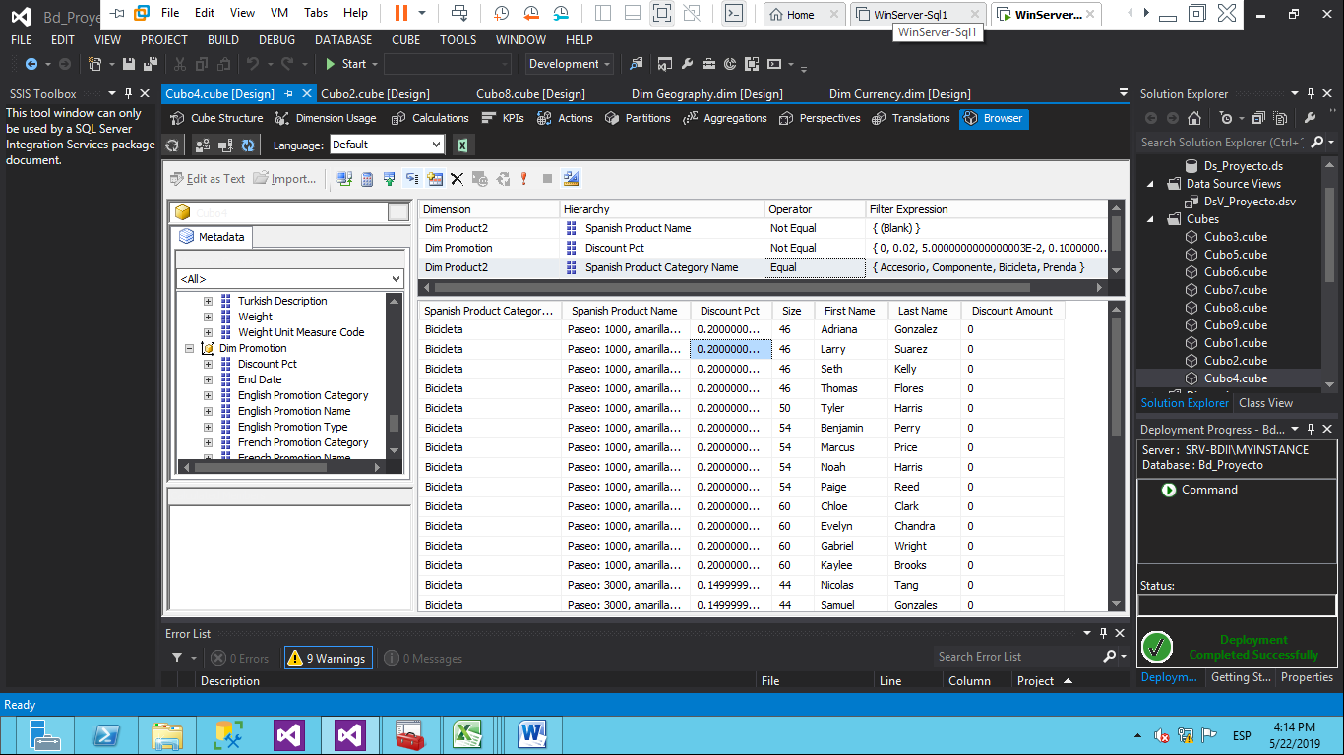

## Estudio 5

Determinar por año, el o los meses en donde se presentan las menores ventas, desagregadas por producto y con antecedentes de al menos 2 años.

### Representación en excel de las ventas menores por producto del año 2007



### Representación en Excel de las ventas menores por producto del año 2008

|  |  |  |  |  |  |  |  |  |  |
| --- | --- | --- | --- | --- | --- | --- | --- | --- | --- |
| **Producto** | **1** | **2** | **3** | **4** | **5** | **6** | **7** | **Total general** | **Venta menor** |
| All-Purpose Bike Stand | 2544 | 3021 | 2703 | 4611 | 3975 | 2067 | 1749 | 20670 | 1749 |
| AWC Logo Cap | 1600.22 | 1842.95 | 1789.01 | 1708.1 | 1815.98 | 2121.64 | 854.05 | 11731.95 | 854.05 |
| Bike Wash - Dissolver | 715.5 | 620.1 | 445.2 | 548.55 | 731.4 | 763.2 | 349.8 | 4173.75 | 349.8 |
| Classic Vest, L | 1079.5 | 1206.5 | 1397 | 1587.5 | 825.5 | 1333.5 | 698.5 | 8128 | 698.5 |
| Classic Vest, M | 1270 | 1397 | 1206.5 | 1143 | 1143 | 1016 | 889 | 8064.5 | 889 |
| Classic Vest, S | 889 | 698.5 | 762 | 1079.5 | 1651 | 762 | 635 | 6477 | 635 |
| Fender Set - Mountain | 4352.04 | 3340.96 | 3890.46 | 3868.48 | 4923.52 | 4483.92 | 2351.86 | 27211.24 | 2351.86 |
| Half-Finger Gloves, L | 930.62 | 1028.58 | 710.21 | 1077.56 | 1273.48 | 1248.99 | 391.84 | 6661.28 | 391.84 |
| Half-Finger Gloves, M | 881.64 | 1077.56 | 1200.01 | 1126.54 | 1420.42 | 1102.05 | 636.74 | 7444.96 | 636.74 |
| Half-Finger Gloves, S | 1053.07 | 930.62 | 685.72 | 1028.58 | 1053.07 | 1322.46 | 612.25 | 6685.77 | 612.25 |
| Hitch Rack - 4-Bike | 2160 | 2880 | 3840 | 2520 | 5400 | 3720 | 2400 | 22920 | 2160 |
| HL Mountain Tire | 4270 | 4025 | 3955 | 3920 | 5600 | 4515 | 2275 | 28560 | 2275 |
| HL Road Tire | 2445 | 2053.8 | 2379.8 | 2379.8 | 2249.4 | 1825.6 | 1760.4 | 15093.8 | 1760.4 |
| Hydration Pack - 70 oz. | 3244.41 | 3629.34 | 4014.27 | 2584.53 | 4399.2 | 4179.24 | 1484.73 | 23535.72 | 1484.73 |
| LL Mountain Tire | 1649.34 | 1949.22 | 1949.22 | 2024.19 | 1649.34 | 1674.33 | 1574.37 | 12470.01 | 1574.37 |
| LL Road Tire | 1848.14 | 2041.55 | 1568.77 | 2256.45 | 2084.53 | 1891.12 | 1375.36 | 13065.92 | 1375.36 |
| Long-Sleeve Logo Jersey, L | 2199.56 | 1749.65 | 1949.61 | 2349.53 | 1699.66 | 2149.57 | 999.8 | 13097.38 | 999.8 |
| Long-Sleeve Logo Jersey, M | 1749.65 | 1649.67 | 1999.6 | 2149.57 | 2349.53 | 2649.47 | 1199.76 | 13747.25 | 1199.76 |
| Long-Sleeve Logo Jersey, S | 1849.63 | 2149.57 | 2199.56 | 1799.64 | 2349.53 | 2249.55 | 1399.72 | 13997.2 | 1399.72 |
| Long-Sleeve Logo Jersey, XL | 1999.6 | 1399.72 | 1999.6 | 1949.61 | 1649.67 | 1699.66 | 1099.78 | 11797.64 | 1099.78 |
| ML Mountain Tire | 3238.92 | 2609.13 | 3088.97 | 2819.06 | 2879.04 | 2849.05 | 2339.22 | 19823.39 | 2339.22 |
| ML Road Tire | 1674.33 | 2199.12 | 1549.38 | 2224.11 | 2149.14 | 2623.95 | 899.64 | 13319.67 | 899.64 |
| Mountain Bottle Cage | 1758.24 | 1828.17 | 1808.19 | 1748.25 | 1928.07 | 2087.91 | 839.16 | 11997.99 | 839.16 |
| Mountain Tire Tube | 1337.32 | 1237.52 | 1282.43 | 1342.31 | 1367.26 | 1392.21 | 933.13 | 8892.18 | 933.13 |
| Mountain-200 Black, 38 | 91799.6 | 98684.57 | 78029.66 | 94094.59 | 121634.47 | 103274.55 |  | 587517.44 | 78029.66 |
| Mountain-200 Black, 42 | 57374.75 | 82619.64 | 105569.54 | 91799.6 | 103274.55 | 135404.41 |  | 576042.49 | 57374.75 |
| Mountain-200 Black, 46 | 82619.64 | 78029.66 | 75734.67 | 78029.66 | 114749.5 | 100979.56 |  | 530142.69 | 75734.67 |
| Mountain-200 Silver, 38 | 64959.72 | 83519.64 | 81199.65 | 104399.55 | 111359.52 | 143839.38 |  | 589277.46 | 64959.72 |
| Mountain-200 Silver, 42 | 69599.7 | 78879.66 | 78879.66 | 76559.67 | 109039.53 | 122959.47 |  | 535917.69 | 69599.7 |
| Mountain-200 Silver, 46 | 95119.59 | 90479.61 | 88159.62 | 69599.7 | 134559.42 | 102079.56 |  | 579997.5 | 69599.7 |
| Mountain-400-W Silver, 38 | 8464.39 | 10772.86 | 10772.86 | 10772.86 | 13850.82 | 15389.8 |  | 70023.59 | 8464.39 |
| Mountain-400-W Silver, 40 | 8464.39 | 7694.9 | 13081.33 | 11542.35 | 7694.9 | 11542.35 |  | 60020.22 | 7694.9 |
| Mountain-400-W Silver, 42 | 8464.39 | 6155.92 | 10003.37 | 6925.41 | 12311.84 | 18467.76 |  | 62328.69 | 6155.92 |
| Mountain-400-W Silver, 46 | 7694.9 | 9233.88 | 7694.9 | 15389.8 | 16159.29 | 10003.37 |  | 66176.14 | 7694.9 |
| Mountain-500 Black, 40 | 2699.95 | 3239.94 | 2699.95 | 1619.97 | 2159.96 | 1079.98 |  | 13499.75 | 1079.98 |
| Mountain-500 Black, 42 | 2159.96 | 539.99 | 2159.96 | 3779.93 | 1619.97 | 4319.92 |  | 14579.73 | 539.99 |
| Mountain-500 Black, 44 | 3239.94 | 1079.98 | 1619.97 | 4859.91 | 4319.92 | 2699.95 |  | 17819.67 | 1079.98 |
| Mountain-500 Black, 48 | 2159.96 | 2699.95 | 2699.95 | 2159.96 | 5939.89 | 4859.91 |  | 20519.62 | 2159.96 |
| Mountain-500 Black, 52 | 1619.97 | 2159.96 | 3239.94 | 3239.94 | 1079.98 | 3779.93 |  | 15119.72 | 1079.98 |
| Mountain-500 Silver, 40 | 564.99 | 4519.92 | 1694.97 | 2824.95 | 4519.92 | 2824.95 |  | 16949.7 | 564.99 |
| Mountain-500 Silver, 42 | 2259.96 | 2259.96 | 2824.95 | 2824.95 | 1694.97 | 3389.94 |  | 15254.73 | 1694.97 |
| Mountain-500 Silver, 44 | 1129.98 | 2259.96 | 2259.96 | 1129.98 | 2259.96 | 3389.94 |  | 12429.78 | 1129.98 |
| Mountain-500 Silver, 48 | 3389.94 | 1129.98 | 3954.93 | 1129.98 | 3389.94 | 3389.94 |  | 16384.71 | 1129.98 |
| Mountain-500 Silver, 52 | 2824.95 | 1694.97 | 1694.97 | 2259.96 | 2824.95 | 3389.94 |  | 14689.74 | 1694.97 |
| Patch Kit/8 Patches | 606.85 | 618.3 | 570.21 | 696.16 | 677.84 | 618.3 | 414.49 | 4202.15 | 414.49 |
| Racing Socks, L | 188.79 | 170.81 | 197.78 | 260.71 | 224.75 | 287.68 | 71.92 | 1402.44 | 71.92 |
| Racing Socks, M | 278.69 | 215.76 | 206.77 | 188.79 | 224.75 | 206.77 | 152.83 | 1474.36 | 152.83 |
| Road Bottle Cage | 1267.59 | 1366.48 | 1411.43 | 1627.19 | 1582.24 | 1690.12 | 89.9 | 9034.95 | 89.9 |
| Road Tire Tube | 849.87 | 774.06 | 710.22 | 813.96 | 849.87 | 857.85 | 638.4 | 5494.23 | 638.4 |
| Road-250 Black, 44 | 19546.8 | 26876.85 | 29320.2 | 21990.15 | 24433.5 | 14660.1 |  | 136827.6 | 14660.1 |
| Road-250 Black, 48 | 14660.1 | 31763.55 | 31763.55 | 26876.85 | 19546.8 | 31763.55 |  | 156374.4 | 14660.1 |
| Road-250 Black, 52 | 36650.25 | 21990.15 | 17103.45 | 21990.15 | 24433.5 | 19546.8 |  | 141714.3 | 17103.45 |
| Road-250 Black, 58 | 39093.6 | 12216.75 | 21990.15 | 19546.8 | 31763.55 | 21990.15 |  | 146601 | 12216.75 |
| Road-250 Red, 58 | 31763.55 | 36650.25 | 21990.15 | 26876.85 | 9773.4 | 26876.85 |  | 153931.05 | 9773.4 |
| Road-350-W Yellow, 40 | 35720.79 | 34019.8 | 44225.74 | 42524.75 | 42524.75 | 68039.6 |  | 267055.43 | 34019.8 |
| Road-350-W Yellow, 42 | 25514.85 | 45926.73 | 40823.76 | 49328.71 | 39122.77 | 61235.64 |  | 261952.46 | 25514.85 |
| Road-350-W Yellow, 44 | 18710.89 | 32318.81 | 45926.73 | 35720.79 | 57833.66 | 57833.66 |  | 248344.54 | 18710.89 |
| Road-350-W Yellow, 48 | 34019.8 | 35720.79 | 25514.85 | 57833.66 | 57833.66 | 51029.7 |  | 261952.46 | 25514.85 |
| Road-550-W Yellow, 38 | 20168.82 | 17927.84 | 22409.8 | 19048.33 | 30253.23 | 21289.31 |  | 131097.33 | 17927.84 |
| Road-550-W Yellow, 40 | 19048.33 | 13445.88 | 20168.82 | 30253.23 | 31373.72 | 28012.25 |  | 142302.23 | 13445.88 |
| Road-550-W Yellow, 42 | 16807.35 | 26891.76 | 15686.86 | 29132.74 | 34735.19 | 34735.19 |  | 157989.09 | 15686.86 |
| Road-550-W Yellow, 44 | 15686.86 | 15686.86 | 19048.33 | 22409.8 | 31373.72 | 28012.25 |  | 132217.82 | 15686.86 |
| Road-550-W Yellow, 48 | 13445.88 | 22409.8 | 15686.86 | 20168.82 | 34735.19 | 22409.8 |  | 128856.35 | 13445.88 |
| Road-750 Black, 44 | 15659.71 | 15659.71 | 15119.72 | 18359.66 | 22679.58 | 24839.54 |  | 112317.92 | 15119.72 |
| Road-750 Black, 48 | 11879.78 | 17819.67 | 19439.64 | 21599.6 | 22139.59 | 16739.69 |  | 109617.97 | 11879.78 |
| Road-750 Black, 52 | 16199.7 | 14579.73 | 22679.58 | 22679.58 | 24839.54 | 25919.52 |  | 126897.65 | 14579.73 |
| Road-750 Black, 58 | 15659.71 | 15119.72 | 14579.73 | 17279.68 | 17279.68 | 24299.55 |  | 104218.07 | 14579.73 |
| Short-Sleeve Classic Jersey, L | 1943.64 | 1511.72 | 1403.74 | 1835.66 | 1997.63 | 2591.52 | 431.92 | 11715.83 | 431.92 |
| Short-Sleeve Classic Jersey, M | 2213.59 | 1565.71 | 1295.76 | 1619.7 | 1943.64 | 2537.53 | 1133.79 | 12309.72 | 1133.79 |
| Short-Sleeve Classic Jersey, S | 2105.61 | 1673.69 | 1781.67 | 2375.56 | 1781.67 | 2051.62 | 593.89 | 12363.71 | 593.89 |
| Short-Sleeve Classic Jersey, XL | 1457.73 | 2267.58 | 2105.61 | 1889.65 | 1997.63 | 2807.48 | 1025.81 | 13551.49 | 1025.81 |
| Sport-100 Helmet, Black | 5248.5 | 5983.29 | 5773.35 | 7242.93 | 6963.01 | 7312.91 | 3254.07 | 41778.06 | 3254.07 |
| Sport-100 Helmet, Blue | 5528.42 | 5948.3 | 6788.06 | 6753.07 | 8117.68 | 7872.75 | 3359.04 | 44367.32 | 3359.04 |
| Sport-100 Helmet, Red | 6928.02 | 6193.23 | 7242.93 | 7137.96 | 8747.5 | 7557.84 | 2799.2 | 46606.68 | 2799.2 |
| Touring Tire | 2435.16 | 2232.23 | 2522.13 | 2841.02 | 2812.03 | 2464.15 | 1565.46 | 16872.18 | 1565.46 |
| Touring Tire Tube | 583.83 | 568.86 | 658.68 | 733.53 | 778.44 | 698.6 | 454.09 | 4476.03 | 454.09 |
| Touring-1000 Blue, 46 | 40529.19 | 52449.54 | 42913.26 | 61985.82 | 52449.54 | 33376.98 |  | 283704.33 | 33376.98 |
| Touring-1000 Blue, 50 | 28608.84 | 33376.98 | 26224.77 | 47681.4 | 30992.91 | 45297.33 |  | 212182.23 | 26224.77 |
| Touring-1000 Blue, 54 | 33376.98 | 42913.26 | 33376.98 | 40529.19 | 47681.4 | 57217.68 |  | 255095.49 | 33376.98 |
| Touring-1000 Blue, 60 | 30992.91 | 40529.19 | 42913.26 | 35761.05 | 38145.12 | 35761.05 |  | 224102.58 | 30992.91 |
| Touring-1000 Yellow, 46 | 38145.12 | 35761.05 | 38145.12 | 45297.33 | 52449.54 | 61985.82 |  | 271783.98 | 35761.05 |
| Touring-1000 Yellow, 50 | 38145.12 | 47681.4 | 40529.19 | 26224.77 | 30992.91 | 47681.4 |  | 231254.79 | 26224.77 |
| Touring-1000 Yellow, 54 | 23840.7 | 33376.98 | 42913.26 | 45297.33 | 50065.47 | 47681.4 |  | 243175.14 | 23840.7 |
| Touring-1000 Yellow, 60 | 38145.12 | 21456.63 | 35761.05 | 38145.12 | 45297.33 | 33376.98 |  | 212182.23 | 21456.63 |
| Touring-2000 Blue, 46 | 8503.95 | 7289.1 | 9718.8 | 13363.35 | 7289.1 | 13363.35 |  | 59527.65 | 7289.1 |
| Touring-2000 Blue, 50 | 9718.8 | 8503.95 | 9718.8 | 12148.5 | 17007.9 | 20652.45 |  | 77750.4 | 8503.95 |
| Touring-2000 Blue, 54 | 8503.95 | 8503.95 | 9718.8 | 7289.1 | 14578.2 | 13363.35 |  | 61957.35 | 7289.1 |
| Touring-2000 Blue, 60 | 7289.1 | 9718.8 | 8503.95 | 10933.65 | 9718.8 | 10933.65 |  | 57097.95 | 7289.1 |
| Touring-3000 Blue, 44 | 5938.8 | 2227.05 | 1484.7 | 1484.7 | 5938.8 | 5196.45 |  | 22270.5 | 1484.7 |
| Touring-3000 Blue, 50 | 2969.4 | 1484.7 | 742.35 | 1484.7 | 2227.05 | 7423.5 |  | 16331.7 | 742.35 |
| Touring-3000 Blue, 54 | 5938.8 | 4454.1 | 5196.45 | 5196.45 | 2227.05 | 2969.4 |  | 25982.25 | 2227.05 |
| Touring-3000 Blue, 58 | 3711.75 | 1484.7 | 4454.1 | 4454.1 | 4454.1 | 5196.45 |  | 23755.2 | 1484.7 |
| Touring-3000 Blue, 62 | 2227.05 | 4454.1 | 5196.45 | 6681.15 | 7423.5 | 5938.8 |  | 31921.05 | 2227.05 |
| Touring-3000 Yellow, 44 | 1484.7 | 3711.75 | 4454.1 | 2969.4 | 3711.75 | 11135.25 |  | 27466.95 | 1484.7 |
| Touring-3000 Yellow, 50 | 1484.7 | 3711.75 | 2969.4 | 6681.15 | 7423.5 | 2969.4 |  | 25239.9 | 1484.7 |
| Touring-3000 Yellow, 54 | 2227.05 | 1484.7 | 2227.05 | 2227.05 | 7423.5 | 2969.4 |  | 18558.75 | 1484.7 |
| Touring-3000 Yellow, 58 | 2969.4 | 3711.75 | 4454.1 | 5196.45 | 2969.4 | 2969.4 |  | 22270.5 | 2969.4 |
| Touring-3000 Yellow, 62 | 2969.4 | 4454.1 | 2969.4 | 4454.1 | 3711.75 | 5196.45 |  | 23755.2 | 2969.4 |
| Water Bottle - 30 oz. | 1771.45 | 1876.24 | 1946.1 | 1981.03 | 2015.96 | 2055.88 | 838.32 | 12484.98 | 838.32 |
| Women's Mountain Shorts, L | 1959.72 | 2309.67 | 2379.66 | 2169.69 | 1889.73 | 2169.69 | 1749.75 | 14627.91 | 1749.75 |
| Women's Mountain Shorts, M | 1819.74 | 1259.82 | 1539.78 | 2589.63 | 2029.71 | 2729.61 | 1469.79 | 13438.08 | 1259.82 |
| Women's Mountain Shorts, S | 1749.75 | 1959.72 | 1959.72 | 2099.7 | 1819.74 | 2169.69 | 1049.85 | 12808.17 | 1049.85 |
| **Total general** | **1340244.95** | **1462479.83** | **1480905.18** | **1608750.53** | **1878317.51** | **1949361.11** | **50840.63** | **9770899.74** | 50840.63 |

## Estudio 6

Determinar el Tax a pagar, según proyección de ventas para los 5 años siguientes al último registrado en la Base de Datos respectiva.

|  |  |  |  |
| --- | --- | --- | --- |
|  | Año | Venta | Tax |
|  | 2006 | 7072084.24 | 565766.751 |
|  | 2007 | 5762134.3 | 460970.785 |
|  | 2008 | 16473618.1 | 1317889.44 |
|  | 2009 | 50840.63 | 4067.2504 |
| PROYECCION | 2010 | 4751607.53 | 380128.597 |
| PROYECCION | 2011 | 3716382.82 | 2728822.83 |
| PROYECCION | 2012 | 2681158.12 | 1835500.77 |
| PROYECCION | 2013 | 1645933.41 | 2100041.67 |
| PROYECCION | 2014 | 610708.698 | 2364582.58 |

## Estudio 7

Determinar que promoción y en que fechas se han tenido los mayores impactos en las ventas.

### Representación en Excel del impacto de promociones según la promoción.

#### Touring -1000 Promotion

|  |  |  |  |
| --- | --- | --- | --- |
| **Fecha** | **Sales Amount** | **Fecha Mayor Impacto** | **Venta** |
| 2007-07-10 | 2384.07 | 2007-09-20 | 4768.14 |
| 2007-07-19 | 2384.07 |  |  |
| 2007-07-27 | 2384.07 |  |  |
| 2007-07-30 | 2384.07 |  |  |
| 2007-08-24 | 2384.07 |  |  |
| 2007-08-28 | 2384.07 |  |  |
| 2007-08-30 | 2384.07 |  |  |
| 2007-09-09 | 2384.07 |  |  |
| 2007-09-10 | 2384.07 |  |  |
| 2007-09-20 | 4768.14 |  |  |
| 2007-09-22 | 2384.07 |  |  |
| 2007-09-23 | 2384.07 |  |  |
| **Total general** | **30992.91** |  |  |

#### Touring -3000 Promotion

|  |  |  |  |
| --- | --- | --- | --- |
| **Fecha** | **Sales Amount** | **Fecha Mayor Impacto** | **Venta** |
| 2007-07-14 | 742.35 | 2007-07-27 | 1484.7 |
| 2007-07-22 | 742.35 | 2007-08-24 | 1484.7 |
| 2007-07-24 | 742.35 | 2007-09-13 | 1484.7 |
| 2007-07-27 | 1484.7 | 2007-09-18 | 1484.7 |
| 2007-08-04 | 742.35 |  |  |
| 2007-08-07 | 742.35 |  |  |
| 2007-08-08 | 742.35 |  |  |
| 2007-08-24 | 1484.7 |  |  |
| 2007-08-26 | 742.35 |  |  |
| 2007-08-31 | 742.35 |  |  |
| 2007-09-03 | 742.35 |  |  |
| 2007-09-08 | 742.35 |  |  |
| 2007-09-13 | 1484.7 |  |  |
| 2007-09-14 | 742.35 |  |  |
| 2007-09-18 | 1484.7 |  |  |
| 2007-09-28 | 742.35 |  |  |
| **Total general** | **14847** |  |  |

#### Volume Discount 11 to 14

|  |  |
| --- | --- |
| **Fecha Mayor Impacto** | **Venta** |
| 2008-04-27 | 14446.38 |

#### Promocion con Mayor Impacto

|  |  |  |
| --- | --- | --- |
| **Promoción** | **Venta** | **Fecha** |
| Volume Discount 11 to 14 | 14446.38 | 2008-05-09 |

### Conclusión:

La promoción con mayor impacto es Volume Discount 11 to 14 con una venta de 14446.38 en la fecha 2008-05-09

## Estudio 8

Determinar cuál es el tipo de moneda y ciudad donde más se utiliza ésta para realizar las compras.

### Representación en Excel de la moneda más utilizada.

|  |  |
| --- | --- |
| **Moneda** | **Sales Amount** |
| Australian Dollar | 609157.695 |
| Canadian Dollar | 117164.7674 |
| United Kingdom Pound | 263211.5232 |
| US Dollar | 1061536.153 |
| **Total general** | **2051070.138** |

### Representación gráfica de las moneda más usadas en compras.

### Conclusión.

La moneda más utilizada para cancelar las compras es el dollar américano, seguido del dólar australiano.

## Estudio 9

Obtener información de contacto de los clientes.

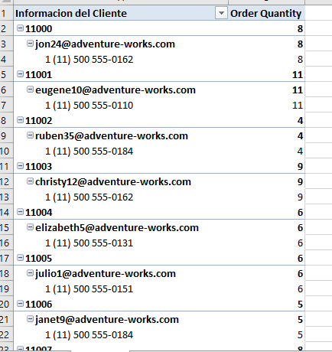

# Capítulo 4

# Minería de Datos

## Definición de Vista

### Query de Vista:

Se realizó el query que desplegará la vista para poder llevar a cabo el análisis en la minería de datos, el cual consistió en identificar la información conforme a las condiciones dadas, la cual servirá para búsqueda de resultados y su respectivo análisis.

USE [AdventureWorksDW2012]

GO

CREATE VIEW dbo.ProyectoMineria

AS

select DISTINCT CLIENTE.CustomerKey

,DATEDIFF(YEAR,CLIENTE.BirthDate,GETDATE()) AS Age

,CLIENTE.MaritalStatus

,CLIENTE.NumberCarsOwned

,CLIENTE.HouseOwnerFlag

,CLIENTE.TotalChildren

,ISNULL(CLIENTE.FirstName,'NO EXISTENTE') AS FirstName

,ISNULL(CLIENTE.MiddleName,'NO EXISTENTE') AS MiddleName

,ISNULL(CLIENTE.LastName,'NO EXISTENTE') AS LastName

,CLIENTE.EmailAddress

,CLIENTE.YearlyIncome

,CLIENTE.AddressLine1

,ISNULL(CLIENTE.AddressLine2,'NO EXISTENTE') AS AddressLine2

,CASE WHEN CLIENTE.YearlyIncome BETWEEN 50000 AND 75000 THEN 3

WHEN CLIENTE.YearlyIncome > 75000 AND CLIENTE.YearlyIncome <= 100000 THEN 2

ELSE 1 END AS Posible_Comprador

FROM DimCustomer AS CLIENTE

INNER JOIN FactInternetSales AS INTVENTAS

ON

INTVENTAS.CustomerKey = CLIENTE.CustomerKey

INNER JOIN DimProduct AS PRODUCTO

ON

PRODUCTO.ProductKey = INTVENTAS.ProductKey

INNER JOIN

DimProductSubcategory AS CATPRODUCT

ON

CATPRODUCT.ProductSubcategoryKey = PRODUCTO.ProductSubcategoryKey

INNER JOIN

DimSalesTerritory AS TERRITORIO

ON

TERRITORIO.SalesTerritoryKey = INTVENTAS.SalesTerritoryKey

WHERE

CATPRODUCT.SpanishProductSubcategoryName in ('Bicicleta de Montaña','Bicicleta de Carretera','Bicicleta de Paseo')

and PRODUCTO.SpanishProductName NOT LIKE 'Casco deportivo: 100,%'

AND CLIENTE.YearlyIncome > 50000

AND DATEDIFF(YEAR,CLIENTE.BirthDate,GETDATE()) > 35

AND CLIENTE.MaritalStatus IN ('M','S')

AND (CONVERT(int, CLIENTE.NumberCarsOwned)>=1)

AND TERRITORIO.SalesTerritoryRegion IN ('United States','Canada','Germany','France','Australia')

go

### Nombre de Vista.

Una vez teniendo el Query definido con sus criterios se guarda la vista con el nombre: ProyectoMineria, de esta manera podremos identificarla y posteriormente utilizarla en el Data Mining.

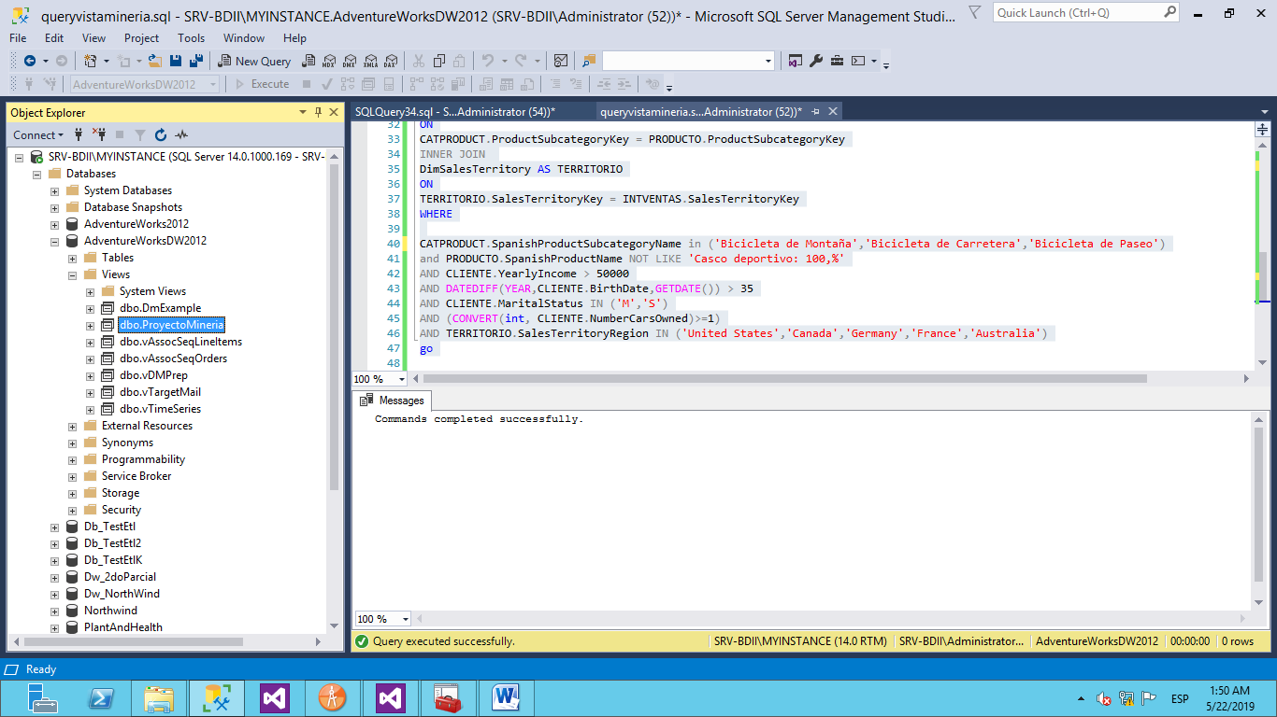

Se muestra los resultados obtenidos en la ejecución de la vista.

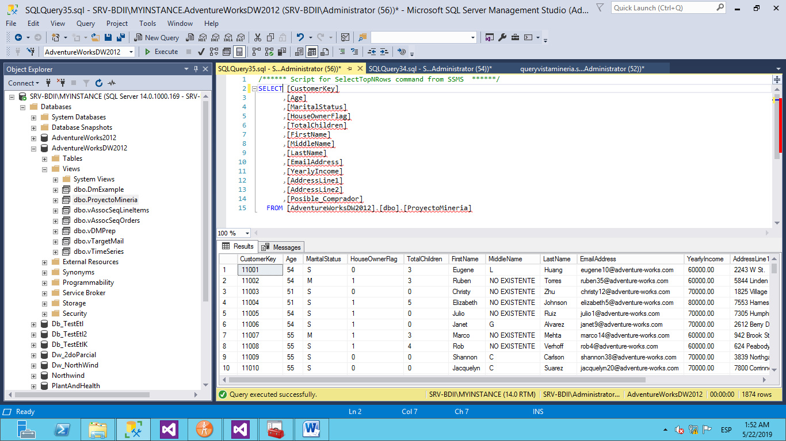

### Creación del Proyecto Data Mining

Para la realización del Data Mining se utilizó a herramienta Data Tools de Visual Studio, se creó el proyecto llamado: ProyectoMineria.

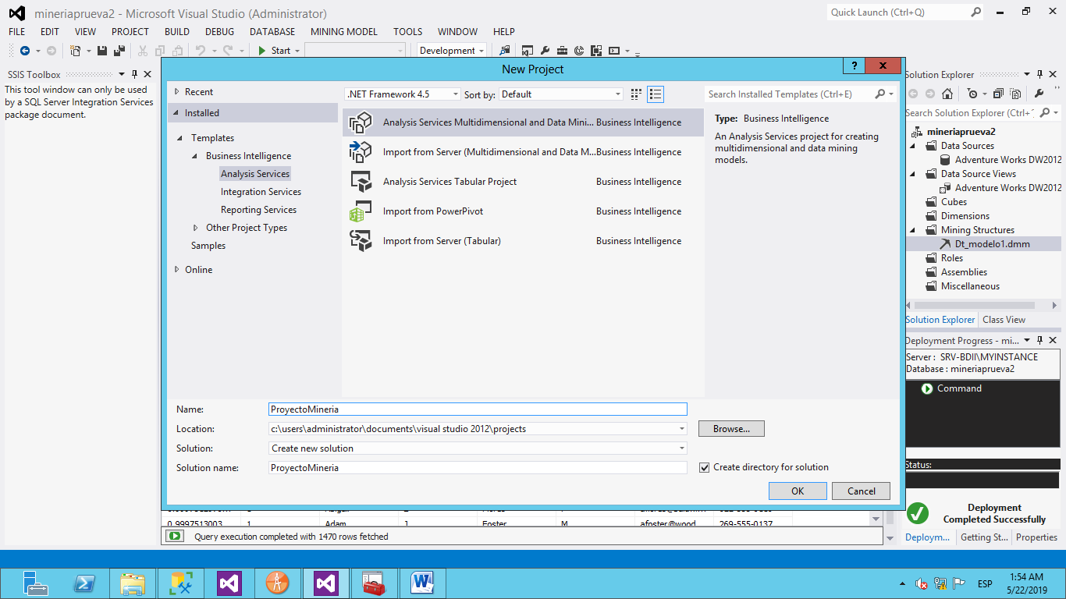

### Creación Data Sources

Se procede a crear el Data Source que conecta con nuestra Base de Datos y de la cual estaremos extrayendo información para su posterior análisis.

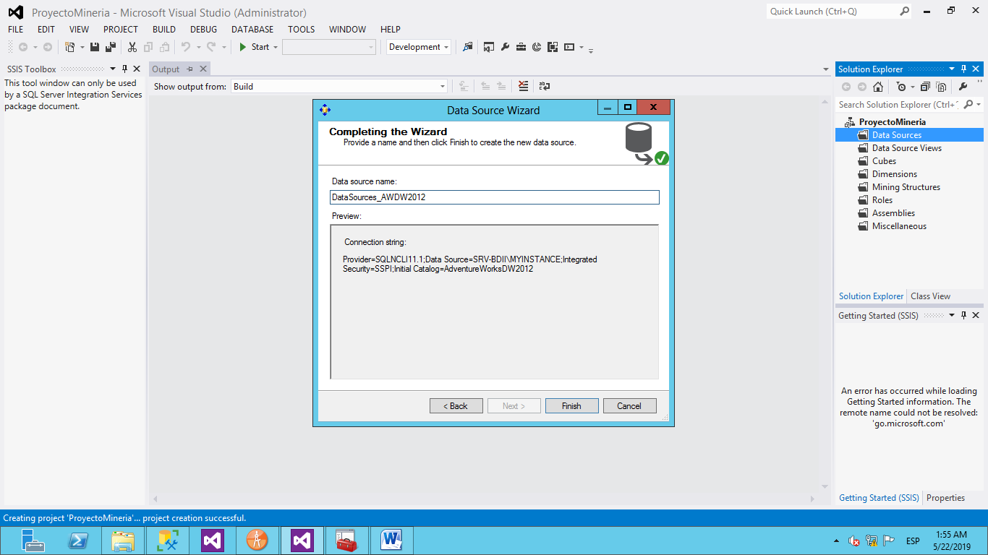

Data Source Views

Se lleva a cabo la creación de Data Source views para las siguientes tablas y vista.

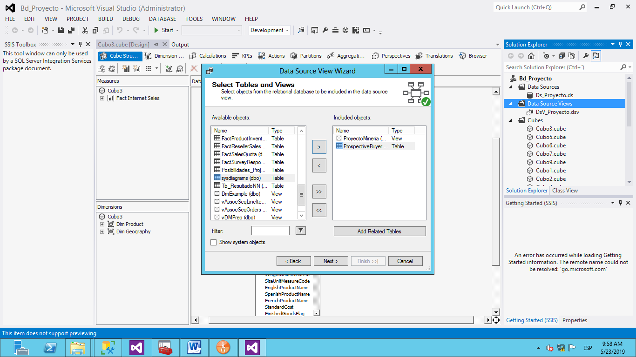

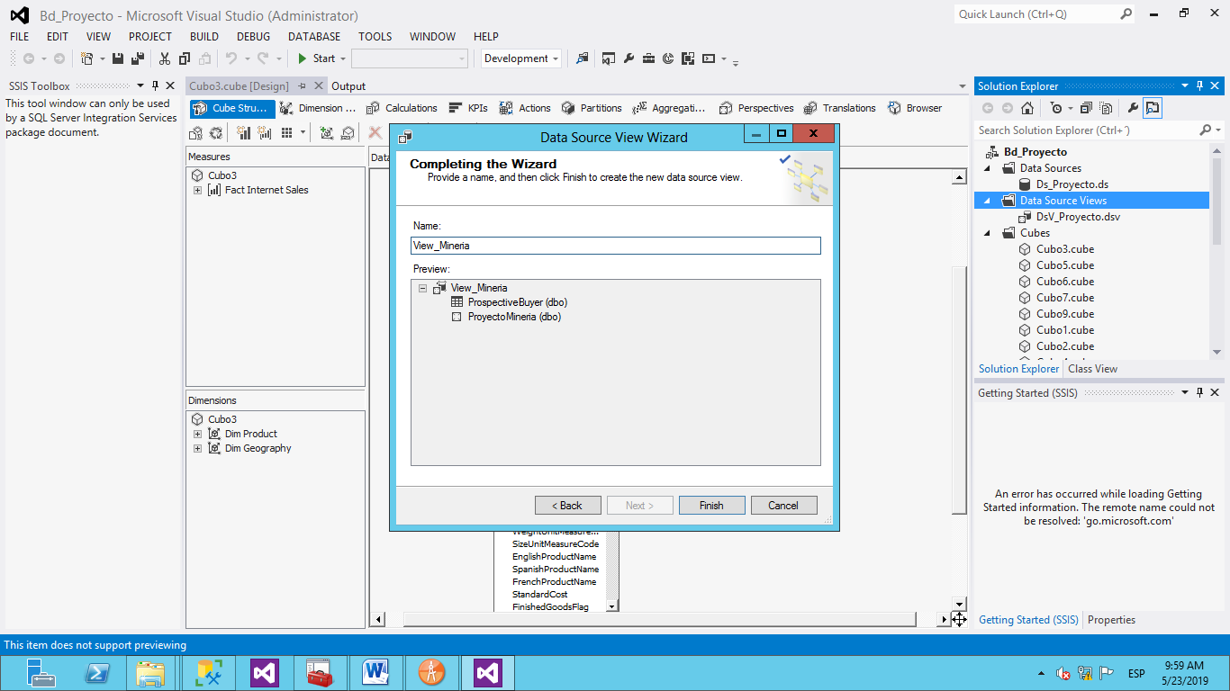

Se creo una tabla de calculo llamada “Age” para poder obtener la edad del posible comprador a partir de su fecha de nacimiento.

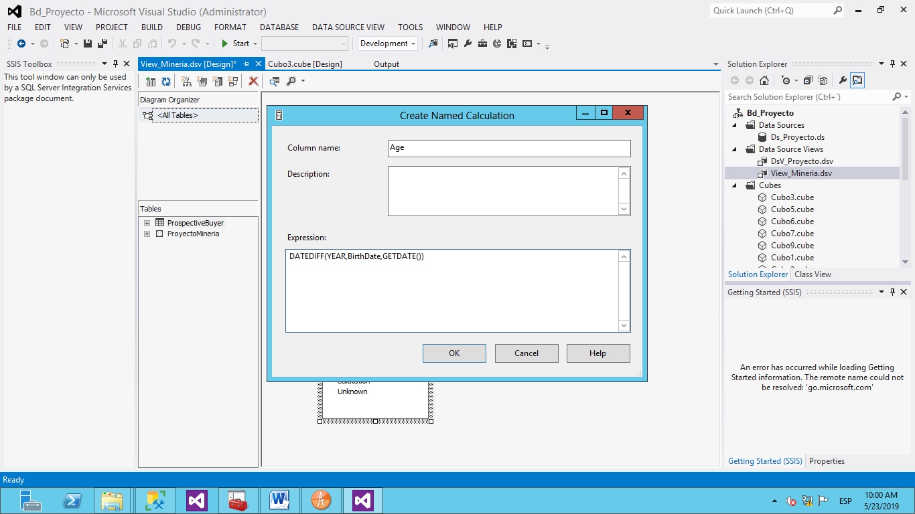

### Modelo de Minería.

La creación del modelo de minería se creo para obtener los datos necesario para el equipo de Marketing, el modelo se nombró: Proyecto_Mineria

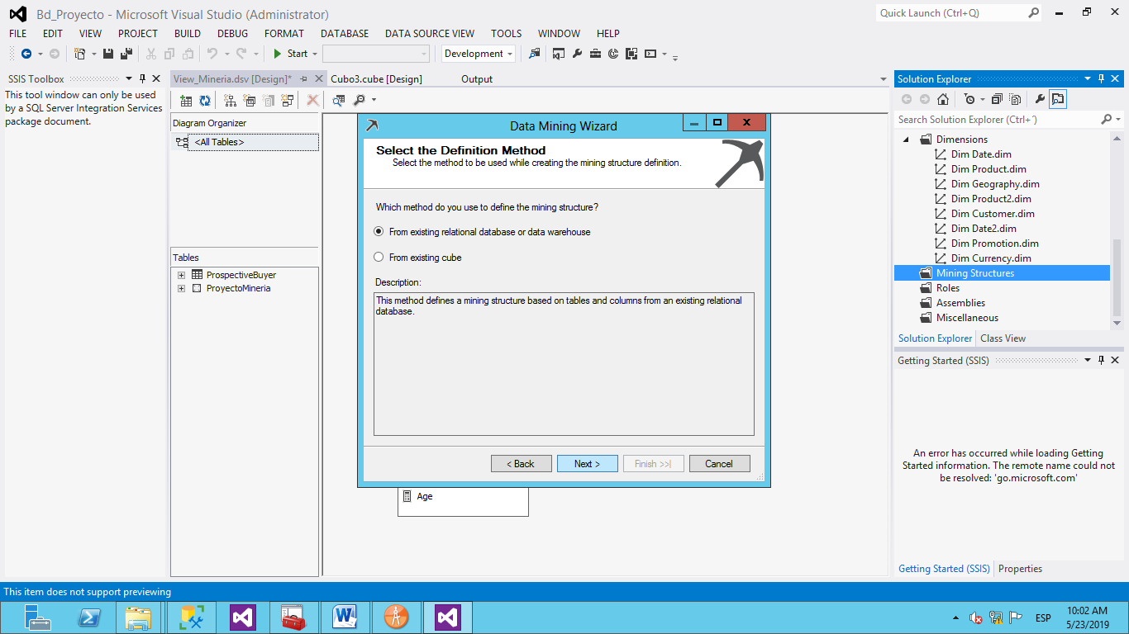

### Seleccion del primer modelo

El modelo con el que se inicio fue el de arbol.

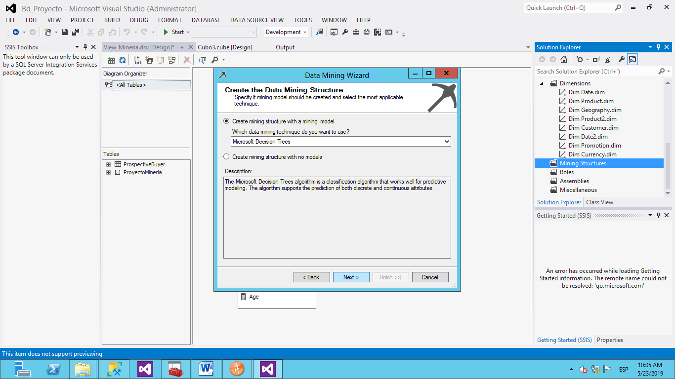

Se procede a la selección de la Data Source View la cual contiene los modelos y tablas para llevar a cabo la implementación.

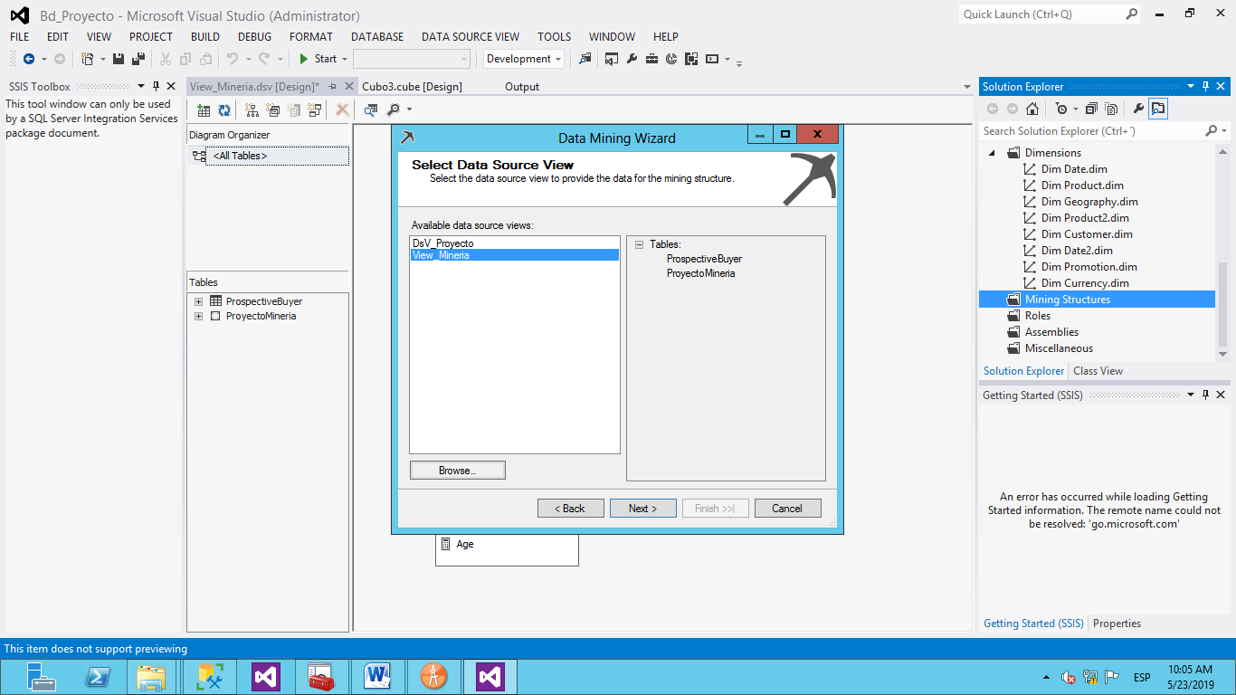

### Especificación del caso de uso para la minería.

Se selecciono el método de casos de uso.

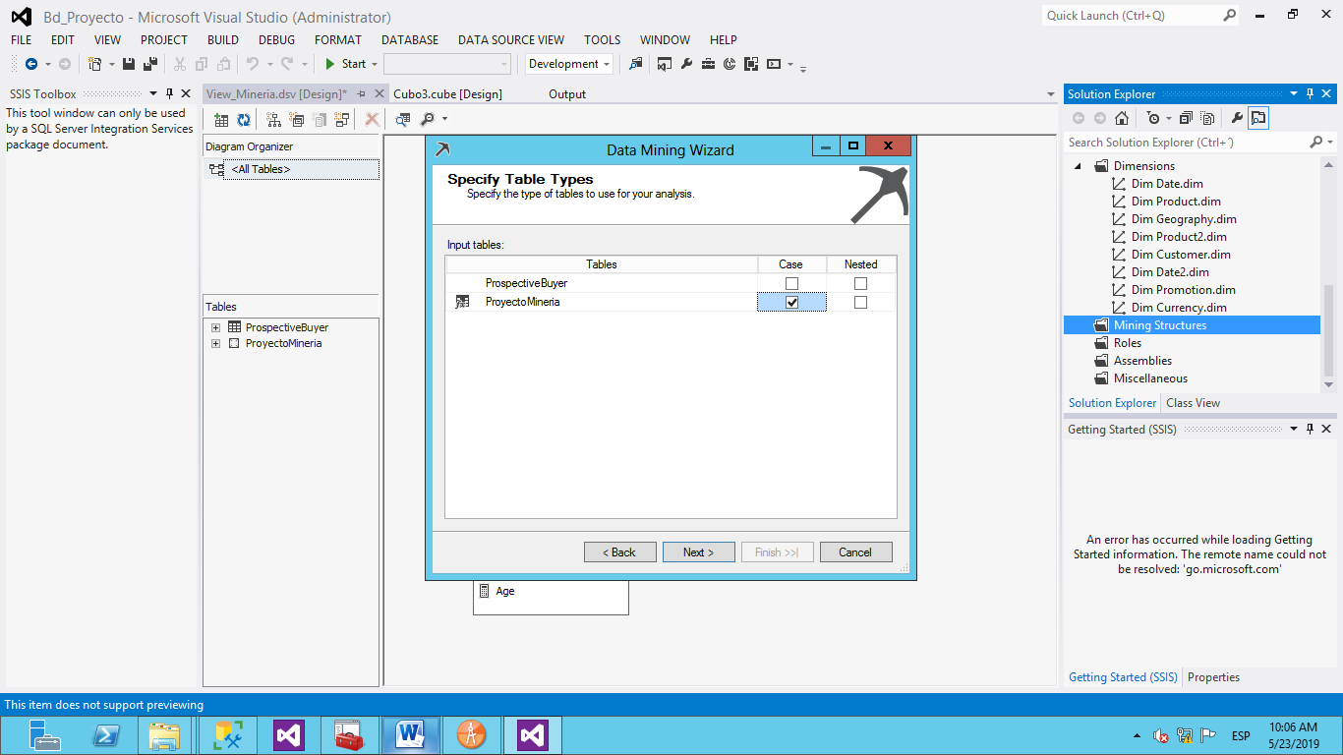

Seleccion de la llave para identifiacion de los datos, los datos de entrata para el prosesamiento y el dato predictivo.

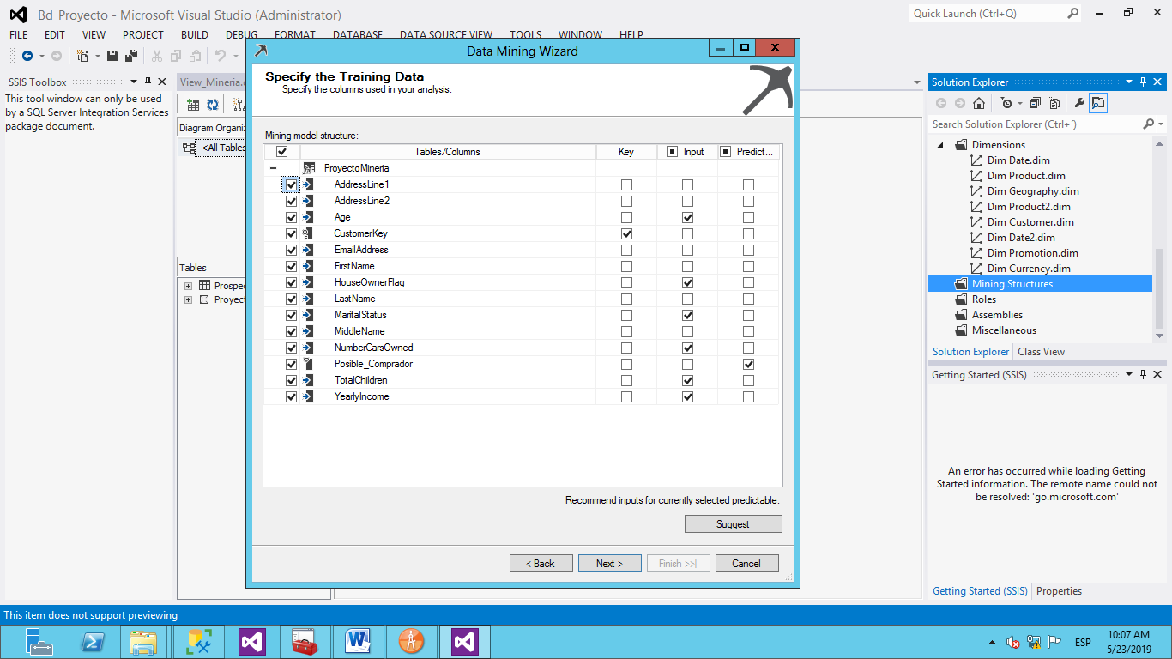

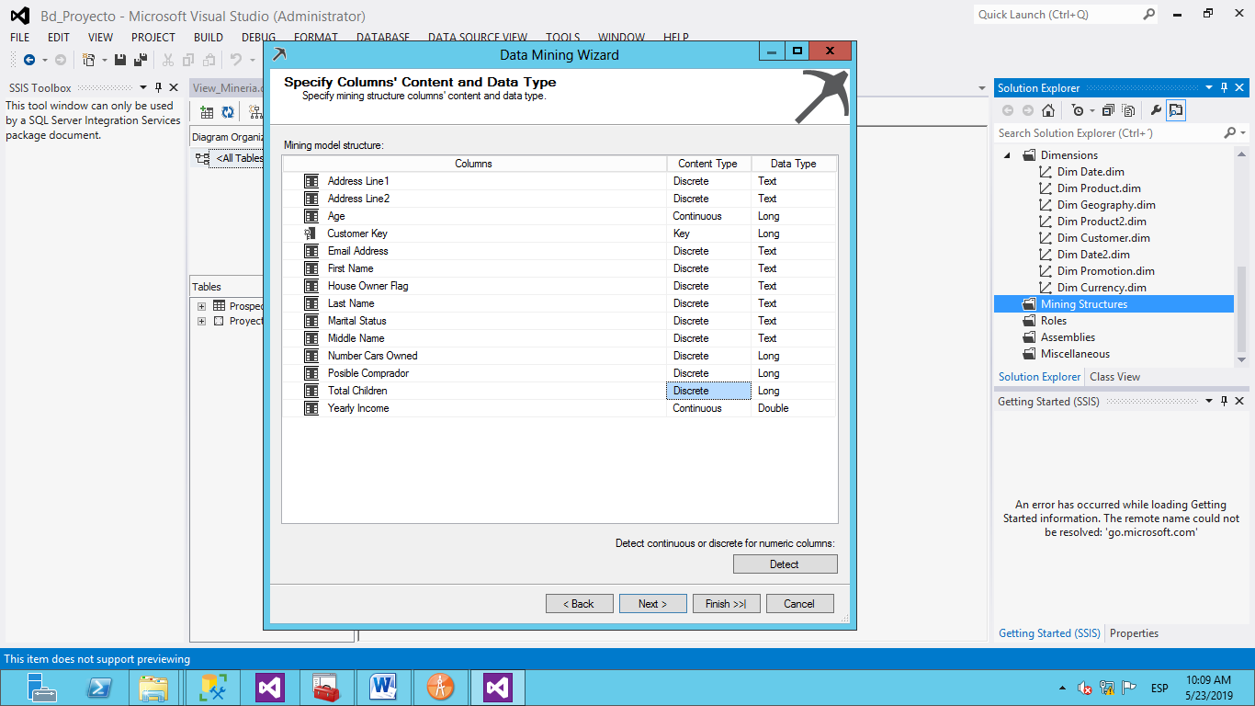

### Especificando el número de casos para el modelo de testeo.

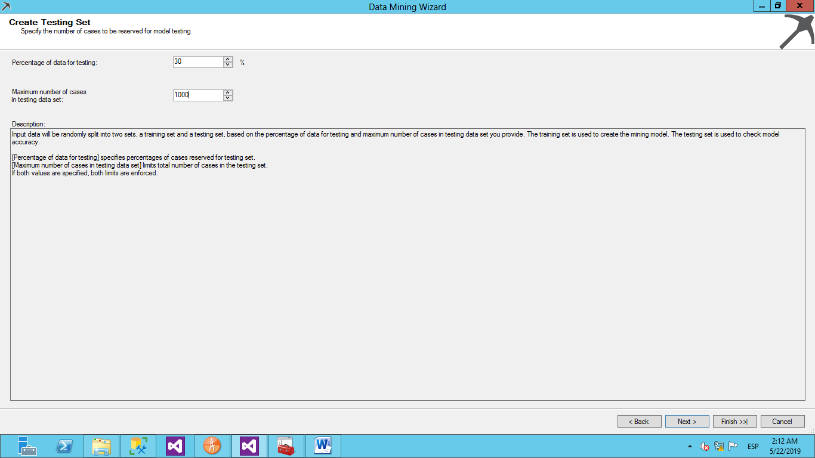

### Nombrando la Estructura

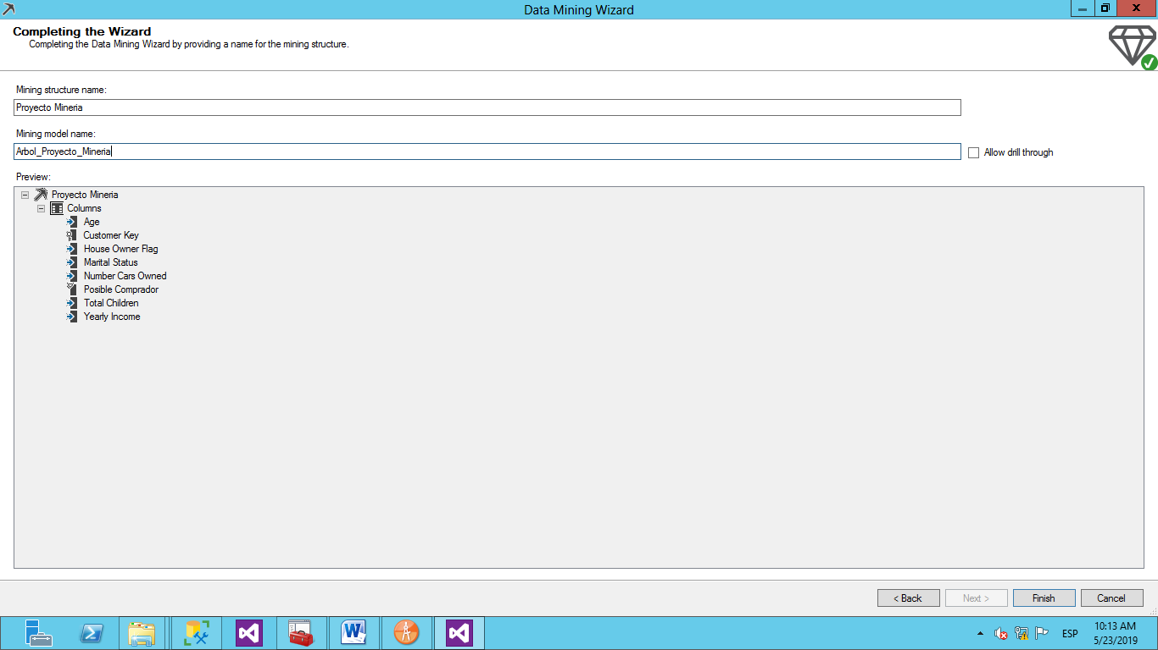

### Creación de los modelos restantes para el análisis.

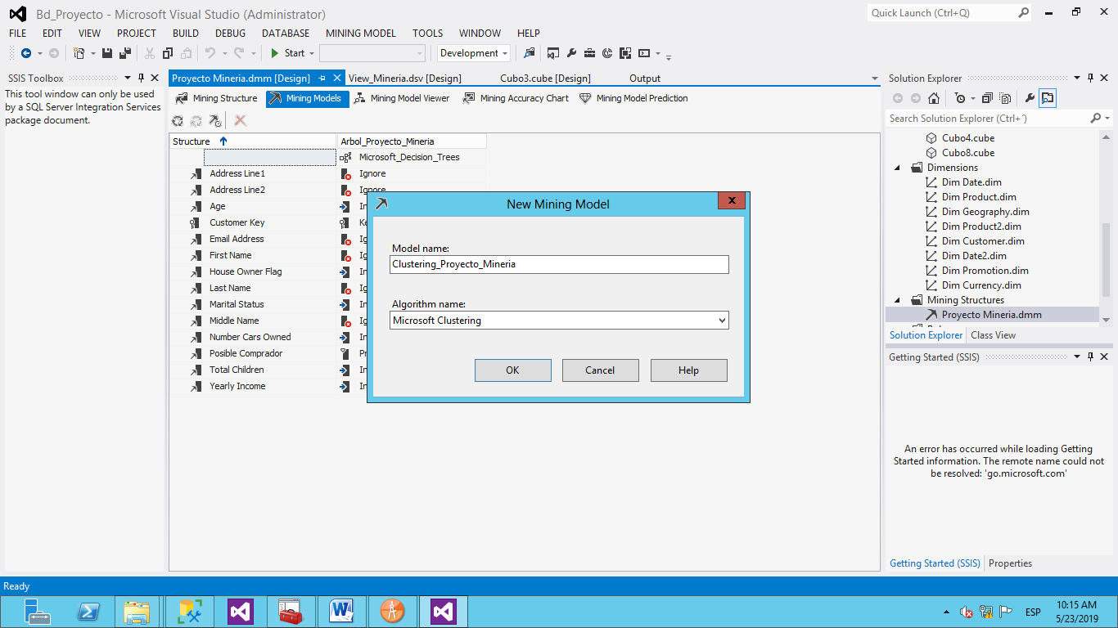

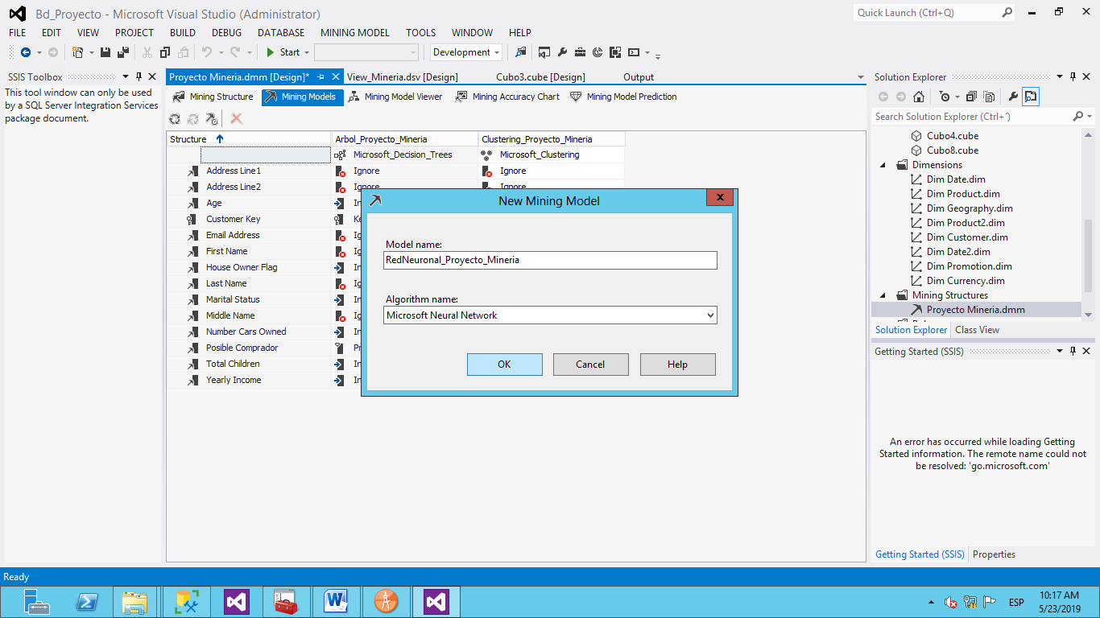

### Procesamiento de los datos.

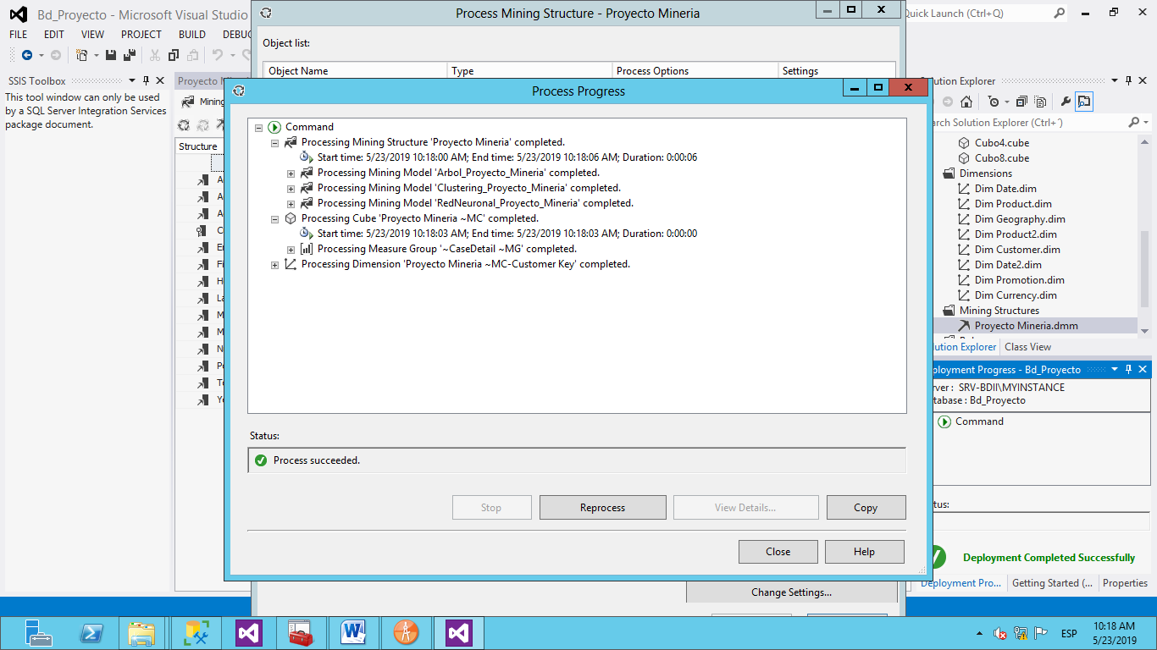

### Analsis Árbol de decisiones

Se llevó a cabo el análisis en el modelo de árbol, tomando como condiciones principales que los ingresos anuales son superen las siguientes cifras.

Ingresos anuales menos a 71,000

Ingresos anuales entre 71,000 y 104,000

Ingresos anuales mayores a 104,000

Aplicando el análisis de árbol, este nos dio el resultado que hay una mayor posibilidad de compra en aquellos clientes que sus ingresos anuales son de 71,000 con un porcentaje de 46.18%, seguidamente están los clientes que sus ingresos anuales estén entre 71,000 y 104,000 con un porcentaje de 33.53%, por ultimo se tiene una menor posibilidad en aquellos clientes en los que sus ingresos anuales superan los 104,000 con un porcentaje de 20.28%.

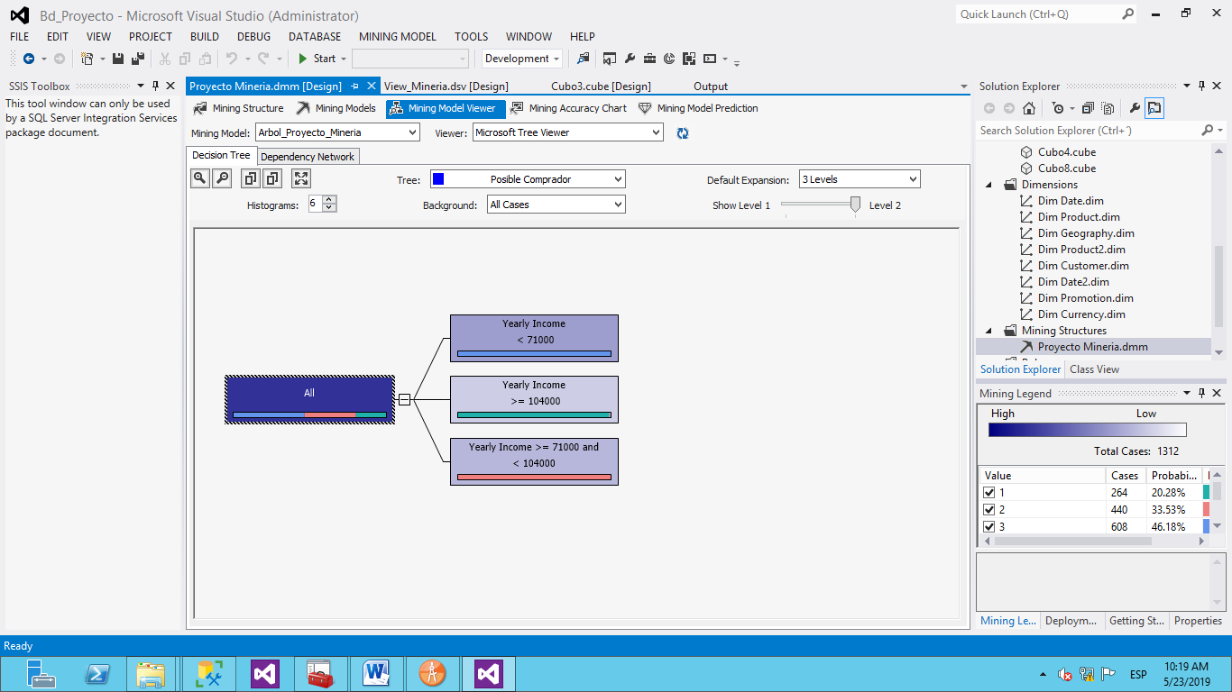

Se muestra que el valor mejor a tomar es cuenta es basarnos en el tipo de ingreso anual del cliente

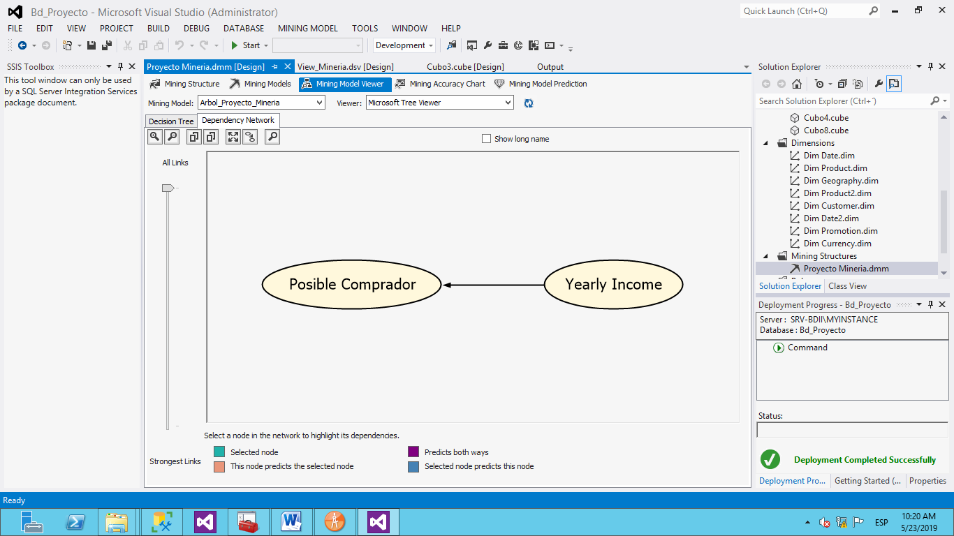

### Analisis Clustering

Relaciones entre los distintos cluster y su infuencia entre ellos.

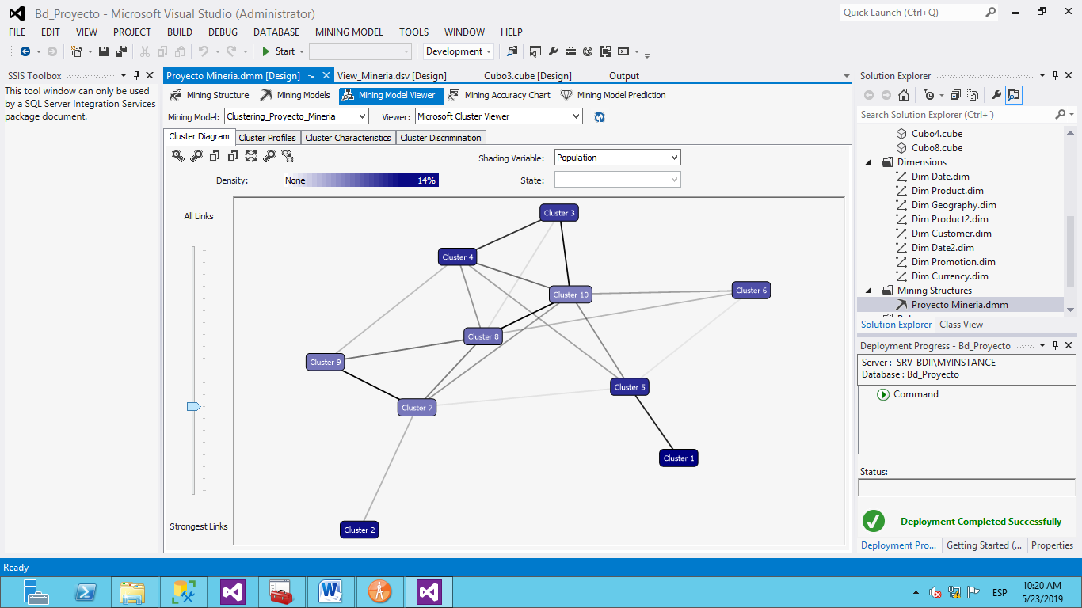

El análisis que se determinó a partir de Clustering es que en los grupos 2 y 5 son los que presentan mayor posibilidad de adquirir el seguro.

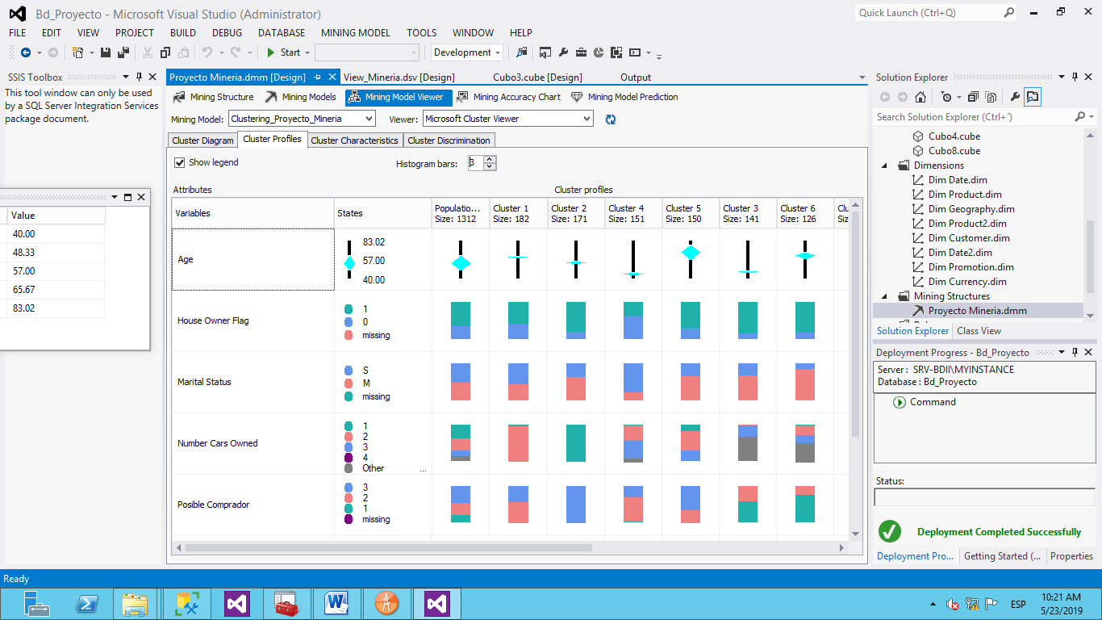

En la compracion de los cluster 2 y 5 nos da como resultado que las personas que ganan menos de 70,000 y que tengan hijos indistintamente del genero existen mas probabilidades de que adquieran el seguro.

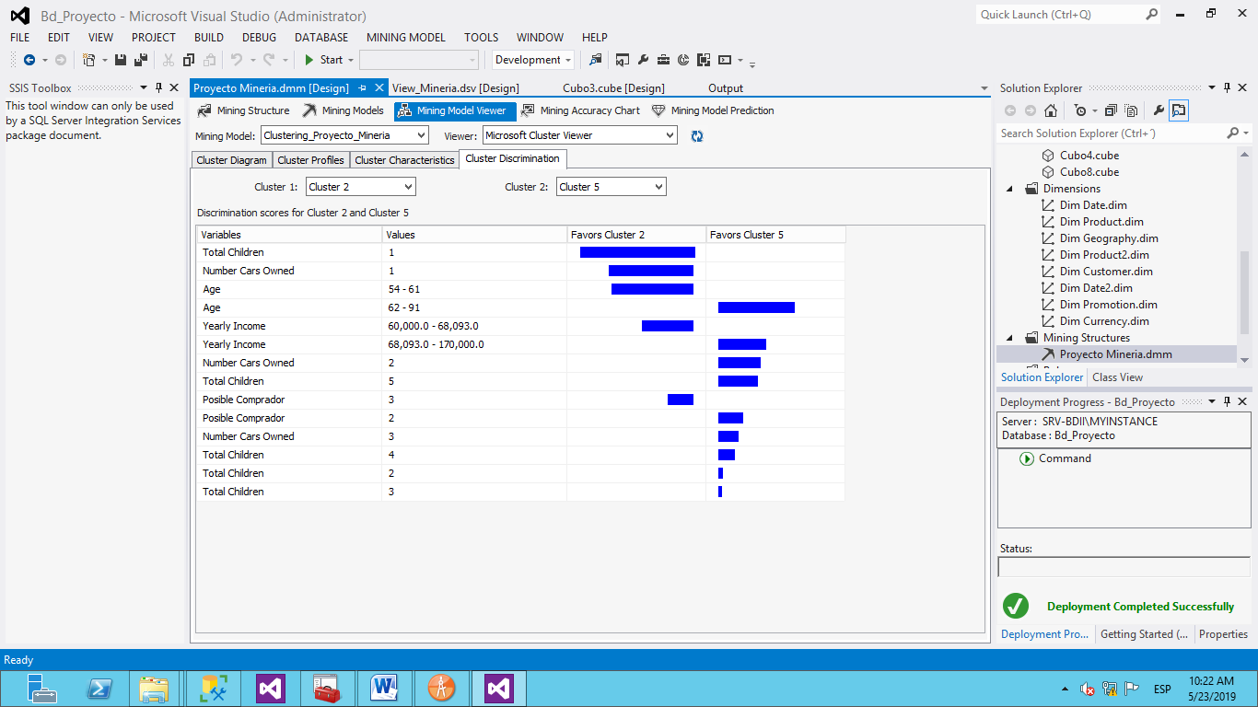

Análisis Redes Neuronales

El estudio del presente modelo reveló que las personas con un ingreso anual entre 50000 y 75000 su toma de decisión es influyente la cantidad de hijos, dando lugar a que a mayor cantidad de hijos que este tenga la probabilidad de que opte por un seguro es menor.

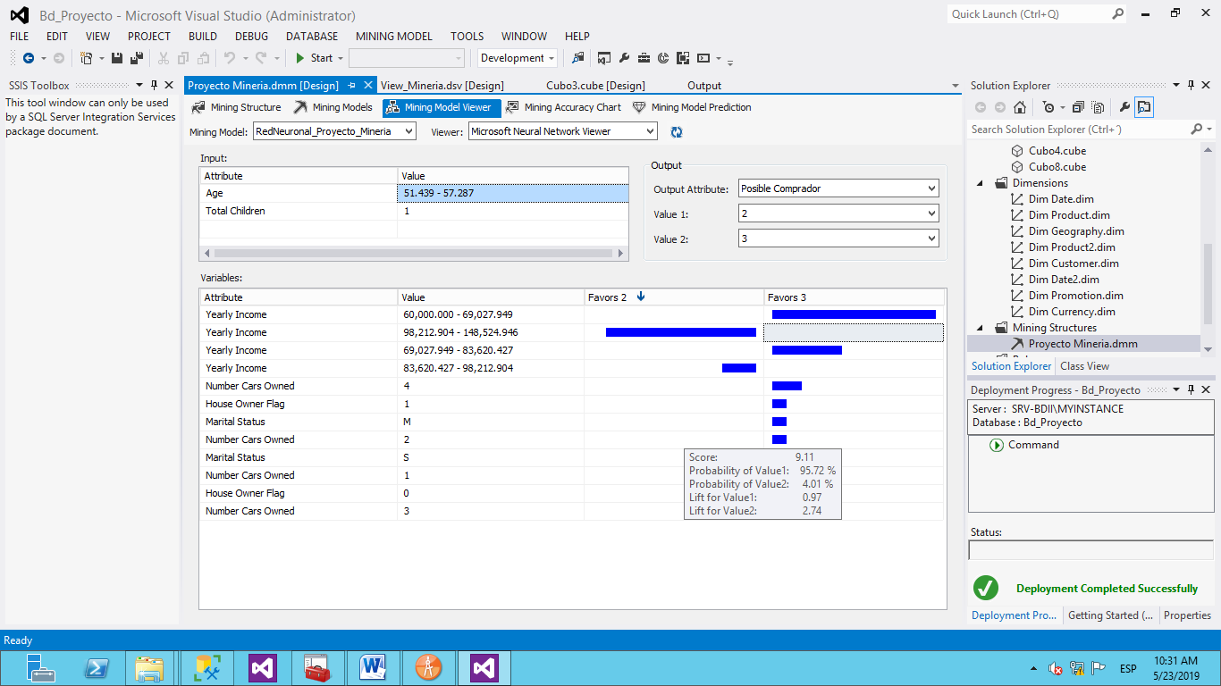

Pero seguido de que observo que en el caso de las personas con un rango de 75000 y entre 100000 de ingreso anual un valor influyente entre ellos es su edad, el cual a mayor edad menos probable es de que opten por un seguro.

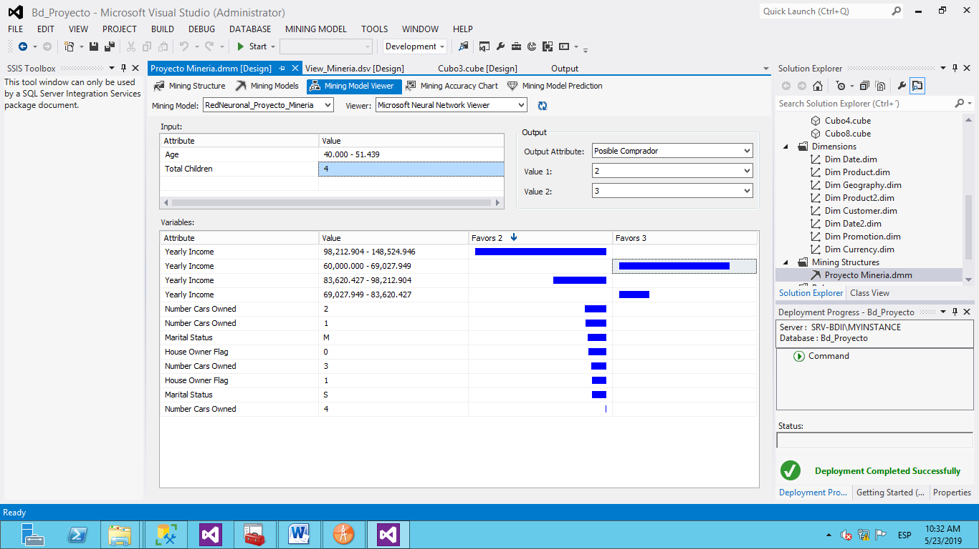

Como análisis final se representa que el modelo más cercano al 100% es por Árbol de decisiones dando un lugar al 99.64% para el cual este modelo será usado para nuestra predicción.

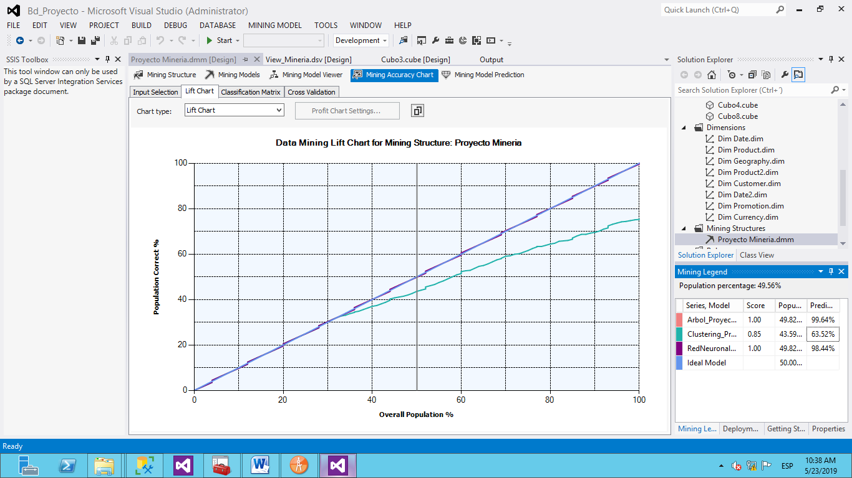

Luego de determinar el modelo más eficiente para la toma decisiones, se procede a guardar la información de los posibles compradores del seguro propuesto para vender, por medio de la comparación del modelo que sugiere la herramienta y la tabla de posibles compradores que provee el DATAWAREHOUSE.

Como se ve observa en la siguiente imagen, se muestra la selección del modelo de minería, el cual en este caso sera el árbol de decisiones.

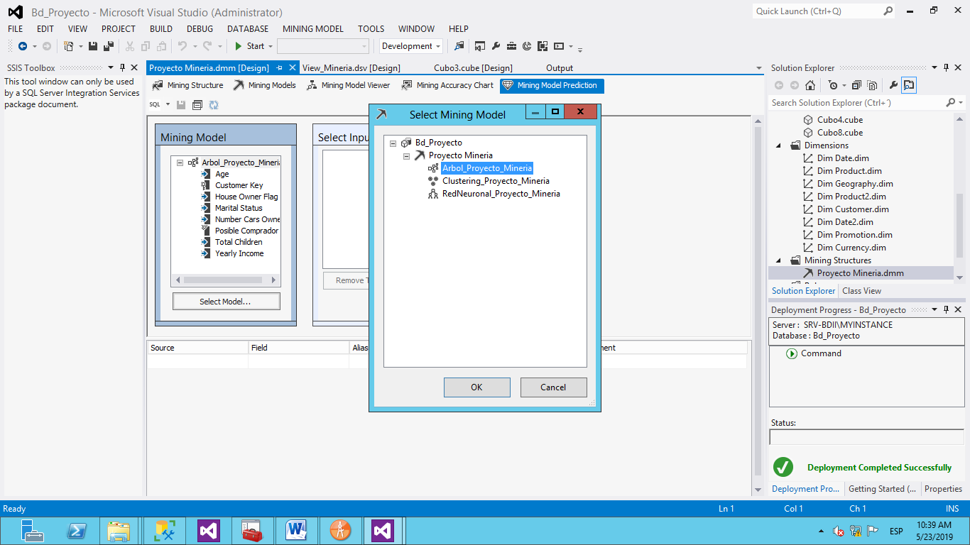

Se selecciona la tabla ProspectiveBuyer que contiene información de posibles compradores.

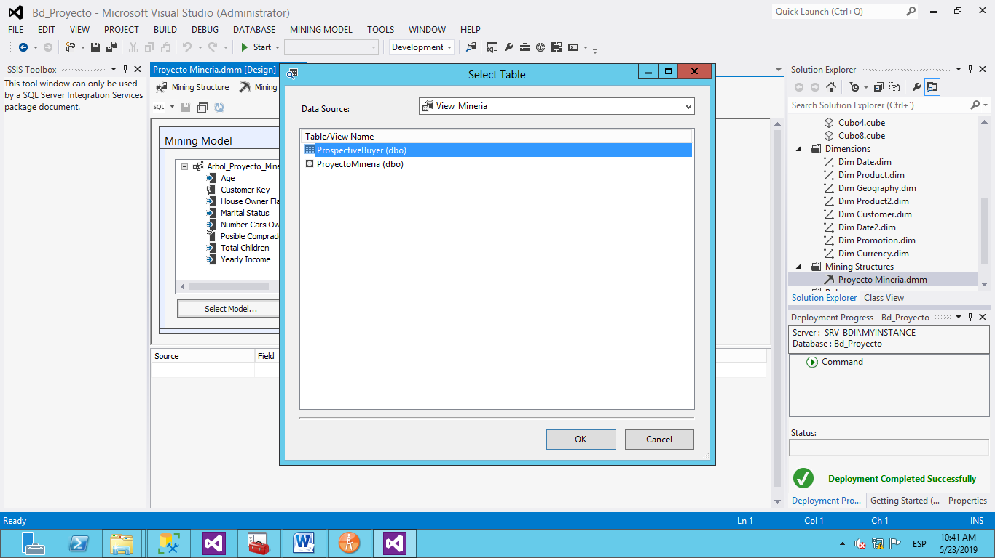

Se verifica el mapeo de datos del modelo de minería con la tabla previamente seleccionada.

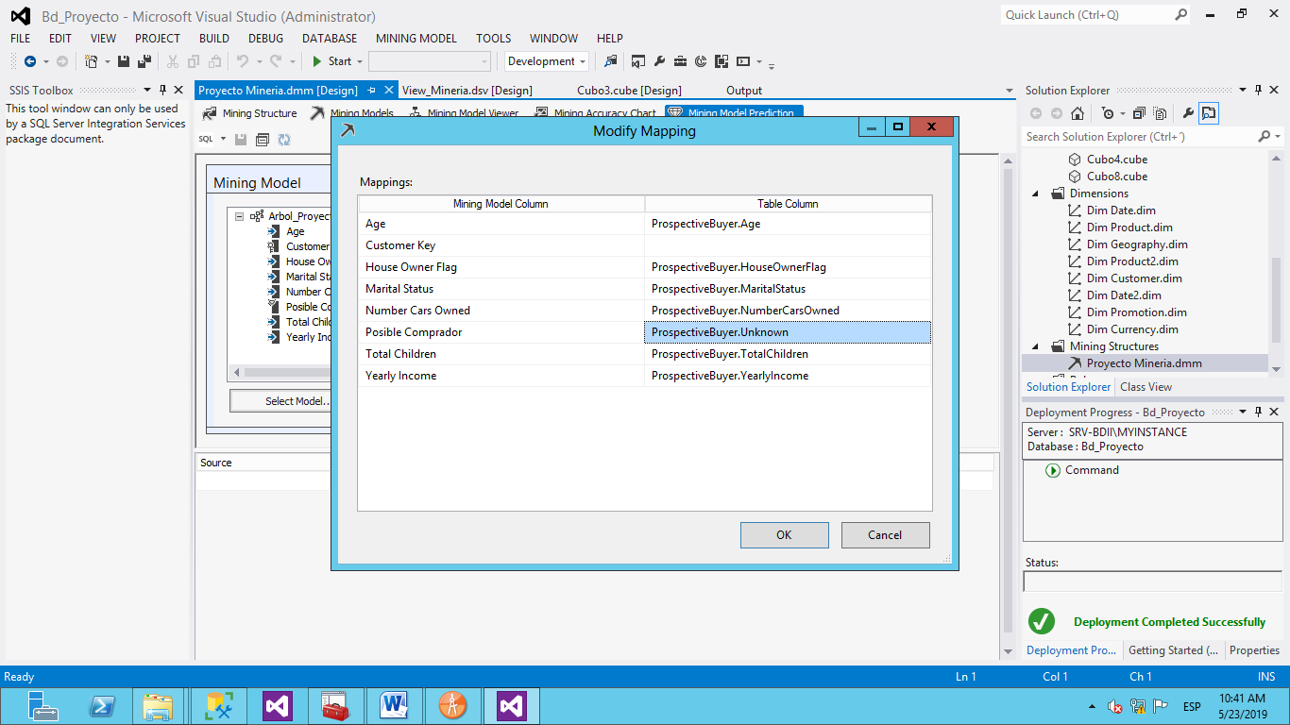

Se seleccionan los datos a mostrar en el informe.

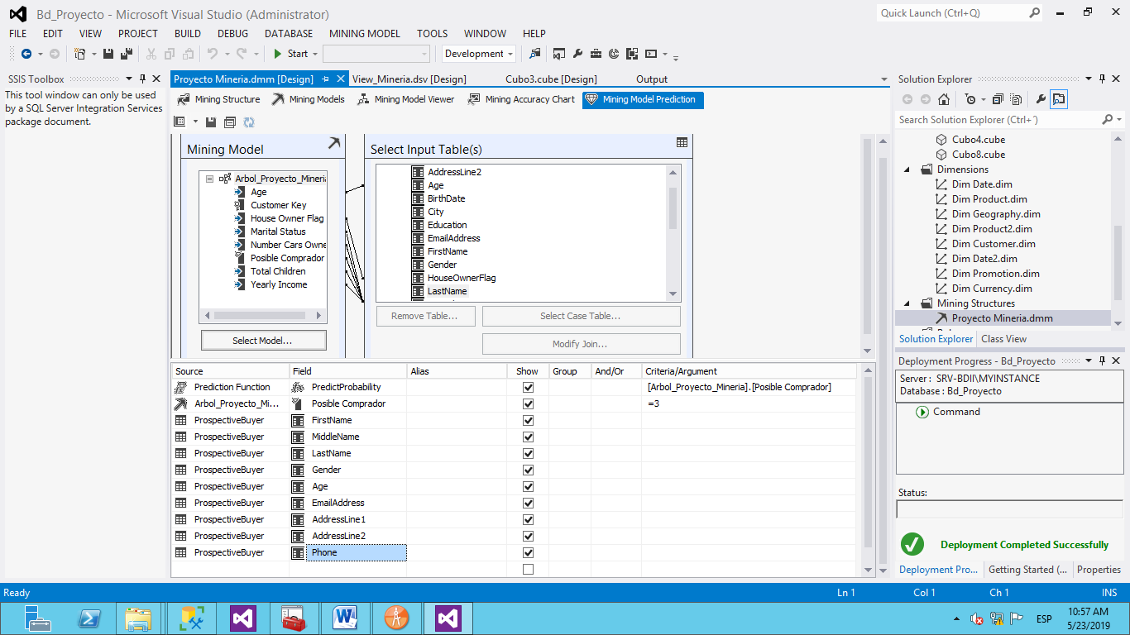

Se muestra el resultado del select de la herramienta con una cantidad de 1622 filas.

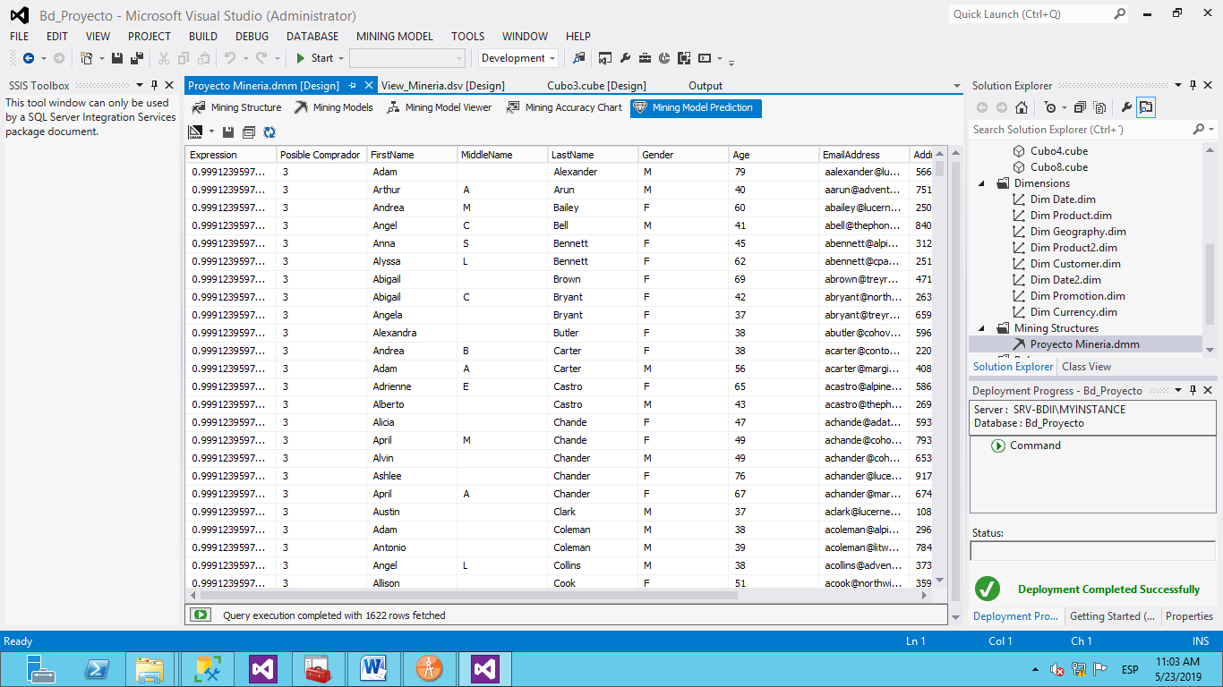

Se almacena la información en una tabla nueva llamada Tb_DataMining

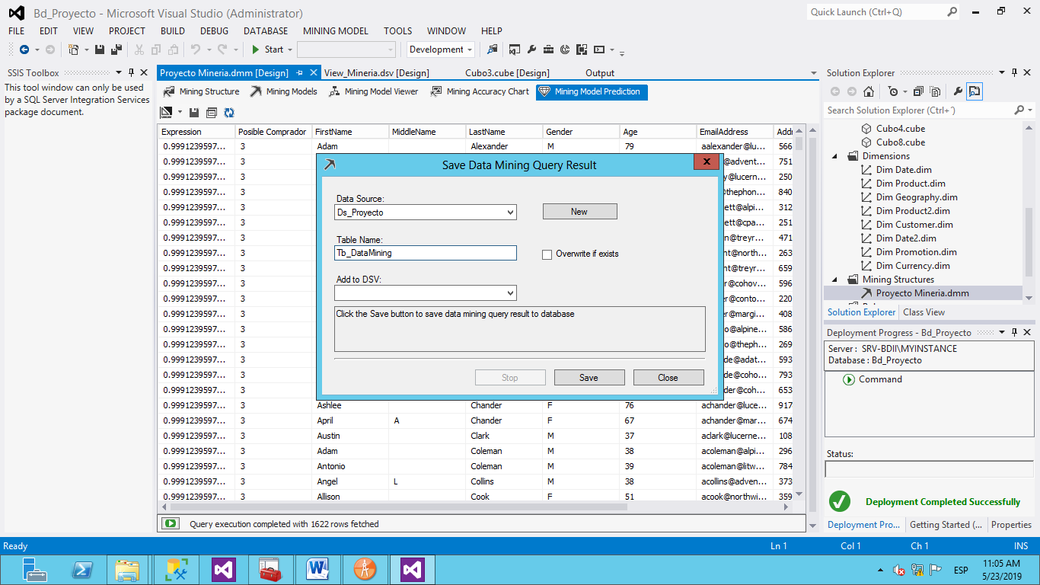

Conclusión:

Se concluye que de la población inicial de 1874, serán 1622 posibles compradores de un seguro. 252 descartan la compra de uno.

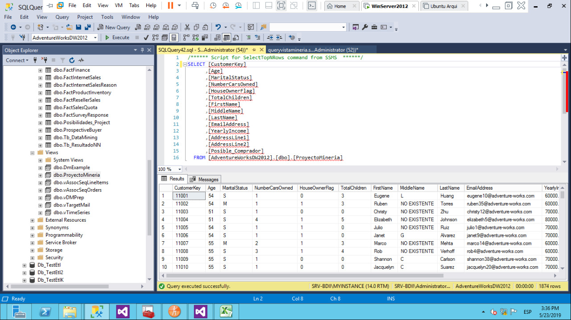

# Capítulo 5

# Diccionario de Datos

**Tabla: dbo.DimCurrency**

|  |  |  |  |
| --- | --- | --- | --- |
| Name | Owner | Type | Created_datetime |
| DimCurrency | dbo | user table | 12:47.5 |

|  |  |  |  |  |  |  |  |  |  |
| --- | --- | --- | --- | --- | --- | --- | --- | --- | --- |
| Column_name | Type | Computed | Length | Prec | Scale | Nullable | TrimTrailingBlanks | FixedLenNullInSource | Collation |
| CurrencyKey | int | no | 00:00.0 | 10 | 0 | no | (n/a) | (n/a) | NULL |
| CurrencyAlternateKey | nchar | no | 6 |  |  | no | (n/a) | (n/a) | SQL_Latin1_General_CP1_CI_AS |
| CurrencyName | nvarchar | no | 100 |  |  | no | (n/a) | (n/a) | SQL_Latin1_General_CP1_CI_AS |

|  |  |  |
| --- | --- | --- |
| index_name | index_description | index_keys |
| AK_DimCurrency_CurrencyAlternateKey | nonclustered, unique, unique key located on PRIMARY | CurrencyAlternateKey |
| PK_DimCurrency_CurrencyKey | clustered, unique, primary key located on PRIMARY | CurrencyKey |

|  |
| --- |
| Data_located_on_filegroup |
| PRIMARY |

|  |  |  |  |  |
| --- | --- | --- | --- | --- |
| Identity | Seed | Increment | Not For Replication | |
| CurrencyKey | 1 | 1 | 0 |  |

|  |  |  |  |  |
| --- | --- | --- | --- | --- |
|  |  |  |  | |
|  | |  |  |  | |
|  | |  |  |  | |

|  |  |  |  |  |  |  |
| --- | --- | --- | --- | --- | --- | --- |
| constraint_type | constraint_name | delete_action | update_action | status_enabled | status_for_replication | constraint_keys |
| UNIQUE (non-clustered) | AK_DimCurrency_CurrencyAlternateKey | (n/a) | (n/a) | (n/a) | (n/a) | CurrencyAlternateKey |
| PRIMARY KEY (clustered) | PK_DimCurrency_CurrencyKey | (n/a) | (n/a) | (n/a) | (n/a) | CurrencyKey |

|  |  |  |  |  |
| --- | --- | --- | --- | --- |
| Table is referenced by foreign key |  |  |  |  |
| AdventureWorksDW2012.dbo.DimOrganization: FK_DimOrganization_DimCurrency | | | | |
| AdventureWorksDW2012.dbo.FactCurrencyRate: FK_FactCurrencyRate_DimCurrency | | | | |
| AdventureWorksDW2012.dbo.FactInternetSales: FK_FactInternetSales_DimCurrency | | | | |
| AdventureWorksDW2012.dbo.FactResellerSales: FK_FactResellerSales_DimCurrency | | | | |

**Tabla: dbo.DimDate**

|  |  |  |  |  |
| --- | --- | --- | --- | --- |
| Name | Owner | Type | Created_datetime | |
| DimDate | dbo | user table | 12:47.5 |  |

|  |  |  |  |  |  |  |  |  |  |  |
| --- | --- | --- | --- | --- | --- | --- | --- | --- | --- | --- |
| Column_name | Type | Computed | Length | Prec | Scale | Nullable | TrimTrailingBlanks | FixedLenNullInSource | Collation | |
| DateKey | int | no | 4 | 10 | 0 | no | (n/a) | (n/a) | NULL | |
| FullDateAlternateKey | date | no | 3 | 10 | 0 | no | (n/a) | (n/a) | NULL |  |
| DayNumberOfWeek | tinyint | no | 1 | 3 | 0 | no | (n/a) | (n/a) | NULL |  |
| EnglishDayNameOfWeek | nvarchar | no | 20 |  |  | no | (n/a) | (n/a) | SQL_Latin1_General_CP1_CI_AS | |
| SpanishDayNameOfWeek | nvarchar | no | 20 |  |  | no | (n/a) | (n/a) | SQL_Latin1_General_CP1_CI_AS | |
| FrenchDayNameOfWeek | nvarchar | no | 20 |  |  | no | (n/a) | (n/a) | SQL_Latin1_General_CP1_CI_AS | |
| DayNumberOfMonth | tinyint | no | 1 | 3 | 0 | no | (n/a) | (n/a) | NULL | |
| DayNumberOfYear | smallint | no | 2 | 5 | 0 | no | (n/a) | (n/a) | NULL | |
| WeekNumberOfYear | tinyint | no | 1 | 3 | 0 | no | (n/a) | (n/a) | NULL | |
| EnglishMonthName | nvarchar | no | 20 |  |  | no | (n/a) | (n/a) | SQL_Latin1_General_CP1_CI_AS | |
| SpanishMonthName | nvarchar | no | 20 |  |  | no | (n/a) | (n/a) | SQL_Latin1_General_CP1_CI_AS | |
| FrenchMonthName | nvarchar | no | 20 |  |  | no | (n/a) | (n/a) | SQL_Latin1_General_CP1_CI_AS | |
| MonthNumberOfYear | tinyint | no | 1 | 3 | 0 | no | (n/a) | (n/a) | NULL | |
| CalendarQuarter | tinyint | no | 1 | 3 | 0 | no | (n/a) | (n/a) | NULL | |
| CalendarYear | smallint | no | 2 | 5 | 0 | no | (n/a) | (n/a) | NULL | |
| CalendarSemester | tinyint | no | 1 | 3 | 0 | no | (n/a) | (n/a) | NULL | |
| FiscalQuarter | tinyint | no | 1 | 3 | 0 | no | (n/a) | (n/a) | NULL | |
| FiscalYear | smallint | no | 2 | 5 | 0 | no | (n/a) | (n/a) | NULL | |
| FiscalSemester | tinyint | no | 1 | 3 | 0 | no | (n/a) | (n/a) | NULL | |

|  |  |  |  |
| --- | --- | --- | --- |
| Identity | Seed | Increment | Not For Replication |
| No identity column defined. | NULL | NULL | NULL |

|  |
| --- |
| Data_located_on_filegroup |
| PRIMARY |

|  |  |  |  |
| --- | --- | --- | --- |
| index_name | index_description | index_keys |  |
| AK_DimDate_FullDateAlternateKey | nonclustered, unique, unique key located on PRIMARY | FullDateAlternateKey | |
| PK_DimDate_DateKey | clustered, unique, primary key located on PRIMARY | DateKey | |

|  |  |  |  |  |  |  |
| --- | --- | --- | --- | --- | --- | --- |
| constraint_type | constraint_name | delete_action | update_action | status_enabled | status_for_replication | constraint_keys |
| UNIQUE (non-clustered) | AK_DimDate_FullDateAlternateKey | (n/a) | (n/a) | (n/a) | (n/a) | FullDateAlternateKey |
| PRIMARY KEY (clustered) | PK_DimDate_DateKey | (n/a) | (n/a) | (n/a) | (n/a) | DateKey |

|  |  |  |  |  |
| --- | --- | --- | --- | --- |
| Table is referenced by foreign key |  |  |  |  |
| AdventureWorksDW2012.dbo.FactCallCenter: FK_FactCallCenter_DimDate | | | |  |
| AdventureWorksDW2012.dbo.FactCurrencyRate: FK_FactCurrencyRate_DimDate | | | | |
| AdventureWorksDW2012.dbo.FactFinance: FK_FactFinance_DimDate | | | |  |
| AdventureWorksDW2012.dbo.FactInternetSales: FK_FactInternetSales_DimDate | | | | |
| AdventureWorksDW2012.dbo.FactInternetSales: FK_FactInternetSales_DimDate1 | | | | |
| AdventureWorksDW2012.dbo.FactInternetSales: FK_FactInternetSales_DimDate2 | | | | |
| AdventureWorksDW2012.dbo.FactProductInventory: FK_FactProductInventory_DimDate | | | | |
| AdventureWorksDW2012.dbo.FactResellerSales: FK_FactResellerSales_DimDate | | | | |
| AdventureWorksDW2012.dbo.FactResellerSales: FK_FactResellerSales_DimDate1 | | | | |
| AdventureWorksDW2012.dbo.FactResellerSales: FK_FactResellerSales_DimDate2 | | | | |
| AdventureWorksDW2012.dbo.FactSalesQuota: FK_FactSalesQuota_DimDate | | | | |
| AdventureWorksDW2012.dbo.FactSurveyResponse: FK_FactSurveyResponse_DateKey | | | | |

**Tabla: dbo.Dimgeography**

|  |  |  |  |  |
| --- | --- | --- | --- | --- |
| Name | Owner | Type | Created_datetime | |
| DimGeography | dbo | user table | 12:47.5 |  |

|  |  |  |  |  |  |  |  |  |  |
| --- | --- | --- | --- | --- | --- | --- | --- | --- | --- |
| Column_name | Type | Computed | Length | Prec | Scale | Nullable | TrimTrailingBlanks | FixedLenNullInSource | Collation |
| GeographyKey | int | no | 4 | 10 | 0 | no | (n/a) | (n/a) | NULL |
| City | nvarchar | no | 60 |  |  | yes | (n/a) | (n/a) | SQL_Latin1_General_CP1_CI_AS |
| StateProvinceCode | nvarchar | no | 6 |  |  | yes | (n/a) | (n/a) | SQL_Latin1_General_CP1_CI_AS |
| StateProvinceName | nvarchar | no | 100 |  |  | yes | (n/a) | (n/a) | SQL_Latin1_General_CP1_CI_AS |
| CountryRegionCode | nvarchar | no | 6 |  |  | yes | (n/a) | (n/a) | SQL_Latin1_General_CP1_CI_AS |
| EnglishCountryRegionName | nvarchar | no | 100 |  |  | yes | (n/a) | (n/a) | SQL_Latin1_General_CP1_CI_AS |
| SpanishCountryRegionName | nvarchar | no | 100 |  |  | yes | (n/a) | (n/a) | SQL_Latin1_General_CP1_CI_AS |
| FrenchCountryRegionName | nvarchar | no | 100 |  |  | yes | (n/a) | (n/a) | SQL_Latin1_General_CP1_CI_AS |
| PostalCode | nvarchar | no | 30 |  |  | yes | (n/a) | (n/a) | SQL_Latin1_General_CP1_CI_AS |
| SalesTerritoryKey | int | no | 4 | 10 | 0 | yes | (n/a) | (n/a) | NULL |
| IpAddressLocator | nvarchar | no | 30 |  |  | yes | (n/a) | (n/a) | SQL_Latin1_General_CP1_CI_AS |

|  |  |  |  |
| --- | --- | --- | --- |
| Identity | Seed | Increment | Not For Replication |
| GeographyKey | 1 | 1 | 0 |

|  |
| --- |
| Data_located_on_filegroup |
| PRIMARY |

|  |  |  |
| --- | --- | --- |
| index_name | index_description | index_keys |
| PK_DimGeography_GeographyKey | clustered, unique, primary key located on PRIMARY | GeographyKey |

|  |  |  |  |  |  |  |
| --- | --- | --- | --- | --- | --- | --- |
| constraint_type | constraint_name | delete_action | update_action | status_enabled | status_for_replication | constraint_keys |
| FOREIGN KEY | FK_DimGeography_DimSalesTerritory | No Action | No Action | Enabled | Is_For_Replication | SalesTerritoryKey |
|  |  |  |  |  |  | REFERENCES AdventureWorksDW2012.dbo.DimSalesTerritory (SalesTerritoryKey) |
| PRIMARY KEY (clustered) | PK_DimGeography_GeographyKey | (n/a) | (n/a) | (n/a) | (n/a) | GeographyKey |

**Tabla: dbo.DimSalesterritorio**

|  |  |  |  |
| --- | --- | --- | --- |
| Name | Owner | Type | Created_datetime |
| DimSalesTerritory | dbo | user table | 12:47.5 |

|  |  |  |  |  |  |  |  |  |  |
| --- | --- | --- | --- | --- | --- | --- | --- | --- | --- |
| Column_name | Type | Computed | Length | Prec | Scale | Nullable | TrimTrailingBlanks | FixedLenNullInSource | Collation |
| SalesTerritoryKey | int | no | 4 | 10 | 0 | no | (n/a) | (n/a) | NULL |
| SalesTerritoryAlternateKey | int | no | 4 | 10 | 0 | yes | (n/a) | (n/a) | NULL |
| SalesTerritoryRegion | nvarchar | no | 100 |  |  | no | (n/a) | (n/a) | SQL_Latin1_General_CP1_CI_AS |
| SalesTerritoryCountry | nvarchar | no | 100 |  |  | no | (n/a) | (n/a) | SQL_Latin1_General_CP1_CI_AS |
| SalesTerritoryGroup | nvarchar | no | 100 |  |  | yes | (n/a) | (n/a) | SQL_Latin1_General_CP1_CI_AS |
| SalesTerritoryImage | varbinary | no | -1 |  |  | yes | no | Yes | NULL |

|  |  |  |  |
| --- | --- | --- | --- |
| Identity | Seed | Increment | Not For Replication |
| SalesTerritoryKey | 1 | 1 | 0 |

|  |
| --- |
| Data_located_on_filegroup |
| PRIMARY |

|  |  |  |
| --- | --- | --- |
| index_name | index_description | index_keys |
| AK_DimSalesTerritory_SalesTerritoryAlternateKey | nonclustered, unique, unique key located on PRIMARY | SalesTerritoryAlternateKey |
| PK_DimSalesTerritory_SalesTerritoryKey | clustered, unique, primary key located on PRIMARY | SalesTerritoryKey |

|  |  |  |  |  |  |  |
| --- | --- | --- | --- | --- | --- | --- |
| constraint_type | constraint_name | delete_action | update_action | status_enabled | status_for_replication | constraint_keys |
| UNIQUE (non-clustered) | AK_DimSalesTerritory_SalesTerritoryAlternateKey | (n/a) | (n/a) | (n/a) | (n/a) | SalesTerritoryAlternateKey |
| PRIMARY KEY (clustered) | PK_DimSalesTerritory_SalesTerritoryKey | (n/a) | (n/a) | (n/a) | (n/a) | SalesTerritoryKey |

|  |
| --- |
| Table is referenced by foreign key |
| AdventureWorksDW2012.dbo.DimEmployee: FK_DimEmployee_DimSalesTerritory |
| AdventureWorksDW2012.dbo.DimGeography: FK_DimGeography_DimSalesTerritory |
| AdventureWorksDW2012.dbo.FactInternetSales: FK_FactInternetSales_DimSalesTerritory |
| AdventureWorksDW2012.dbo.FactResellerSales: FK_FactResellerSales_DimSalesTerritory |

**Tabla: dbo.DimSalesterritorio**

|  |  |  |  |
| --- | --- | --- | --- |
| Name | Owner | Type | Created_datetime |
| FactInternetSales | dbo | user table | 12:47.5 |

|  |  |  |  |  |  |  |  |  |  |
| --- | --- | --- | --- | --- | --- | --- | --- | --- | --- |
| Column_name | Type | Computed | Length | Prec | Scale | Nullable | TrimTrailingBlanks | FixedLenNullInSource | Collation |
| ProductKey | int | no | 4 | 10 | 0 | no | (n/a) | (n/a) | NULL |
| OrderDateKey | int | no | 4 | 10 | 0 | no | (n/a) | (n/a) | NULL |
| DueDateKey | int | no | 4 | 10 | 0 | no | (n/a) | (n/a) | NULL |
| ShipDateKey | int | no | 4 | 10 | 0 | no | (n/a) | (n/a) | NULL |
| CustomerKey | int | no | 4 | 10 | 0 | no | (n/a) | (n/a) | NULL |
| PromotionKey | int | no | 4 | 10 | 0 | no | (n/a) | (n/a) | NULL |
| CurrencyKey | int | no | 4 | 10 | 0 | no | (n/a) | (n/a) | NULL |
| SalesTerritoryKey | int | no | 4 | 10 | 0 | no | (n/a) | (n/a) | NULL |
| SalesOrderNumber | nvarchar | no | 40 |  |  | no | (n/a) | (n/a) | SQL_Latin1_General_CP1_CI_AS |
| SalesOrderLineNumber | tinyint | no | 1 | 3 | 0 | no | (n/a) | (n/a) | NULL |
| RevisionNumber | tinyint | no | 1 | 3 | 0 | no | (n/a) | (n/a) | NULL |
| OrderQuantity | smallint | no | 2 | 5 | 0 | no | (n/a) | (n/a) | NULL |
| UnitPrice | money | no | 8 | 19 | 4 | no | (n/a) | (n/a) | NULL |
| ExtendedAmount | money | no | 8 | 19 | 4 | no | (n/a) | (n/a) | NULL |
| UnitPriceDiscountPct | float | no | 8 | 53 | NULL | no | (n/a) | (n/a) | NULL |
| DiscountAmount | float | no | 8 | 53 | NULL | no | (n/a) | (n/a) | NULL |
| ProductStandardCost | money | no | 8 | 19 | 4 | no | (n/a) | (n/a) | NULL |
| TotalProductCost | money | no | 8 | 19 | 4 | no | (n/a) | (n/a) | NULL |
| SalesAmount | money | no | 8 | 19 | 4 | no | (n/a) | (n/a) | NULL |
| TaxAmt | money | no | 8 | 19 | 4 | no | (n/a) | (n/a) | NULL |
| Freight | money | no | 8 | 19 | 4 | no | (n/a) | (n/a) | NULL |
| CarrierTrackingNumber | nvarchar | no | 50 |  |  | yes | (n/a) | (n/a) | SQL_Latin1_General_CP1_CI_AS |
| CustomerPONumber | nvarchar | no | 50 |  |  | yes | (n/a) | (n/a) | SQL_Latin1_General_CP1_CI_AS |
| OrderDate | datetime | no | 8 |  |  | yes | (n/a) | (n/a) | NULL |
| DueDate | datetime | no | 8 |  |  | yes | (n/a) | (n/a) | NULL |
| ShipDate | datetime | no | 8 |  |  | yes | (n/a) | (n/a) | NULL |

|  |
| --- |
| Data_located_on_filegroup |
| PRIMARY |

|  |  |  |
| --- | --- | --- |
| index_name | index_description | index_keys |
| IX_FactIneternetSales_ShipDateKey | nonclustered located on PRIMARY | ShipDateKey |
| IX_FactInternetSales_CurrencyKey | nonclustered located on PRIMARY | CurrencyKey |
| IX_FactInternetSales_CustomerKey | nonclustered located on PRIMARY | CustomerKey |
| IX_FactInternetSales_DueDateKey | nonclustered located on PRIMARY | DueDateKey |
| IX_FactInternetSales_OrderDateKey | nonclustered located on PRIMARY | OrderDateKey |
| IX_FactInternetSales_ProductKey | nonclustered located on PRIMARY | ProductKey |
| IX_FactInternetSales_PromotionKey | nonclustered located on PRIMARY | PromotionKey |
| PK_FactInternetSales_SalesOrderNumber_SalesOrderLineNumber | clustered, unique, primary key located on PRIMARY | SalesOrderNumber, SalesOrderLineNumber |

|  |  |  |  |  |  |  |
| --- | --- | --- | --- | --- | --- | --- |
| constraint_type | constraint_name | delete_action | update_action | status_enabled | status_for_replication | constraint_keys |
| FOREIGN KEY | FK_FactInternetSales_DimCurrency | No Action | No Action | Enabled | Is_For_Replication | CurrencyKey |
|  |  |  |  |  |  | REFERENCES AdventureWorksDW2012.dbo.DimCurrency (CurrencyKey) |
| FOREIGN KEY | FK_FactInternetSales_DimCustomer | No Action | No Action | Enabled | Is_For_Replication | CustomerKey |
|  |  |  |  |  |  | REFERENCES AdventureWorksDW2012.dbo.DimCustomer (CustomerKey) |
| FOREIGN KEY | FK_FactInternetSales_DimDate | No Action | No Action | Enabled | Is_For_Replication | OrderDateKey |
|  |  |  |  |  |  | REFERENCES AdventureWorksDW2012.dbo.DimDate (DateKey) |
| FOREIGN KEY | FK_FactInternetSales_DimDate1 | No Action | No Action | Enabled | Is_For_Replication | DueDateKey |
|  |  |  |  |  |  | REFERENCES AdventureWorksDW2012.dbo.DimDate (DateKey) |
| FOREIGN KEY | FK_FactInternetSales_DimDate2 | No Action | No Action | Enabled | Is_For_Replication | ShipDateKey |
|  |  |  |  |  |  | REFERENCES AdventureWorksDW2012.dbo.DimDate (DateKey) |
| FOREIGN KEY | FK_FactInternetSales_DimProduct | No Action | No Action | Enabled | Is_For_Replication | ProductKey |
|  |  |  |  |  |  | REFERENCES AdventureWorksDW2012.dbo.DimProduct (ProductKey) |
| FOREIGN KEY | FK_FactInternetSales_DimPromotion | No Action | No Action | Enabled | Is_For_Replication | PromotionKey |
|  |  |  |  |  |  | REFERENCES AdventureWorksDW2012.dbo.DimPromotion (PromotionKey) |
| FOREIGN KEY | FK_FactInternetSales_DimSalesTerritory | No Action | No Action | Enabled | Is_For_Replication | SalesTerritoryKey |
|  |  |  |  |  |  | REFERENCES AdventureWorksDW2012.dbo.DimSalesTerritory (SalesTerritoryKey) |
| PRIMARY KEY (clustered) | PK_FactInternetSales_SalesOrderNumber_SalesOrderLineNumber | (n/a) | (n/a) | (n/a) | (n/a) | SalesOrderNumber, SalesOrderLineNumber |

AdventureWorksDW2012.dbo.FactInternetSalesReason: FK_FactInternetSalesReason_FactInternetSales

**Tabla: dbo.DimCustomers**

|  |  |  |  |
| --- | --- | --- | --- |
| Name | Owner | Type | Created_datetime |
| DimCustomer | dbo | user table | 12:47.5 |

|  |  |  |  |  |  |  |  |  |  |
| --- | --- | --- | --- | --- | --- | --- | --- | --- | --- |
| Column_name | Type | Computed | Length | Prec | Scale | Nullable | TrimTrailingBlanks | FixedLenNullInSource | Collation |
| CustomerKey | int | no | 4 | 10 | 0 | no | (n/a) | (n/a) | NULL |
| GeographyKey | int | no | 4 | 10 | 0 | yes | (n/a) | (n/a) | NULL |
| CustomerAlternateKey | nvarchar | no | 30 |  |  | no | (n/a) | (n/a) | SQL_Latin1_General_CP1_CI_AS |
| Title | nvarchar | no | 16 |  |  | yes | (n/a) | (n/a) | SQL_Latin1_General_CP1_CI_AS |
| FirstName | nvarchar | no | 100 |  |  | yes | (n/a) | (n/a) | SQL_Latin1_General_CP1_CI_AS |
| MiddleName | nvarchar | no | 100 |  |  | yes | (n/a) | (n/a) | SQL_Latin1_General_CP1_CI_AS |
| LastName | nvarchar | no | 100 |  |  | yes | (n/a) | (n/a) | SQL_Latin1_General_CP1_CI_AS |
| NameStyle | bit | no | 1 |  |  | yes | (n/a) | (n/a) | NULL |
| BirthDate | date | no | 3 | 10 | 0 | yes | (n/a) | (n/a) | NULL |
| MaritalStatus | nchar | no | 2 |  |  | yes | (n/a) | (n/a) | SQL_Latin1_General_CP1_CI_AS |
| Suffix | nvarchar | no | 20 |  |  | yes | (n/a) | (n/a) | SQL_Latin1_General_CP1_CI_AS |
| Gender | nvarchar | no | 2 |  |  | yes | (n/a) | (n/a) | SQL_Latin1_General_CP1_CI_AS |
| EmailAddress | nvarchar | no | 100 |  |  | yes | (n/a) | (n/a) | SQL_Latin1_General_CP1_CI_AS |
| YearlyIncome | money | no | 8 | 19 | 4 | yes | (n/a) | (n/a) | NULL |
| TotalChildren | tinyint | no | 1 | 3 | 0 | yes | (n/a) | (n/a) | NULL |
| NumberChildrenAtHome | tinyint | no | 1 | 3 | 0 | yes | (n/a) | (n/a) | NULL |
| EnglishEducation | nvarchar | no | 80 |  |  | yes | (n/a) | (n/a) | SQL_Latin1_General_CP1_CI_AS |
| SpanishEducation | nvarchar | no | 80 |  |  | yes | (n/a) | (n/a) | SQL_Latin1_General_CP1_CI_AS |
| FrenchEducation | nvarchar | no | 80 |  |  | yes | (n/a) | (n/a) | SQL_Latin1_General_CP1_CI_AS |
| EnglishOccupation | nvarchar | no | 200 |  |  | yes | (n/a) | (n/a) | SQL_Latin1_General_CP1_CI_AS |
| SpanishOccupation | nvarchar | no | 200 |  |  | yes | (n/a) | (n/a) | SQL_Latin1_General_CP1_CI_AS |
| FrenchOccupation | nvarchar | no | 200 |  |  | yes | (n/a) | (n/a) | SQL_Latin1_General_CP1_CI_AS |
| HouseOwnerFlag | nchar | no | 2 |  |  | yes | (n/a) | (n/a) | SQL_Latin1_General_CP1_CI_AS |
| NumberCarsOwned | tinyint | no | 1 | 3 | 0 | yes | (n/a) | (n/a) | NULL |
| AddressLine1 | nvarchar | no | 240 |  |  | yes | (n/a) | (n/a) | SQL_Latin1_General_CP1_CI_AS |
| AddressLine2 | nvarchar | no | 240 |  |  | yes | (n/a) | (n/a) | SQL_Latin1_General_CP1_CI_AS |
| Phone | nvarchar | no | 40 |  |  | yes | (n/a) | (n/a) | SQL_Latin1_General_CP1_CI_AS |
| DateFirstPurchase | date | no | 3 | 10 | 0 | yes | (n/a) | (n/a) | NULL |
| CommuteDistance | nvarchar | no | 30 |  |  | yes | (n/a) | (n/a) | SQL_Latin1_General_CP1_CI_AS |

|  |  |  |  |
| --- | --- | --- | --- |
| Identity | Seed | Increment | Not For Replication |
| CustomerKey | 1 | 1 | 0 |

|  |
| --- |
| RowGuidCol |
| No rowguidcol column defined. |

|  |
| --- |
| Data_located_on_filegroup |
| PRIMARY |

|  |  |  |
| --- | --- | --- |
| index_name | index_description | index_keys |
| IX_DimCustomer_CustomerAlternateKey | nonclustered, unique, unique key located on PRIMARY | CustomerAlternateKey |
| IX_DimCustomer_GeographyKey | nonclustered located on PRIMARY | GeographyKey |
| PK_DimCustomer_CustomerKey | clustered, unique, primary key located on PRIMARY | CustomerKey |

|  |  |  |  |  |  |  |
| --- | --- | --- | --- | --- | --- | --- |
| constraint_type | constraint_name | delete_action | update_action | status_enabled | status_for_replication | constraint_keys |
| FOREIGN KEY | FK_DimCustomer_DimGeography | No Action | No Action | Enabled | Is_For_Replication | GeographyKey |
|  |  |  |  |  |  | REFERENCES AdventureWorksDW2012.dbo.DimGeography (GeographyKey) |
| UNIQUE (non-clustered) | IX_DimCustomer_CustomerAlternateKey | (n/a) | (n/a) | (n/a) | (n/a) | CustomerAlternateKey |
| PRIMARY KEY (clustered) | PK_DimCustomer_CustomerKey | (n/a) | (n/a) | (n/a) | (n/a) | CustomerKey |

|  |
| --- |
| Table is referenced by foreign key |
| AdventureWorksDW2012.dbo.FactInternetSales: FK_FactInternetSales_DimCustomer |
| AdventureWorksDW2012.dbo.FactSurveyResponse: FK_FactSurveyResponse_CustomerKey |

**Tabla: dbo.DimProduct**

|  |  |  |  |
| --- | --- | --- | --- |
| Name | Owner | Type | Created_datetime |
| DimProduct | dbo | user table | 12:47.5 |

|  |  |  |  |  |  |  |  |  |  |
| --- | --- | --- | --- | --- | --- | --- | --- | --- | --- |
| Column_name | Type | Computed | Length | Prec | Scale | Nullable | TrimTrailingBlanks | FixedLenNullInSource | Collation |
| ProductKey | int | no | 4 | 10 | 0 | no | (n/a) | (n/a) | NULL |
| ProductAlternateKey | nvarchar | no | 50 |  |  | yes | (n/a) | (n/a) | SQL_Latin1_General_CP1_CI_AS |
| ProductSubcategoryKey | int | no | 4 | 10 | 0 | yes | (n/a) | (n/a) | NULL |
| WeightUnitMeasureCode | nchar | no | 6 |  |  | yes | (n/a) | (n/a) | SQL_Latin1_General_CP1_CI_AS |
| SizeUnitMeasureCode | nchar | no | 6 |  |  | yes | (n/a) | (n/a) | SQL_Latin1_General_CP1_CI_AS |
| EnglishProductName | nvarchar | no | 100 |  |  | no | (n/a) | (n/a) | SQL_Latin1_General_CP1_CI_AS |
| SpanishProductName | nvarchar | no | 100 |  |  | no | (n/a) | (n/a) | SQL_Latin1_General_CP1_CI_AS |
| FrenchProductName | nvarchar | no | 100 |  |  | no | (n/a) | (n/a) | SQL_Latin1_General_CP1_CI_AS |
| StandardCost | money | no | 8 | 19 | 4 | yes | (n/a) | (n/a) | NULL |
| FinishedGoodsFlag | bit | no | 1 |  |  | no | (n/a) | (n/a) | NULL |
| Color | nvarchar | no | 30 |  |  | no | (n/a) | (n/a) | SQL_Latin1_General_CP1_CI_AS |
| SafetyStockLevel | smallint | no | 2 | 5 | 0 | yes | (n/a) | (n/a) | NULL |
| ReorderPoint | smallint | no | 2 | 5 | 0 | yes | (n/a) | (n/a) | NULL |
| ListPrice | money | no | 8 | 19 | 4 | yes | (n/a) | (n/a) | NULL |
| Size | nvarchar | no | 100 |  |  | yes | (n/a) | (n/a) | SQL_Latin1_General_CP1_CI_AS |
| SizeRange | nvarchar | no | 100 |  |  | yes | (n/a) | (n/a) | SQL_Latin1_General_CP1_CI_AS |
| Weight | float | no | 8 | 53 | NULL | yes | (n/a) | (n/a) | NULL |
| DaysToManufacture | int | no | 4 | 10 | 0 | yes | (n/a) | (n/a) | NULL |
| ProductLine | nchar | no | 4 |  |  | yes | (n/a) | (n/a) | SQL_Latin1_General_CP1_CI_AS |
| DealerPrice | money | no | 8 | 19 | 4 | yes | (n/a) | (n/a) | NULL |
| Class | nchar | no | 4 |  |  | yes | (n/a) | (n/a) | SQL_Latin1_General_CP1_CI_AS |
| Style | nchar | no | 4 |  |  | yes | (n/a) | (n/a) | SQL_Latin1_General_CP1_CI_AS |
| ModelName | nvarchar | no | 100 |  |  | yes | (n/a) | (n/a) | SQL_Latin1_General_CP1_CI_AS |
| LargePhoto | varbinary | no | -1 |  |  | yes | No | yes | NULL |
| EnglishDescription | nvarchar | no | 800 |  |  | yes | (n/a) | (n/a) | SQL_Latin1_General_CP1_CI_AS |
| FrenchDescription | nvarchar | no | 800 |  |  | yes | (n/a) | (n/a) | French_CI_AS |
| ChineseDescription | nvarchar | no | 800 |  |  | yes | (n/a) | (n/a) | Chinese_PRC_CI_AI |
| ArabicDescription | nvarchar | no | 800 |  |  | yes | (n/a) | (n/a) | Arabic_CI_AS |
| HebrewDescription | nvarchar | no | 800 |  |  | yes | (n/a) | (n/a) | Hebrew_CI_AS |
| ThaiDescription | nvarchar | no | 800 |  |  | yes | (n/a) | (n/a) | Thai_CI_AS |
| GermanDescription | nvarchar | no | 800 |  |  | yes | (n/a) | (n/a) | Latin1_General_100_CI_AS |
| JapaneseDescription | nvarchar | no | 800 |  |  | yes | (n/a) | (n/a) | Japanese_CI_AS |
| TurkishDescription | nvarchar | no | 800 |  |  | yes | (n/a) | (n/a) | Turkish_CI_AS |
| StartDate | datetime | no | 8 |  |  | yes | (n/a) | (n/a) | NULL |
| EndDate | datetime | no | 8 |  |  | yes | (n/a) | (n/a) | NULL |
| Status | nvarchar | no | 14 |  |  | yes | (n/a) | (n/a) | SQL_Latin1_General_CP1_CI_AS |

|  |  |  |  |
| --- | --- | --- | --- |
| Identity | Seed | Increment | Not For Replication |
| ProductKey | 1 | 1 | 0 |

|  |
| --- |
| RowGuidCol |
| No rowguidcol column defined. |

|  |
| --- |
| Data_located_on_filegroup |
| PRIMARY |

|  |  |  |
| --- | --- | --- |
| index_name | index_description | index_keys |
| AK_DimProduct_ProductAlternateKey_StartDate | nonclustered, unique, unique key located on PRIMARY | ProductAlternateKey, StartDate |
| IX_DimProduct_ProductSubcategoryKey | nonclustered located on PRIMARY | ProductSubcategoryKey |
| PK_DimProduct_ProductKey | clustered, unique, primary key located on PRIMARY | ProductKey |

|  |  |  |  |  |  |  |
| --- | --- | --- | --- | --- | --- | --- |
| constraint_type | constraint_name | delete_action | update_action | status_enabled | status_for_replication | constraint_keys |
| UNIQUE (non-clustered) | AK_DimProduct_ProductAlternateKey_StartDate | (n/a) | (n/a) | (n/a) | (n/a) | ProductAlternateKey, StartDate |
| FOREIGN KEY | FK_DimProduct_DimProductSubcategory | No Action | No Action | Enabled | Is_For_Replication | ProductSubcategoryKey |
|  |  |  |  |  |  | REFERENCES AdventureWorksDW2012.dbo.DimProductSubcategory (ProductSubcategoryKey) |
| PRIMARY KEY (clustered) | PK_DimProduct_ProductKey | (n/a) | (n/a) | (n/a) | (n/a) | ProductKey |

|  |
| --- |
| Table is referenced by foreign key |
| AdventureWorksDW2012.dbo.FactInternetSales: FK_FactInternetSales_DimProduct |
| AdventureWorksDW2012.dbo.FactProductInventory: FK_FactProductInventory_DimProduct |
| AdventureWorksDW2012.dbo.FactResellerSales: FK_FactResellerSales_DimProduct |

**Tabla: dbo.DimPromotion**

|  |  |  |  |
| --- | --- | --- | --- |
| Name | Owner | Type | Created_datetime |
| DimPromotion | **dbo** | **user table** | **12:47.5** |

|  |  |  |  |  |  |  |  |  |  |
| --- | --- | --- | --- | --- | --- | --- | --- | --- | --- |
| Column_name | Type | Computed | Length | Prec | Scale | Nullable | TrimTrailingBlanks | FixedLenNullInSource | Collation |
| PromotionKey | **int** | **no** | **4** | **10** | **0** | **no** | **(n/a)** | **(n/a)** | **NULL** |
| PromotionAlternateKey | **int** | **no** | **4** | **10** | **0** | **yes** | **(n/a)** | **(n/a)** | **NULL** |
| EnglishPromotionName | **nvarchar** | **no** | **510** |  |  | **yes** | **(n/a)** | **(n/a)** | **SQL_Latin1_General_CP1_CI_AS** |
| SpanishPromotionName | **nvarchar** | **no** | **510** |  |  | **yes** | **(n/a)** | **(n/a)** | **SQL_Latin1_General_CP1_CI_AS** |
| FrenchPromotionName | **nvarchar** | **no** | **510** |  |  | **yes** | **(n/a)** | **(n/a)** | **SQL_Latin1_General_CP1_CI_AS** |
| DiscountPct | **float** | **no** | **8** | **53** | **NULL** | **yes** | **(n/a)** | **(n/a)** | **NULL** |
| EnglishPromotionType | **nvarchar** | **no** | **100** |  |  | **yes** | **(n/a)** | **(n/a)** | **SQL_Latin1_General_CP1_CI_AS** |
| SpanishPromotionType | **nvarchar** | **no** | **100** |  |  | **yes** | **(n/a)** | **(n/a)** | **SQL_Latin1_General_CP1_CI_AS** |
| FrenchPromotionType | **nvarchar** | **no** | **100** |  |  | **yes** | **(n/a)** | **(n/a)** | **SQL_Latin1_General_CP1_CI_AS** |
| EnglishPromotionCategory | **nvarchar** | **no** | **100** |  |  | **yes** | **(n/a)** | **(n/a)** | **SQL_Latin1_General_CP1_CI_AS** |
| SpanishPromotionCategory | **nvarchar** | **no** | **100** |  |  | **yes** | **(n/a)** | **(n/a)** | **SQL_Latin1_General_CP1_CI_AS** |
| FrenchPromotionCategory | **nvarchar** | **no** | **100** |  |  | **yes** | **(n/a)** | **(n/a)** | **SQL_Latin1_General_CP1_CI_AS** |
| StartDate | **datetime** | **no** | **8** |  |  | **no** | **(n/a)** | **(n/a)** | **NULL** |
| EndDate | **datetime** | **no** | **8** |  |  | **yes** | **(n/a)** | **(n/a)** | **NULL** |
| MinQty | **int** | **no** | **4** | **10** | **0** | **yes** | **(n/a)** | **(n/a)** | **NULL** |
| MaxQty | **int** | **no** | **4** | **10** | **0** | **yes** | **(n/a)** | **(n/a)** | **NULL** |

|  |  |  |  |
| --- | --- | --- | --- |
| Identity | Seed | Increment | Not For Replication |
| PromotionKey | **1** | **1** | **0** |

|  |
| --- |
| RowGuidCol |
| No rowguidcol column defined. |

|  |
| --- |
| Data_located_on_filegroup |
| PRIMARY |

|  |  |  |
| --- | --- | --- |
| index_name | index_description | index_keys |
| AK_DimPromotion_PromotionAlternateKey | **nonclustered, unique, unique key located on PRIMARY** | **PromotionAlternateKey** |
| PK_DimPromotion_PromotionKey | **clustered, unique, primary key located on PRIMARY** | **PromotionKey** |

|  |  |  |  |  |  |  |
| --- | --- | --- | --- | --- | --- | --- |
| constraint_type | constraint_name | delete_action | update_action | status_enabled | status_for_replication | constraint_keys |
| UNIQUE (non-clustered) | **AK_DimPromotion_PromotionAlternateKey** | **(n/a)** | **(n/a)** | **(n/a)** | **(n/a)** | **PromotionAlternateKey** |
| PRIMARY KEY (clustered) | **PK_DimPromotion_PromotionKey** | **(n/a)** | **(n/a)** | **(n/a)** | **(n/a)** | **PromotionKey** |

|  |
| --- |
| Table is referenced by foreign key |
| AdventureWorksDW2012.dbo.FactInternetSales: FK_FactInternetSales_DimPromotion |
| AdventureWorksDW2012.dbo.FactResellerSales: FK_FactResellerSales_DimPromotion |

**Tabla: dbo.DimProductCategory**

|  |  |  |  |
| --- | --- | --- | --- |
| Name | Owner | Type | Created_datetime |
| DimProductCategory | **dbo** | **user table** | **12:47.5** |

|  |  |  |  |  |  |  |  |  |  |
| --- | --- | --- | --- | --- | --- | --- | --- | --- | --- |
| Column_name | Type | Computed | Length | Prec | Scale | Nullable | TrimTrailingBlanks | FixedLenNullInSource | Collation |
| ProductCategoryKey | **int** | **no** | **4** | **10** | **0** | **no** | **(n/a)** | **(n/a)** | **NULL** |
| ProductCategoryAlternateKey | **int** | **no** | **4** | **10** | **0** | **yes** | **(n/a)** | **(n/a)** | **NULL** |
| EnglishProductCategoryName | **nvarchar** | **no** | **100** |  |  | **no** | **(n/a)** | **(n/a)** | **SQL_Latin1_General_CP1_CI_AS** |
| SpanishProductCategoryName | **nvarchar** | **no** | **100** |  |  | **no** | **(n/a)** | **(n/a)** | **SQL_Latin1_General_CP1_CI_AS** |
| FrenchProductCategoryName | **nvarchar** | **no** | **100** |  |  | **no** | **(n/a)** | **(n/a)** | **SQL_Latin1_General_CP1_CI_AS** |

|  |  |  |  |
| --- | --- | --- | --- |
| Identity | Seed | Increment | Not For Replication |
| ProductCategoryKey | **1** | **1** | **0** |

|  |
| --- |
| RowGuidCol |
| No rowguidcol column defined. |

|  |
| --- |
| Data_located_on_filegroup |
| PRIMARY |

|  |  |  |
| --- | --- | --- |
| index_name | index_description | index_keys |
| AK_DimProductCategory_ProductCategoryAlternateKey | **nonclustered, unique, unique key located on PRIMARY** | **ProductCategoryAlternateKey** |
| PK_DimProductCategory_ProductCategoryKey | **clustered, unique, primary key located on PRIMARY** | **ProductCategoryKey** |

|  |  |  |  |  |  |  |
| --- | --- | --- | --- | --- | --- | --- |
| constraint_type | constraint_name | delete_action | update_action | status_enabled | status_for_replication | constraint_keys |
| UNIQUE (non-clustered) | **AK_DimProductCategory_ProductCategoryAlternateKey** | **(n/a)** | **(n/a)** | **(n/a)** | **(n/a)** | **ProductCategoryAlternateKey** |
| PRIMARY KEY (clustered) | **PK_DimProductCategory_ProductCategoryKey** | **(n/a)** | **(n/a)** | **(n/a)** | **(n/a)** | **ProductCategoryKey** |

|  |
| --- |
| Table is referenced by foreign key |
| AdventureWorksDW2012.dbo.DimProductSubcategory: FK_DimProductSubcategory_DimProductCategory |

**Tabla: dbo.DimProductSubCategory**

|  |  |  |  |
| --- | --- | --- | --- |
| Name | Owner | Type | Created_datetime |
| DimProductSubcategory | **dbo** | **user table** | **12:47.5** |

|  |  |  |  |  |  |  |  |  |  |
| --- | --- | --- | --- | --- | --- | --- | --- | --- | --- |
| Column_name | Type | Computed | Length | Prec | Scale | Nullable | TrimTrailingBlanks | FixedLenNullInSource | Collation |
| ProductSubcategoryKey | **int** | **no** | **4** | **10** | **0** | **no** | **(n/a)** | **(n/a)** | **NULL** |
| ProductSubcategoryAlternateKey | **int** | **no** | **4** | **10** | **0** | **yes** | **(n/a)** | **(n/a)** | **NULL** |
| EnglishProductSubcategoryName | **nvarchar** | **no** | **100** |  |  | **no** | **(n/a)** | **(n/a)** | **SQL_Latin1_General_CP1_CI_AS** |
| SpanishProductSubcategoryName | **nvarchar** | **no** | **100** |  |  | **no** | **(n/a)** | **(n/a)** | **SQL_Latin1_General_CP1_CI_AS** |
| FrenchProductSubcategoryName | **nvarchar** | **no** | **100** |  |  | **no** | **(n/a)** | **(n/a)** | **SQL_Latin1_General_CP1_CI_AS** |
| ProductCategoryKey | **int** | **no** | **4** | **10** | **0** | **yes** | **(n/a)** | **(n/a)** | **NULL** |

|  |  |  |  |
| --- | --- | --- | --- |
| Identity | Seed | Increment | Not For Replication |
| ProductSubcategoryKey | **1** | **1** | **0** |

|  |
| --- |
| RowGuidCol |
| No rowguidcol column defined. |

|  |
| --- |
| Data_located_on_filegroup |
| PRIMARY |

|  |  |  |
| --- | --- | --- |
| index_name | index_description | index_keys |
| AK_DimProductSubcategory_ProductSubcategoryAlternateKey | **nonclustered, unique, unique key located on PRIMARY** | **ProductSubcategoryAlternateKey** |
| PK_DimProductSubcategory_ProductSubcategoryKey | **clustered, unique, primary key located on PRIMARY** | **ProductSubcategoryKey** |

|  |  |  |  |  |  |  |
| --- | --- | --- | --- | --- | --- | --- |
| constraint_type | constraint_name | delete_action | update_action | status_enabled | status_for_replication | constraint_keys |
| UNIQUE (non-clustered) | **AK_DimProductSubcategory_ProductSubcategoryAlternateKey** | **(n/a)** | **(n/a)** | **(n/a)** | **(n/a)** | **ProductSubcategoryAlternateKey** |
| FOREIGN KEY | **FK_DimProductSubcategory_DimProductCategory** | **No Action** | **No Action** | **Enabled** | **Is_For_Replication** | **ProductCategoryKey** |
|  |  |  |  |  |  | **REFERENCES AdventureWorksDW2012.dbo.DimProductCategory (ProductCategoryKey)** |
| PRIMARY KEY (clustered) | **PK_DimProductSubcategory_ProductSubcategoryKey** | **(n/a)** | **(n/a)** | **(n/a)** | **(n/a)** | **ProductSubcategoryKey** |

|  |
| --- |
| Table is referenced by foreign key |
| AdventureWorksDW2012.dbo.DimProduct: FK_DimProduct_DimProductSubcategory |

**Tabla: [dbo].[FactInternetSales]**

|  |  |  |  |
| --- | --- | --- | --- |
| Name | Owner | Type | Created_datetime |
| FactInternetSales | dbo | user table | 12:47.5 |

|  |  |  |  |  |  |  |  |  |  |
| --- | --- | --- | --- | --- | --- | --- | --- | --- | --- |
| Column_name | Type | Computed | Length | Prec | Scale | Nullable | TrimTrailingBlanks | FixedLenNullInSource | Collation |
| ProductKey | int | no | 4 | 10 | 0 | no | (n/a) | (n/a) | NULL |
| OrderDateKey | int | no | 4 | 10 | 0 | no | (n/a) | (n/a) | NULL |
| DueDateKey | int | no | 4 | 10 | 0 | no | (n/a) | (n/a) | NULL |
| ShipDateKey | int | no | 4 | 10 | 0 | no | (n/a) | (n/a) | NULL |
| CustomerKey | int | no | 4 | 10 | 0 | no | (n/a) | (n/a) | NULL |
| PromotionKey | int | no | 4 | 10 | 0 | no | (n/a) | (n/a) | NULL |
| CurrencyKey | int | no | 4 | 10 | 0 | no | (n/a) | (n/a) | NULL |
| SalesTerritoryKey | int | no | 4 | 10 | 0 | no | (n/a) | (n/a) | NULL |
| SalesOrderNumber | nvarchar | no | 40 |  |  | no | (n/a) | (n/a) | SQL_Latin1_General_CP1_CI_AS |
| SalesOrderLineNumber | tinyint | no | 1 | 3 | 0 | no | (n/a) | (n/a) | NULL |
| RevisionNumber | tinyint | no | 1 | 3 | 0 | no | (n/a) | (n/a) | NULL |
| OrderQuantity | smallint | no | 2 | 5 | 0 | no | (n/a) | (n/a) | NULL |
| UnitPrice | money | no | 8 | 19 | 4 | no | (n/a) | (n/a) | NULL |
| ExtendedAmount | money | no | 8 | 19 | 4 | no | (n/a) | (n/a) | NULL |
| UnitPriceDiscountPct | float | no | 8 | 53 | NULL | no | (n/a) | (n/a) | NULL |
| DiscountAmount | float | no | 8 | 53 | NULL | no | (n/a) | (n/a) | NULL |
| ProductStandardCost | money | no | 8 | 19 | 4 | no | (n/a) | (n/a) | NULL |
| TotalProductCost | money | no | 8 | 19 | 4 | no | (n/a) | (n/a) | NULL |
| SalesAmount | money | no | 8 | 19 | 4 | no | (n/a) | (n/a) | NULL |
| TaxAmt | money | no | 8 | 19 | 4 | no | (n/a) | (n/a) | NULL |
| Freight | money | no | 8 | 19 | 4 | no | (n/a) | (n/a) | NULL |
| CarrierTrackingNumber | nvarchar | no | 50 |  |  | yes | (n/a) | (n/a) | SQL_Latin1_General_CP1_CI_AS |
| CustomerPONumber | nvarchar | no | 50 |  |  | yes | (n/a) | (n/a) | SQL_Latin1_General_CP1_CI_AS |
| OrderDate | datetime | no | 8 |  |  | yes | (n/a) | (n/a) | NULL |
| DueDate | datetime | no | 8 |  |  | yes | (n/a) | (n/a) | NULL |
| ShipDate | datetime | no | 8 |  |  | yes | (n/a) | (n/a) | NULL |

|  |
| --- |
| RowGuidCol |
| No rowguidcol column defined. |

|  |  |  |
| --- | --- | --- |
| index_name | index_description | index_keys |
| IX_FactIneternetSales_ShipDateKey | nonclustered located on PRIMARY | ShipDateKey |
| IX_FactInternetSales_CurrencyKey | nonclustered located on PRIMARY | CurrencyKey |
| IX_FactInternetSales_CustomerKey | nonclustered located on PRIMARY | CustomerKey |
| IX_FactInternetSales_DueDateKey | nonclustered located on PRIMARY | DueDateKey |
| IX_FactInternetSales_OrderDateKey | nonclustered located on PRIMARY | OrderDateKey |
| IX_FactInternetSales_ProductKey | nonclustered located on PRIMARY | ProductKey |
| IX_FactInternetSales_PromotionKey | nonclustered located on PRIMARY | PromotionKey |
| PK_FactInternetSales_SalesOrderNumber_SalesOrderLineNumber | clustered, unique, primary key located on PRIMARY | SalesOrderNumber, SalesOrderLineNumber |

|  |  |  |  |  |  |  |
| --- | --- | --- | --- | --- | --- | --- |
| constraint_type | constraint_name | delete_action | update_action | status_enabled | status_for_replication | constraint_keys |
| FOREIGN KEY | FK_FactInternetSales_DimCurrency | No Action | No Action | Enabled | Is_For_Replication | CurrencyKey |
|  |  |  |  |  |  | REFERENCES AdventureWorksDW2012.dbo.DimCurrency (CurrencyKey) |
| FOREIGN KEY | FK_FactInternetSales_DimCustomer | No Action | No Action | Enabled | Is_For_Replication | CustomerKey |
|  |  |  |  |  |  | REFERENCES AdventureWorksDW2012.dbo.DimCustomer (CustomerKey) |
| FOREIGN KEY | FK_FactInternetSales_DimDate | No Action | No Action | Enabled | Is_For_Replication | OrderDateKey |
|  |  |  |  |  |  | REFERENCES AdventureWorksDW2012.dbo.DimDate (DateKey) |
| FOREIGN KEY | FK_FactInternetSales_DimDate1 | No Action | No Action | Enabled | Is_For_Replication | DueDateKey |
|  |  |  |  |  |  | REFERENCES AdventureWorksDW2012.dbo.DimDate (DateKey) |
| FOREIGN KEY | FK_FactInternetSales_DimDate2 | No Action | No Action | Enabled | Is_For_Replication | ShipDateKey |
|  |  |  |  |  |  | REFERENCES AdventureWorksDW2012.dbo.DimDate (DateKey) |
| FOREIGN KEY | FK_FactInternetSales_DimProduct | No Action | No Action | Enabled | Is_For_Replication | ProductKey |
|  |  |  |  |  |  | REFERENCES AdventureWorksDW2012.dbo.DimProduct (ProductKey) |
| FOREIGN KEY | FK_FactInternetSales_DimPromotion | No Action | No Action | Enabled | Is_For_Replication | PromotionKey |
|  |  |  |  |  |  | REFERENCES AdventureWorksDW2012.dbo.DimPromotion (PromotionKey) |
| FOREIGN KEY | FK_FactInternetSales_DimSalesTerritory | No Action | No Action | Enabled | Is_For_Replication | SalesTerritoryKey |
|  |  |  |  |  |  | REFERENCES AdventureWorksDW2012.dbo.DimSalesTerritory (SalesTerritoryKey) |
| PRIMARY KEY (clustered) | PK_FactInternetSales_SalesOrderNumber_SalesOrderLineNumber | (n/a) | (n/a) | (n/a) | (n/a) | SalesOrderNumber, SalesOrderLineNumber |

|  |
| --- |
| Table is referenced by foreign key |
| AdventureWorksDW2012.dbo.FactInternetSalesReason: FK_FactInternetSalesReason_FactInternetSales |

# Capítulo 6

# Alta Disponibilidad

## Configuración

Se habilita Always On para el servicio de base de datos

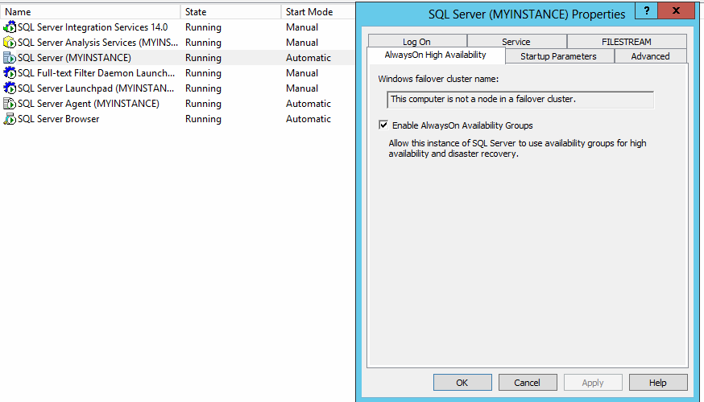

Despues de haber activado Always On se prosiguió a conectar en la maquina 1

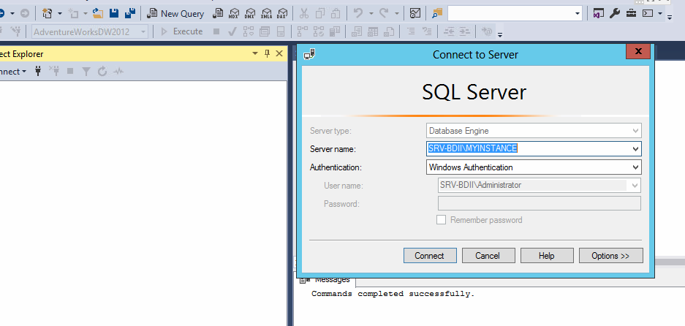

En el apartado de Always On High Availability vamos a crear un nuevo grupo de disponibilidad

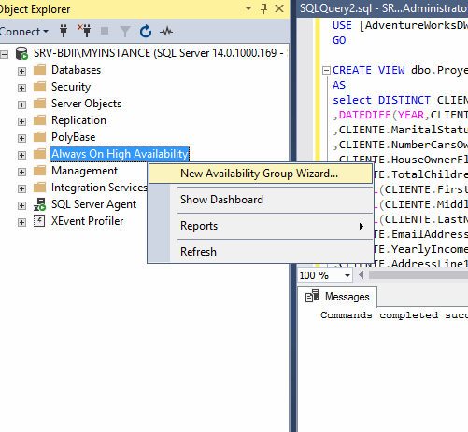

Se da nombre al grupo de alta disponibilidad y se activa el DLHD para que se realice un failover sobre la réplica, cuando la principal falle o se encuentre en estado critico.

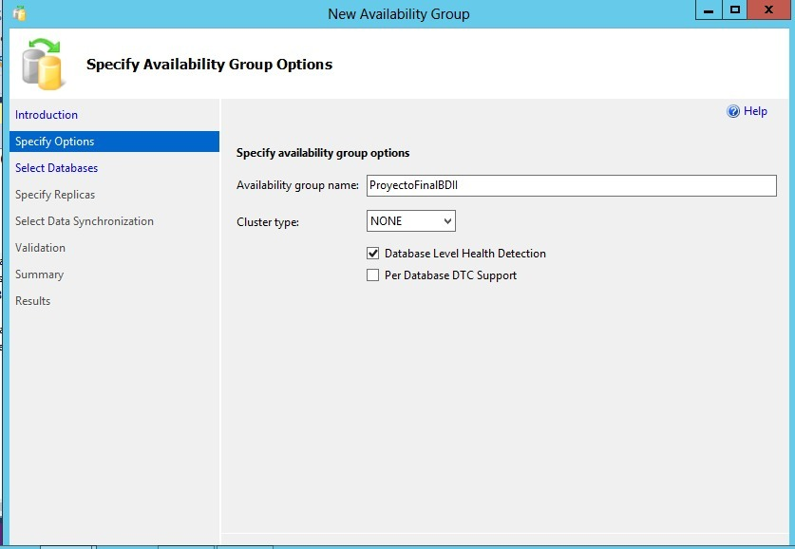

Cuando la base de datos presenta el siguiente mensaje es por el motivo de que el modo de recuperación esta desactivado.

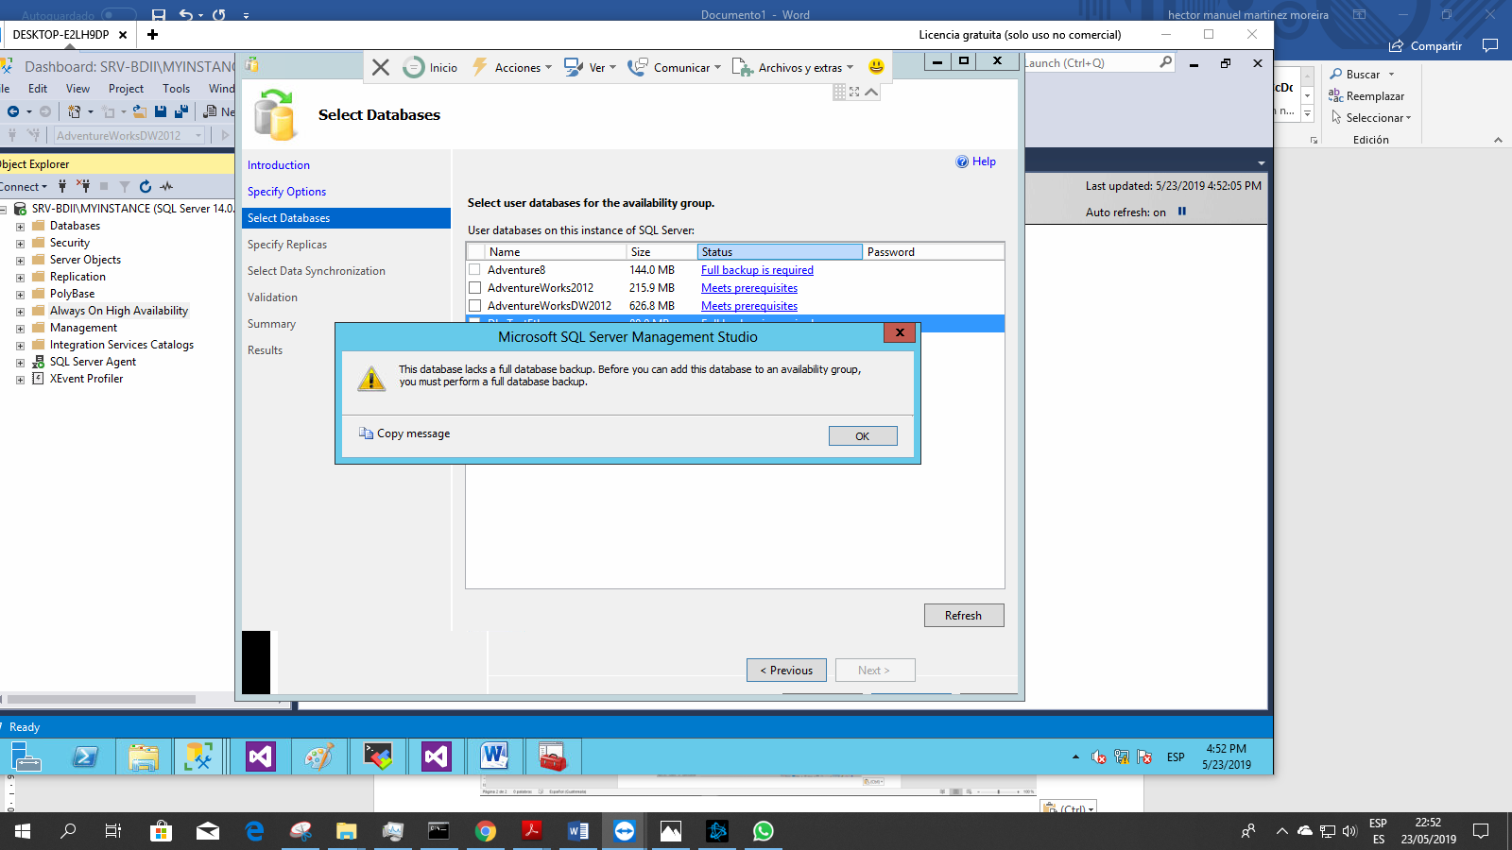

Nos dirigieras a propiedades de la base de datos.

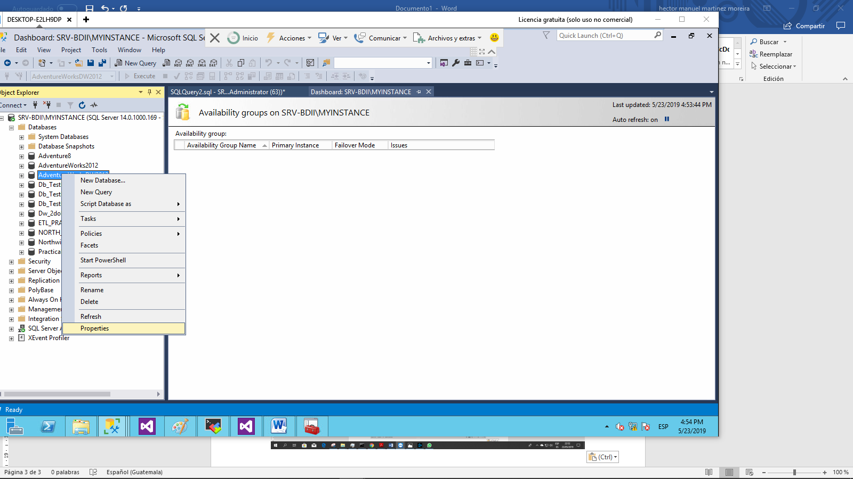

Y al recovery model eligiremos el modo de recuperación completo

.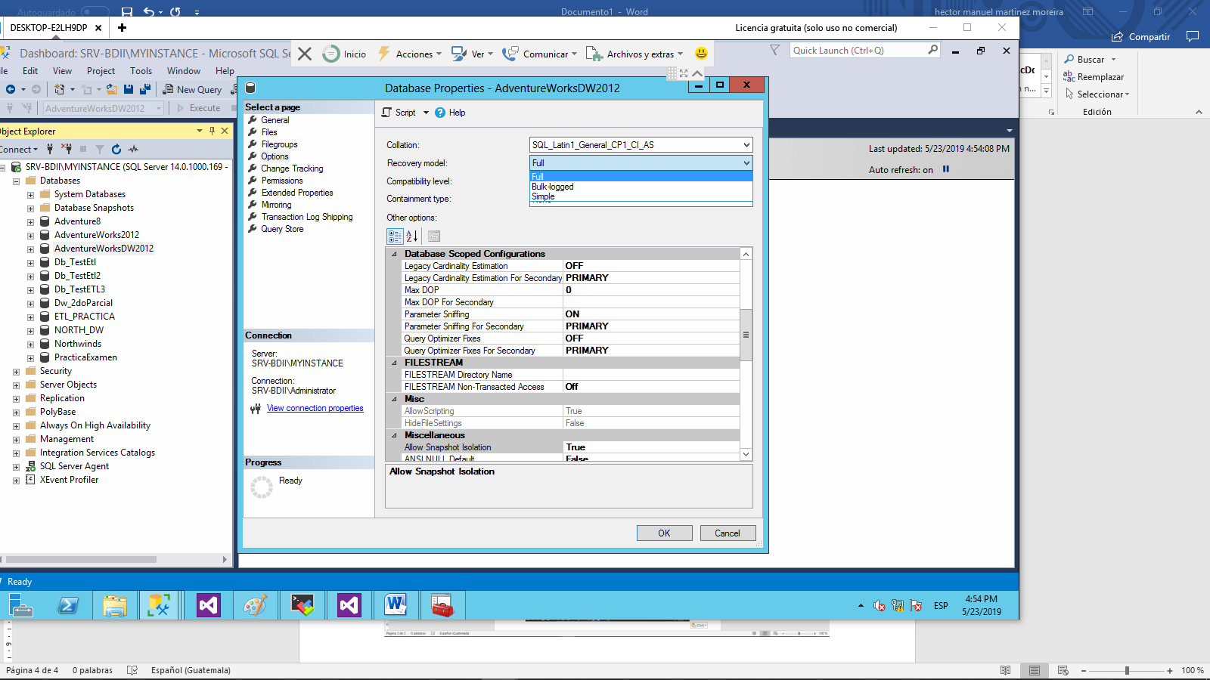

Despues de haber realizado la configuracion anterior de la base de datos, se puede observar que cumple con los requerimientos para la creacion de un Olways On.

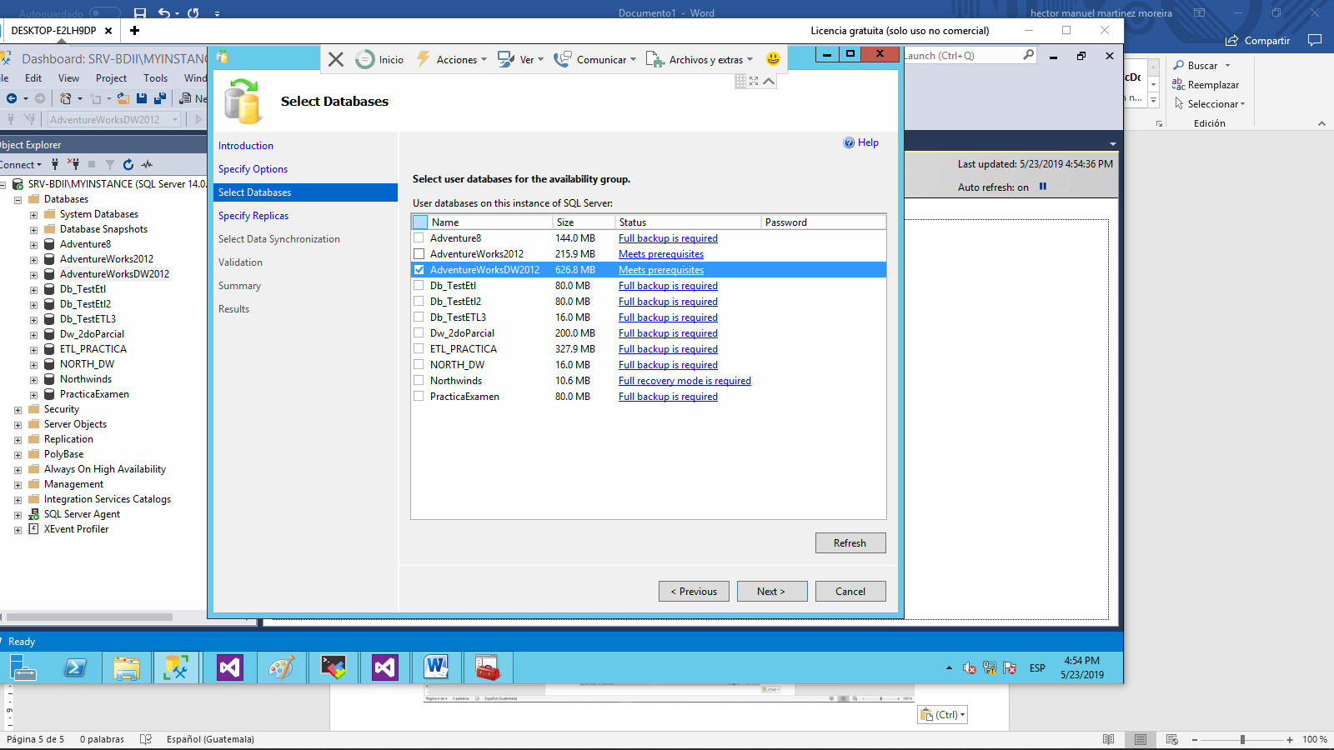

El cual comprobamos que esta correcto

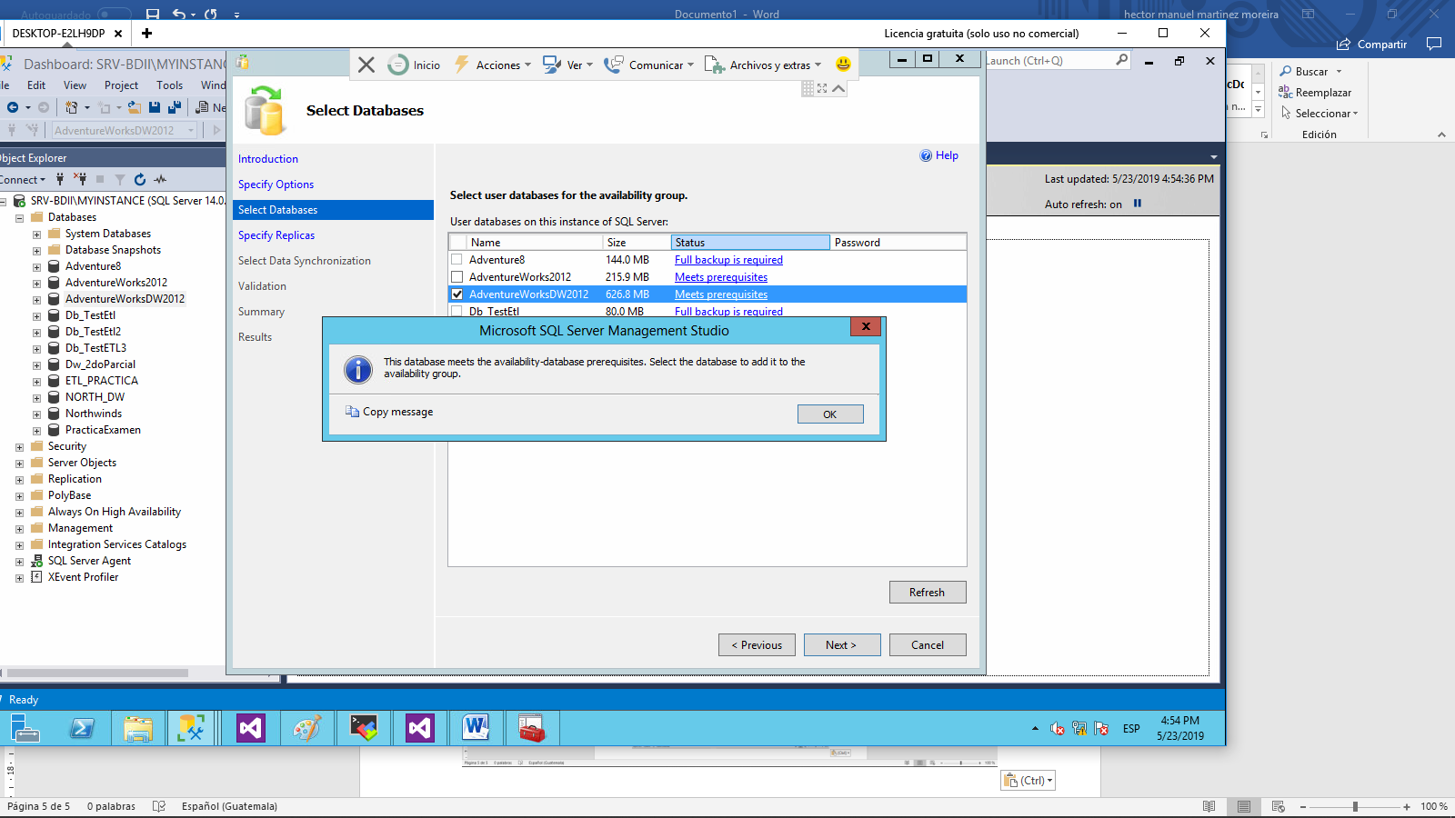

Se selecciona que el modo de alta disponibilidad funcione con una replica de commit síncrono lo que significara que solo soportara un failover.

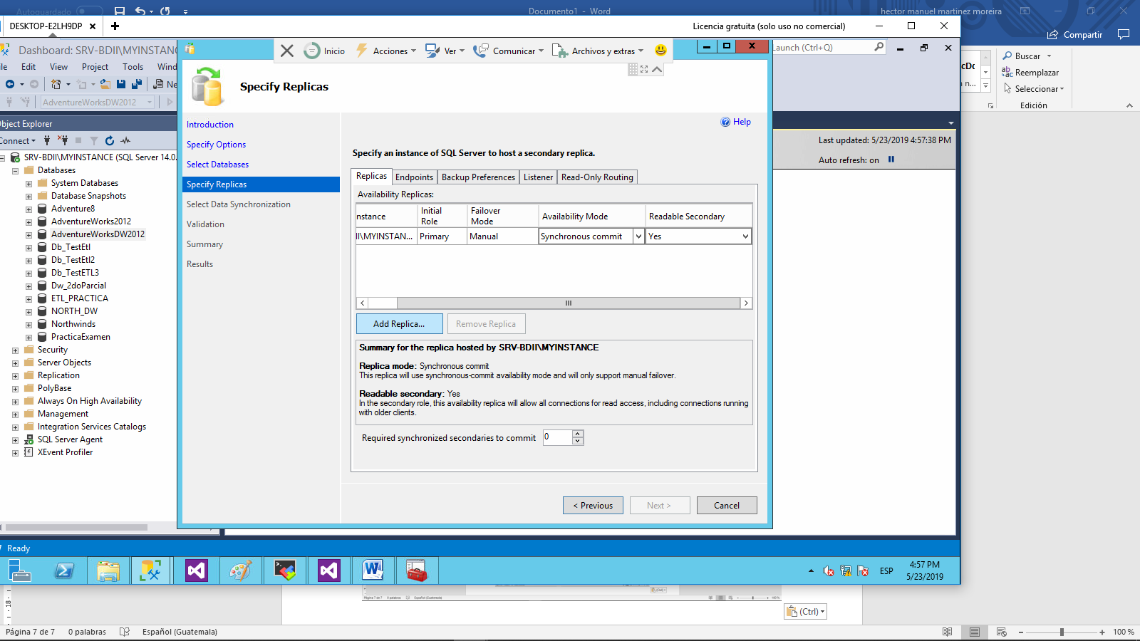

Se conecta con el servido que contendrá la réplica en caso de fialover

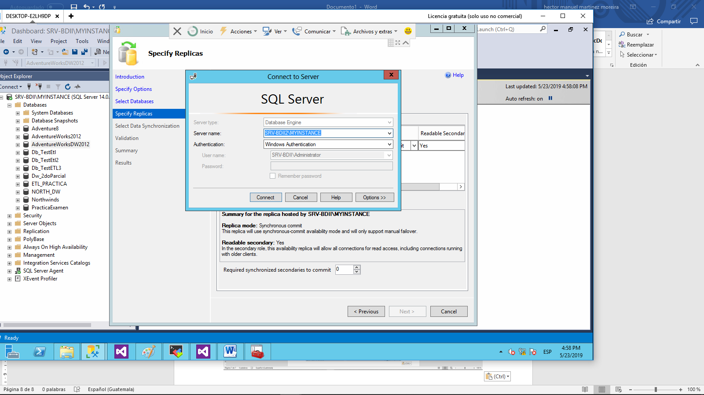

A la segunda maquina se le da misma configuración que la primera instancia.

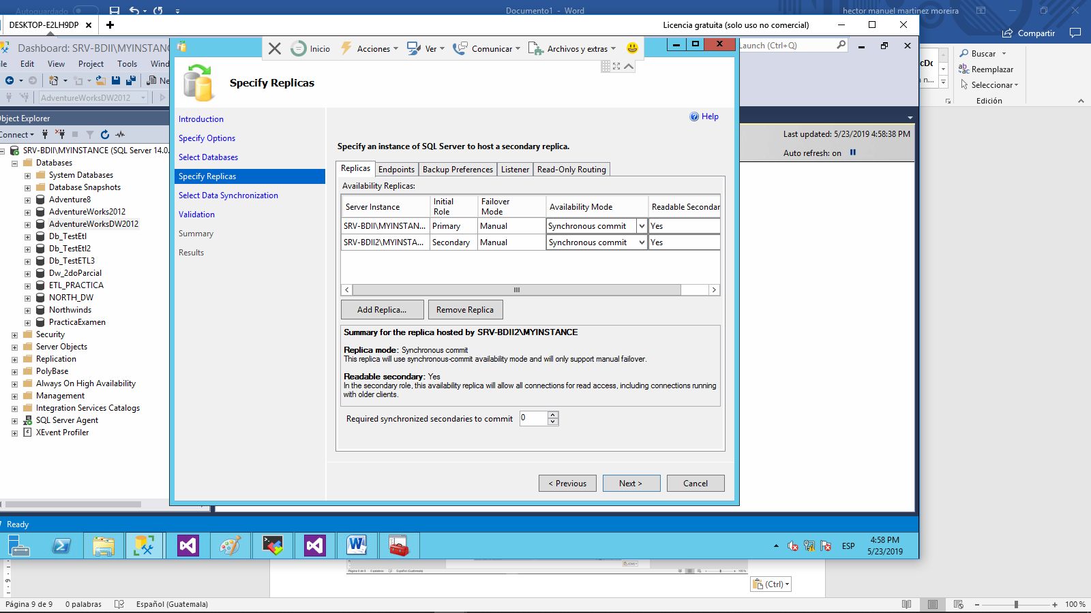

Se selecciona el modo de sincronización automático para evitar problemas de configuración.

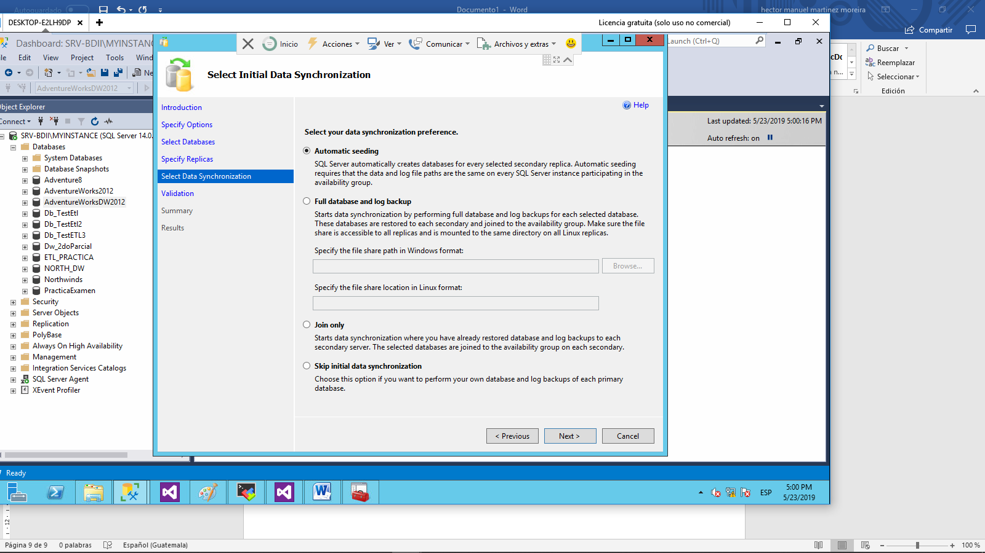

Finalizamos con configuración del grupo de alta disponibilidad.

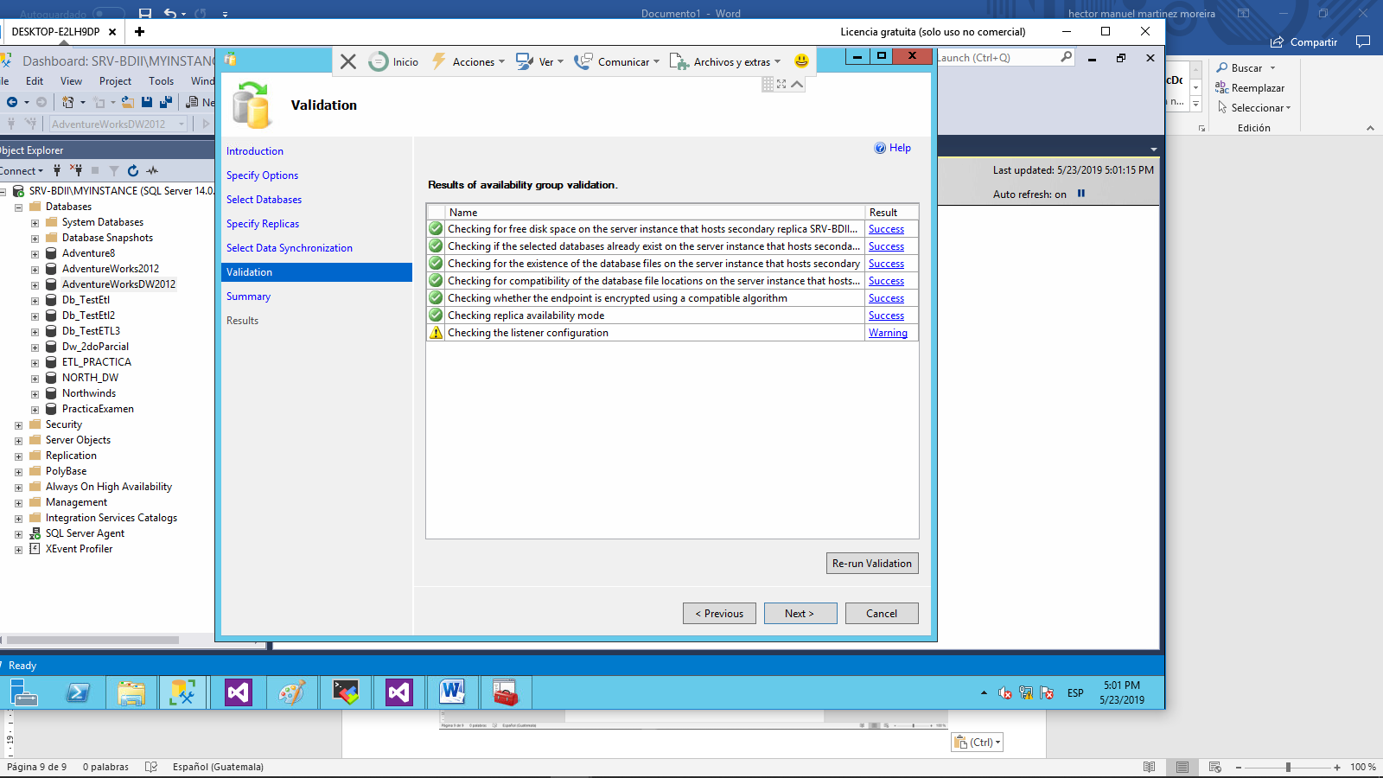

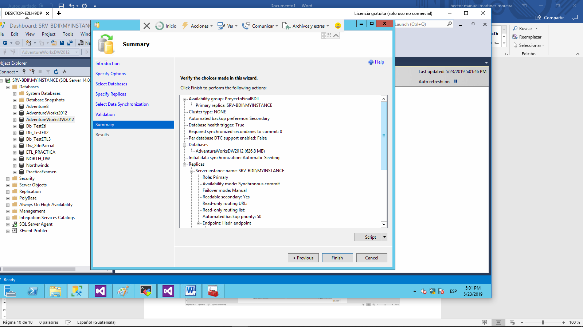

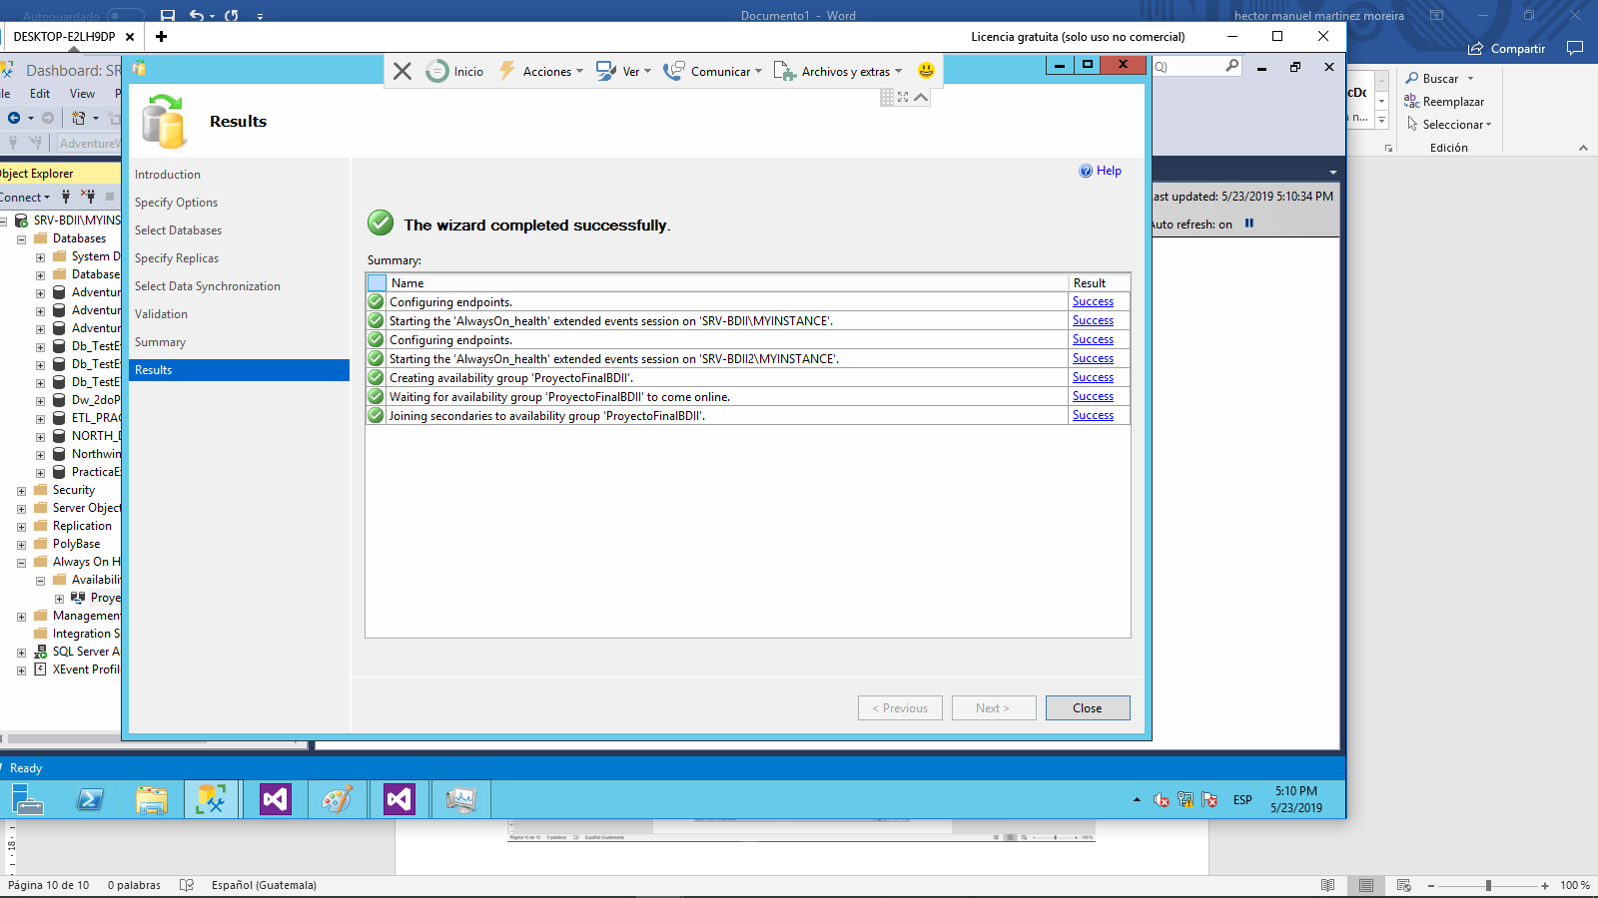

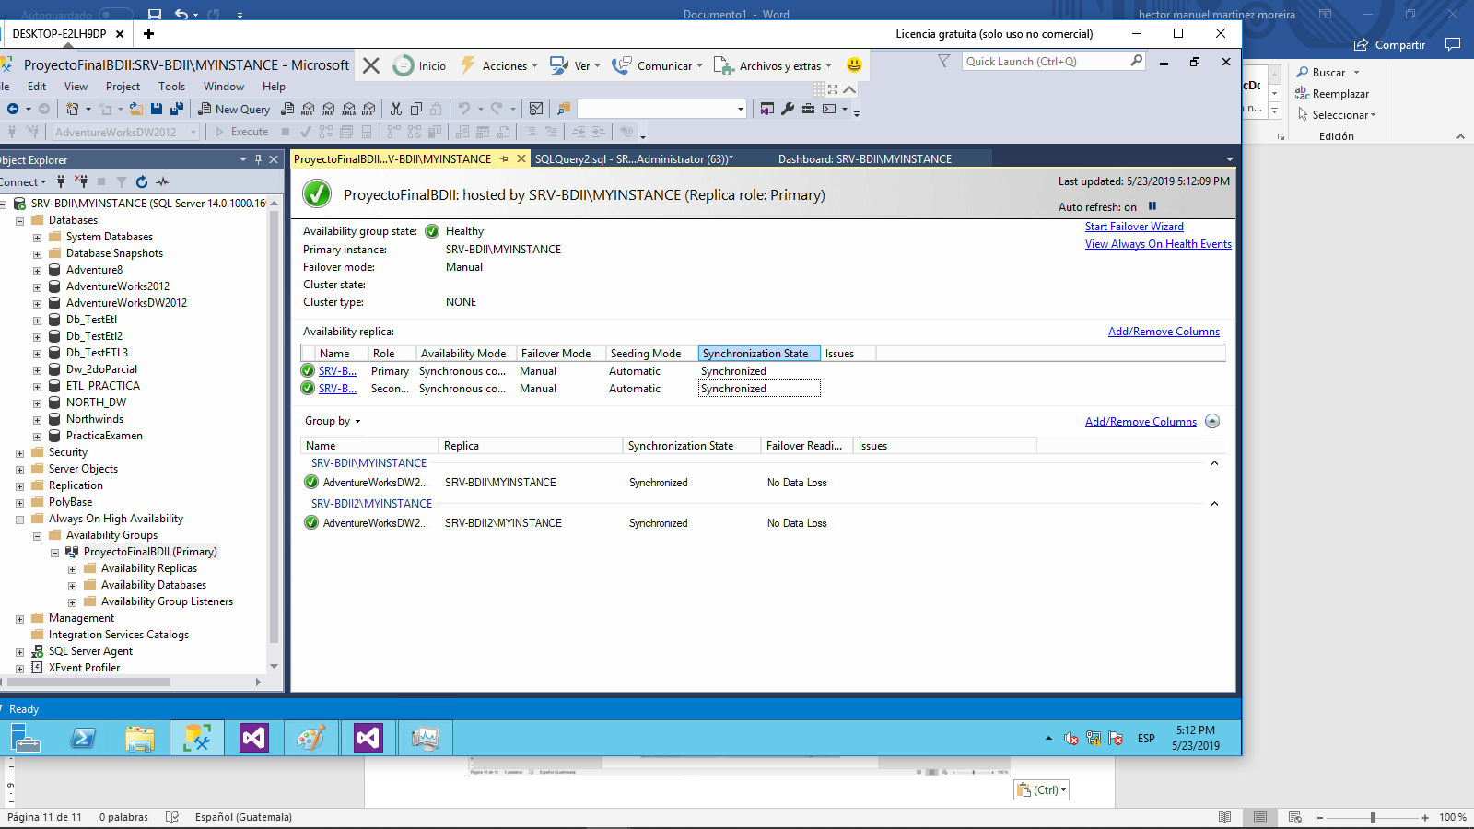

# Capítulo 7

# Conclusiones y Recomendaciones

## Conclusiones

La implementación de Always On tienen un rol indispensable en las empresas dad

que estas proporcionan recuperación ante desastres, con lo cual la información valiosa de la empresa esta resguardada, y esta puede ser consultado en todo momento.

La información es uno de los activos más importantes de una empresa, y herramientas como Data Mining ayudan a la interpretación y la recolección de datos relevantes filtrados de manera conveniente para la empresa. El sistema multidimensional ayuda a las empresas por ejemplificar algo a tener una mejor interpretación de las ventas de un tipo de producto con respecto a su tiempo, permitiendo así hacer análisis de del comportamiento del mercado para poder mejorar las ventas en el caso de una empresa de comercio.

Así pues, podemos concluir de las tecnologías mencionadas hasta esta parte, son de vital importancia para la gestión de datos y su interpretación, permitiendo así tener una

inteligencia de negocios para mejorar cualquier situación presente y/o tomar medidas de

prevención ante cualquier situación.

## Recomendaciones

Toda empresa debe implementar un Data WareHouse, para tener un mejor

control de la información de las situaciones vividas por la empresa y hacer proyecciones a

futuro. Esto debido a que lo mas importante hoy día para sobre salir es conocer el

mercado enfocarse a un grupo de clientes que puedan darnos beneficios

sumamente rentables, y con la información de las situaciones experimentales y

reales de la empresa se pueden hacer cálculos que beneficien el presente y futuro

de la misma.

La implementación de Always On, es de vital importancia, ya que la alta

disponibilidad y la tolerancia a fallos mejoran inmensurablemente cualquier sistema,

y gracias a ello se puede tener la información protegida y siempre disponible para

cuando sea necesario. Si bien el manejo requiere personal bien capacitado el costo

de esto no es comparable a los beneficios que aporta.